Microsoft Loop
Getting Started

Table of Contents
Microsoft Loop – What is it? 1
Where Can I Use Loop? 1
Business Cases 1
The Three Elements of Loop 1
Loop Components 1
Loop Pages 1
Loop Workspaces 2
Outlook Loop Components 2
Create a New Loop Component 2
Share a Loop Component 3
Insert an Existing Loop Component into an Outlook Item 3
Edit a Loop Component 3
View Activity and Access 4
Change Loop Component Sharing Permissions 4
Teams Loop Components 4
Send a Loop Component in Teams Chat 7
Edit a Loop Component 7
View Activity and Access 7
Share a Loop Component in Another Chat 8
View/Edit a Loop Component on Microsoft 365.com 8
Find an Existing Loop Component 8
Share a Loop Component 8
Edit a Loop Component 8
View Activity and Access 9
View/edit a file with a Loop Component on Office.com 9
Find an Existing Loop Component 9
To Edit a Loop Component 9
To Delete a Loop Component 10
Loop Pages 10
Start by opening a workspace. 10
To make a subpage, 10
Rename and style the page: 11
To change the cover, you need to go into the page. 11
Components in a Page 11
Stay in the Loop Across Devices 12

Microsoft Loop – What is it?
Microsoft Loop is a transformative co-creation experience that brings together teams, content and tasks across your tools and devices. Loop combines a powerful and flexible canvas with portable components that move freely and stay in sync across applications — enabling teams to think, plan, and create together.
Loop is made up of - Workspaces, Pages, and Components.

Where Can I Use Loop?
- You can use the Loop app on the web, iOS, and Android.
- You can use Loop components in Teams, Outlook, Word for the web, and Whiteboard.
Does Loop cost money?
- Microsoft Loop is included in the Microsoft 365 subscription plan.

Business Cases
Microsoft Loop can be helpful in several ways, here are just a few:
- Create a list of ideas, projects to launch or features to develop.
- Design a company guide for new hires.
- Developing a Playbook or Wiki for Team Use.
- Setting up To Do Lists and assigning tasks.
- Easily track the progress of a project.

The Three Elements of Loop

Loop Components
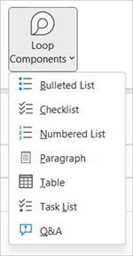
Loop components are portable pieces of content that stay in sync across all the places they are shared. Components allow you to collaborate in the flow of work – on a Loop page or in a chat, email, meeting, or document. They can be lists, tables, notes, and more - you’re always working with the latest information in your preferred app, like Microsoft Teams, Outlook, Word, Whiteboard, and the Loop app.
The first Loop components are generally available in Microsoft Teams, Whiteboard, and Outlook. These components, lists, tables, paragraphs, or task lists are the first basic components that will be available in Microsoft Loop.
When you add a component in an email or Teams chat, then the data is stored in the author’s OneDrive account. Loop uses fluid files (which will later change to loop) to store and share the data. The OneDrive synchronization and share mechanism ensures that all participants see the latest information in the component.

Loop Pages
Loop pages are flexible canvases in the Loop app where you can bring together people and all your components, links, tasks, and data. Loop pages can start small and continue to grow to match the size of your ideas. Loop pages can be shared across M365 apps as a link or as an embedded Loop component.
When you add a component in an email or Teams chat, then the data is stored in the author’s OneDrive account. Loop uses fluid files (which will later change to .loop) to store and share the data. The OneDrive synchronization and share mechanism ensures that all participants see the latest information in the component.

Loop Workspaces
Loop workspaces are shared spaces that allow you and your team to see and group everything important to your project, making it easy for you to catch up on what everyone is working on and track progress toward shared goals.
Loop Workspaces is a place where you can create spaces (projects) for you and your team. The spaces allow you to gather and organize all your files, content, ideas, etc in your project. You can use Loop pages inside your workspace to work and share ideas.
You can share the Loop components from the Loop pages and workspace in Teams, Outlook, or even OneNote to easily work together.

Outlook Loop Components
Loop components are portable, editable pieces of content that stay in sync across all the places they are shared. You can embed them in any Outlook item (email or calendar event) just as you can also do in Teams chats. Streamlining the collaboration workflow, Loop components empower your team to ideate, plan, and create together.
You can create a Loop component (e.g., table, paragraph, task list) in an Outlook email and then paste a link to it in a Teams chat. Others can then view and provide comments or edits which will immediately appear in the Outlook mail for you and all others to see.
Note: Loop components is the first feature of the Microsoft Loop app to become available in Outlook.
Get tasks done faster together. Crowd-source an agenda, track a group's action items, or organize questions and answers. These are just a few scenarios made easier with Loop components. No one ever needs to leave the mail to start collaborating.
Share components. You can now share Loop components into different Outlook emails, calendar events and Teams chats. Recipients can edit from wherever they are and see updates instantly no matter where the changes are made.
Start in email or chat and build from there. Every Loop component you create is automatically saved to a file in OneDrive. So, you might begin collaborating in an Outlook email then later move to the file on Office.com, where you have a larger visual space for editing.

Create a New Loop Component
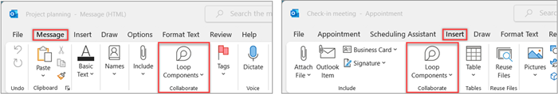
- When writing a new mail or when replying to a mail, insert a new Loop component by going to Message > Loop Components. In a Calendar item, go to Insert, Loop Components.
- Use the drop-down list to select the type of Loop component you want to insert.
- Enter content into the new Loop component.

Share a Loop Component
If you @mention someone within a Loop component, they will get an automatic email notification with a link to the Loop component. You can also send a link to the Loop component using the following steps.
- In the upper-right corner of the Loop component, select the Copy link icon.
- Paste the link into the target location (e.g., Teams chat, Outlook item).

Insert an Existing Loop Component into an Outlook Item
By default, pasting the link to a Loop component displays its actual content – unless you are pasting it inside a table, list, header, or footer.
- In the upper right corner of the Loop component, select the Copy link icon. Or, with the Loop component opened on Office.com, copy the link via the ‘share’ button.
- Go to the destination and paste via CTRL+V or the right-click menu. To paste only the link, select Insert link on the Insert tab.
Note: You must copy and insert the link as described here. The Loop component paste-in won’t display if the link is copied as a web address from a browser address bar.

Edit a Loop Component
Recipients of a Loop component link can easily add edits or comments. No matter where the edits are made, the component will always show the latest changes.
- Within the Loop component, select where you want to add or edit content.
- Proceed with typing and editing.
- Optionally enter a slash (/) to insert things like @mentions or dates. Enter two slashes (//) in existing text to add a comment, which will be attributed to you.

View Activity and Access
If others are editing while you’re viewing the component, you will see different colored cursors therein. You can also see the text being edited in real time.
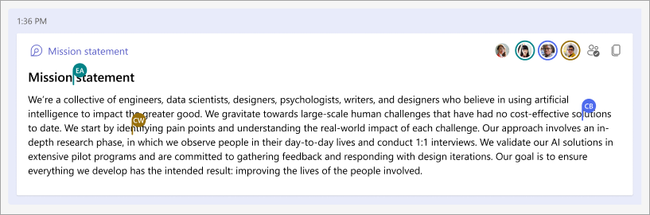
Avatars appear in the upper right corner to indicate who is viewing, editing, or has recently edited the component. Select or hover your cursor over any avatar for details. You can also select the See who has access icon. This will display the avatars of only those who have viewed the component at least once.

Change Loop Component Sharing Permissions
By default, a Loop component sent via Outlook is shared per your organization's existing permissions. While composing the item., you can change who the Loop component will be shared to.
- In the upper-left corner of the Loop component, click on its name.
- Select the permission type. (e.g., People in Organization with this link can edit).
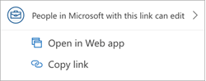
- Use the share dialog to update the Loop component permissions.

Teams Loop Components
Have you ever sent some content to a chat and wished your team could just add their ideas and feedback right in the message, without a bunch of back and forth? With Loop components, this is all possible today. Read on to learn more.
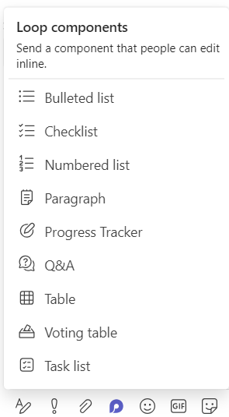
Loop components are built for collaboration - When you send a Loop component, everyone in your chat can edit it inline—and see changes instantly. That means you can collaborate right inside a chat message. To give it a try, go to the messaging area and start with a blank message. Select Loop components , choose a component type, enter some content to guide your collaboration, and press Send . Everyone in your chat will be able to edit your message.
They’re saved automatically - Loop components are saved automatically to your OneDrive, which means you can find them from Office.com in addition to Teams. We suggest giving your components easy-to-remember titles (the title is also used for the file name) to help you search for and find them quickly.
The possibilities for collaboration are endless - Below are five common uses for Loop components. But once you get started, you’ll likely discover new ways to help your team work more efficiently together.
Co-authoring: Want help from your team to find the right words? Use Loop components to wordsmith the intro to a presentation, an upcoming social media post, or even an important email to a client. 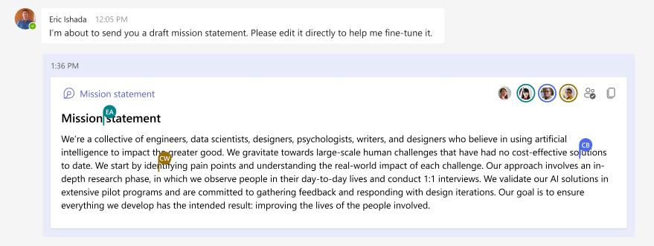
Brainstorming: Ask others to share their ideas, whether you’re looking for names for a new product or topics to discuss at your next team meeting. Use a bulleted or numbered list component to help stay organized.
Compiling data: Send out a table component with clearly labeled columns and rows to your team. In each cell, describe the data you need and @mention the person you believe can provide it. You can also use a table for a simple sign-up sheet.
Managing projects: The task list component offers a super light-weight way to assign work with due dates to people on your team. (Be sure to @mention them so they’re notified they have a task.) When work is completed, each person can mark their task as done. It’s pretty gratifying, actually—the task gets crossed off the list, right before your eyes.
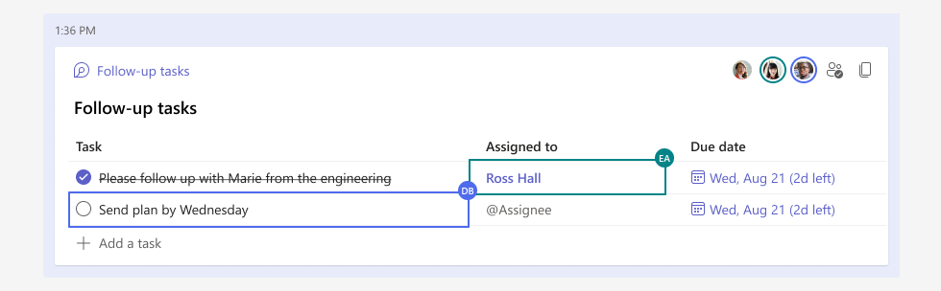
Focusing a discussion: You can use a component as a “mini breakout room” to have a place to focus on a single topic while the main chat thread covers wider ground. This is especially useful when you’re trying to reach alignment and close decisions. A few tips:
- You can always click on any content and hover your mouse there briefly to see who contributed that part of the discussion.
- When asking questions or noting differences of opinion, you may want to insert a comment because this attributes whatever you type to you. Type // inside the component, then select Comment.
- Pin the message with your component for as long as your discussion is active, so it’s easy for everyone to get back to. Go to More options , then select Pin . You'll find your message pinned to the top of your chat.
4. Components are easily shared and always reflect the latest changes
You can start a Loop component in one chat, then share it to another to invite more people to collaborate. Select Copy link in the upper right corner of the component, then paste (Ctrl + V) into the chat you want. No matter where edits are made, the component will always show the latest changes.
5. More is coming from Microsoft Loop
Loop components launched first in Teams chat, but they’ll be coming to Teams channels and to other M365 apps in the future. And Loop components are just one element of Microsoft Loop.

Send a Loop Component in Teams Chat
When you send a Loop component, everyone in your chat will be able to edit it inline—and see changes instantly. You can choose a paragraph, table, checklist, or other component to help focus your team on tasks like co-authoring content, compiling data, or tracking next steps. You’ll be able to collaborate right inside your message, minimizing the need for long chat threads.
- Go to the box where you type a chat message. Select Loop components right beneath the box. (Make sure the box is empty—with no text in it—when you do this.)
- Select the type of component you want to insert into your message.
- Enter content into the component.
- When ready, select Send . Everyone in the chat will be able to edit the content inline.
Tip: @Mention people inside the component to show where you’d like them to contribute. They’ll get an activity feed notification that brings them right to the component.

Edit a Loop Component
Simply, click where you want to add or edit content and start typing.
When editing, you can type / to insert things like an @mention, date, or even a component. If you want to comment on existing text vs. edit it, type //. This will attribute the comment to you.
Tip: Pin the message containing your live component, which puts it at the top of your chat for easy access. To do so, select More options >Pin.

View Activity and Access
If others are editing while you’re viewing the component, you’ll see different colored cursors within the text and you’ll possibly see text being edited as well.
Avatars appear in the upper-right corner to let you know who is viewing, editing, or has recently edited the component. Hover your cursor over any avatar for details.
Select See who has access to understand who can view or edit the component. Avatars of people who have viewed the component at least once appear here, too.
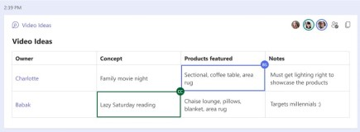

Share a Loop Component in Another Chat
- Go to the upper-right corner of the component and select Copy link .
- Switch to a different chat.
- Go to the box where you type a message, and press Ctrl + V to paste your Loop component into an empty chat.
The people in your original chat and in this additional chat will be able to edit the content. No matter where people are editing, the component will always show the latest updates.

View/Edit a Loop Component on Microsoft 365.com
Here’s how to open a Loop component in Microsoft365.com.
- In the upper-left corner of the Loop component, click/select its name.
- View and edit in the browser.

Find an Existing Loop Component
Your Loop components are saved automatically to your OneDrive. You can easily find them from either Microsoft365.com or OneDrive.
Tip: The title of your Loop component might also be applied as its file name. To facilitate search, use a memorable, descriptive name.

Share a Loop Component
If you @mention someone within a Loop component, they will get an email notification with a link to the Loop component. You can also send a link to the Loop component using the following steps.
- In the upper right corner of the Loop component, select the Copy link icon.
- To share, you can paste the link in other apps (e.g., Teams, Outlook).
Tip: You can also select a shareable link by clicking on the header and then copying via CTRL+ C.

Edit a Loop Component
Once you have created a Loop component in a document, you can share it with others to invite more people to collaborate. No matter where edits are made, the component will always show the latest changes. Here's how collaborators can provide edits and comments:
- Within the existing Loop component, select the location to add or edit content.
- Proceed with typing and editing.
- Optionally enter a slash (/) to insert things like @mentions or dates. Enter two slashes (//) in existing text to add a comment, which will be attributed to you.

View Activity and Access
If others are editing while you’re viewing the component, you will see different colored cursors therein. You may also see the text being edited.
Avatars appear in the upper right corner to indicate who is viewing, editing, or has recently edited the component. Select or hover your cursor over any avatar for details. You can also select the See who has access icon. This will display the avatars of those who have viewed the component at least once.

View/edit a file with a Loop Component on Office.com
Here’s how to open a Loop component in Office.com:
- Select Copy link in the upper right corner of the Loop component.
- Paste the link in a browser.
- View and edit in the browser.

Find an Existing Loop Component
Loop components are saved automatically to your OneDrive. Using Search, you can easily find them on either Office.com or OneDrive.
Tip: The title of your Loop component might also be applied as its filename. To facilitate search, use a memorable, descriptive name.

To Edit a Loop Component
- Using a Mouse: Hover & then double click on the portion of the Loop component you want to edit
- Using a Keyboard:
  - Use Tab to bring focus onto the Loop component.
  - Press Enter to take focus onto the Loop component header.
  - Press Tab to take focus onto the Loop component content.
  - Press Enter to take focus inside the Loop component content and edit as desired.
- Using Touch/Tap: Double tap on the portion of the Loop component you want to edit.
No matter where & how edits are made, the component will always show the latest changes.
Note: On Android & iOS devices, selecting a Loop component will open the source Loop file in Office.com where edits can be made as required

To Delete a Loop Component
- Select a Loop component.
- Select Delete in the component’s context menu or the delete key on your keyboard.

Loop Pages
Pages in Microsoft Loop are used to build and organize project components. You can also share pages, allowing you to construct projects with your team in real time, and across various Microsoft 365 applications.
- Pages are like the chapters of a book, where the book is the workspace and the components are the text on the pages.
- Pages are spaces to create your project’s components. Pages can host numerous components, and you can share the whole page or even specific components within them. You can also create subpages to help you organize your project.
To add content to a page, you can select a template at the bottom, or create your own by typing a forward slash / and selecting a component from the list.
To share a page, click the “Share” button at the top, or hover over the page you want to share in the left menu and click the three dots.
You will have the option to copy the page link. But if you’d like to embed the page in another application, select the option to share as a “Loop component.”

Start by opening a workspace.
- Click the circular plus icon.
- You should find two options:
- New page.
- New link.
- Select “New page.”
Links will appear on the left menu like pages, however, clicking them will either open a link in a new tab or download a document, depending on the type of link you add.
- To make a link, click the circular plus icon.
- Then select “New link” from the dropdown.
- Add in the text, which will appear like a page title on the left menu.
- Add the link address.
- Then hit the “Add” button.

To make a subpage,
- Hover over your page or link on the left menu.
- Then click the three dots.
- Select “New Subpage” from the dropdown.
If you want to reorder your pages and subpages, you can do that by dragging the pages up or down. You can also drag a page or subpage into another page.

Rename and style the page:
- Hover over the page you want to rename and style.
- Click the three dots.
- Select “Rename and style” from the dropdown.
- Click the emoji icon and select a new icon.
- Add a new title.
- Hit the “Update” button.

To change the cover, you need to go into the page.
- There, hover above the page title and click the “Add cover” button.
- You can then select a cover from a list of presets.
- Click “Add” to use the cover you selected.

Components in a Page
Components are building blocks, such as tables, headers, lists, and images. So, if workspaces are books, pages would be the chapters, and components would be the text within those chapters.
Adding components is easily done by typing / followed by the component name or you can select one from the list.
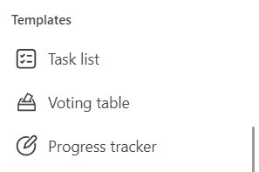
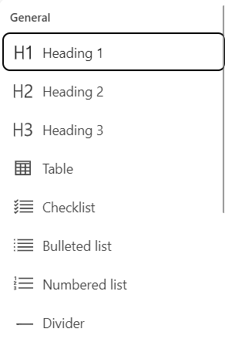
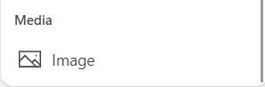
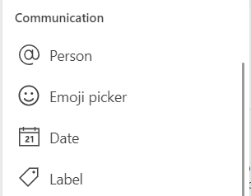
General – Templates – Communication - Media

Stay in the Loop Across Devices
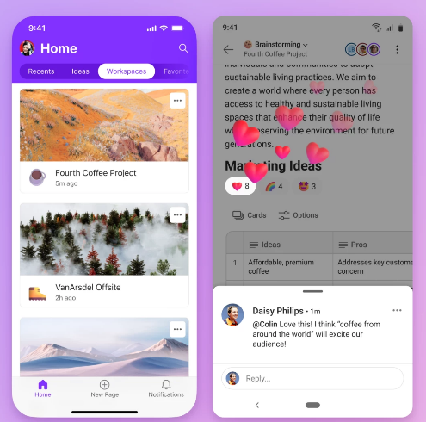
(Currently in early access mode.)
Whether you’re moving from the desk to the couch or making a longer trek, the Microsoft Loop mobile app was built with flexibility in mind. Quickly catch up by accessing your project content from one place on your phone. Easily navigate between workspaces and pages with icons that provide a visual guide; capture ideas by simply snapping a photo of something that inspires you and adding it to your workspace; or continue building on the ideas of others without waiting until you are back at your computer. With the Microsoft Loop mobile app, you can continue co-creating wherever you are!

