Getting Started with
ChatGPT

Table of Contents
ChatGPT – What is it? 1
How does it work? 1
Who invented artificial intelligence (AI)? 2
How to Access ChatGPT 2
What does ChatGPT Cost? 2
Versions of ChatGPT 3
What ChatGPT Won’t Do 4
Thinking Through the Potential Dangers of Chat AI 4
Example Questions to ask: 5
Use ChatGPT Content Creation 5
General Use Cases of ChatGPT for Business 6
Fine-Tuned & Customized Use Cases of ChatGPT for Business 11
Managing Chats 12
Rename or Delete the Conversation 13
How to rename ChatGPT conversations 13
Chatbot vs ChatGPT 13
Key Differences between Chatbot and ChatGPT 13
Microsoft 365 Copilot – your copilot for work 14
Glossary 18
A 18
C 18
D 18
F 19
G 19
H 19
K 19
L 19
M 19
N 19
R 19
S 19
U 20

ChatGPT – What is it?
ChatGPT is a variant of the GPT (Generative Pre-training Transformer) language model that was developed specifically for generating human-like text in a conversational context. It is designed to generate natural language responses when given input from a user — making it potentially useful in a variety of business applications where human-like conversation with customers or clients is desirable.

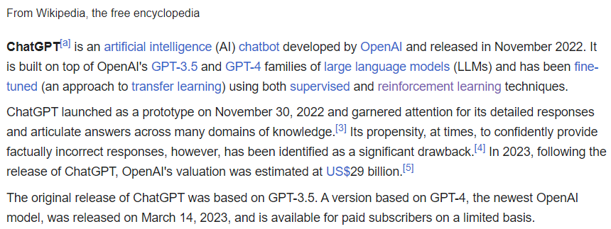
How does it work?
The way ChatGPT works is complicated, but basically it was trained on a huge amount of text data from the internet. This data includes things like books, articles, and websites, so ChatGPT has learned a lot about how people use language.
When you give ChatGPT some text to work with, it uses what it's learned from that massive dataset to try and predict what text should come next. It does this by breaking down the input text into smaller parts and using complex math to figure out what the most likely next part should be.
Then, once ChatGPT has predicted what the next part of the text should be, it generates that text and uses it to keep predicting what comes next. This process continues until ChatGPT has generated a whole response to your original text.
The model doesn’t “know” what it’s saying, but it does know what symbols (words) are likely to come after one another based on the data set it was trained on. The current generation of artificial intelligence chatbots, such as ChatGPT, its Google rival Bard and others, don’t really make intelligently informed decisions; instead, they’re the internet’s parrots, repeating words that are likely to be found next to one another in the course of natural speech.
In ChatGPT’s case, that data set is a large portion of the internet. From there, humans give feedback on the AI’s output to confirm whether the words it uses sound natural.
ChatGPT can be used to:
- Generate Text
- Write Code
- Solve Math
- Translate Languages
- Write a Resume
- Smart Assistant in your daily life

Who invented artificial intelligence (AI)?
The founding fathers of AI are considered to be John McCarthy, Alan Turing, Marvin Minksy, Allen Newell, and Herbert A. Simon. However, it was John McCarthy and his team who coined the term “artificial intelligence” in 1956.

How to Access ChatGPT
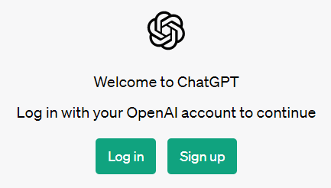
- Open an Internet Brower.
- Go to https://chat.openai.com/
- Click on ‘Try ChatGPT’ if this is your first time.
- Click on ‘Sign up’.
- Enter your email address and click on ‘Continue’. ...
- Enter a password and click on ‘Continue’. ...
- Continue with setup.

What does ChatGPT Cost?
ChatGPT is FREE to use but there is a pay version, ChatGPT Plus. By offering this subscription pricing, we will be able to help support free access availability to as many people as possible.
The new subscription plan, ChatGPT Plus, will be available for $20/month, and subscribers will receive a number of benefits:
- General access to ChatGPT, even during peak times
- Faster response times
- Priority access to new features and improvements
- ChatGPT Plus is available to customers in the United States and around the world.
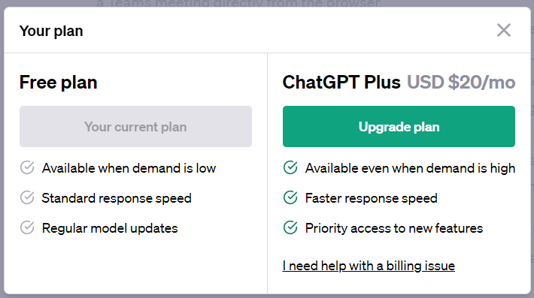
- We expanded access to ChatGPT Plus for customers outside of the United States on February 10th, 2023.

Versions of ChatGPT
The current version of ChatGPT is GPT 3.5 but GPT 4 is now available. ChatGPT-4 is currently only available in the paid for subscription.
- GPT-4 is short for “generative pretrained transformer 4.
- It claims ChatGPT-4 is more accurate, creative and collaborative than the previous iteration, ChatGPT-3.5, and “40% more likely” to produce factual responses.
- Has the ability to handle not only words, but pictures too, in what is being called “multimodal” technology.
- A user will have the ability to submit a picture alongside text — both of which ChatGPT-4 will be able to process and discuss. The ability to input video is also on the horizon.
- Trained on data that existed before 2021.
GPT-4 is a new language model created by OpenAI that can generate text that is similar to human speech. It advances the technology used by ChatGPT, which is currently based on GPT-3.5. GPT is the acronym for Generative Pre-trained Transformer, a deep learning technology that uses artificial neural networks to write like a human.
According to OpenAI, this next-generation language model is more advanced in three key areas: creativity, visual input, and longer context. In terms of creativity, OpenAI says GPT-4 is much better at both creating and collaborating with users on creative projects. Examples of these include music, screenplays, technical writing, and even “learning a user’s writing style.”
GPT-4 will also be available as an API “for developers to build applications and services.” Some of the companies that have already integrated GPT-4 include Duolingo, Be My Eyes, Stripe, and Khan Academy.
The longer context plays into this as well. GPT-4 can now process up to 25,000 words of text from the user. You can even just send GPT-4 a web link and ask it to interact with the text from that page. OpenAI says this can be helpful for the creation of long-form content, as well as “extended conversations.”
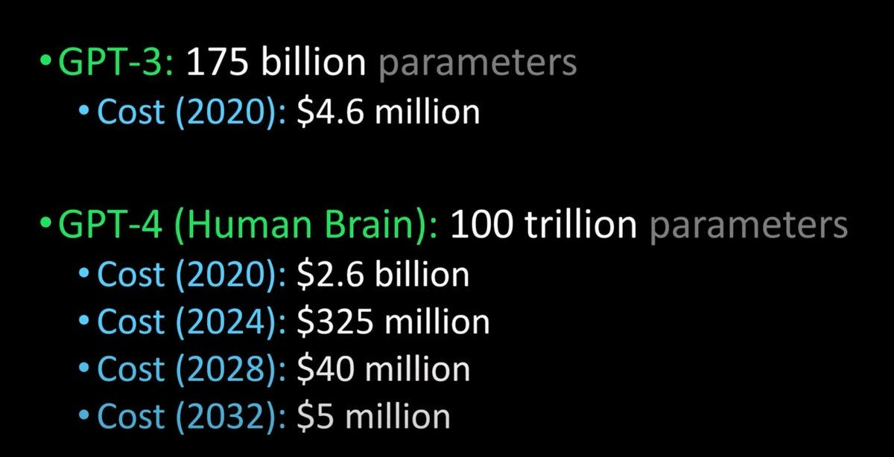

What ChatGPT Won’t Do
- ChatGPT cannot generate the latest information - Since OpenAI has built ChatGPT on GPT3.5, which has been trained with data until 2021, it can not generate up-to-date and accurate responses.
- It won't predict future results of sports events or political contests
- It won't discuss partisan political issues
- It won't always be accurate
- It won't do anything that involves a web lookup

Thinking Through the Potential Dangers of Chat AI
There are enormous opportunities for businesses to use tools like ChatGPT to improve their bottom line and create better customer experiences — but there are some potential dangers with this technology, too.
In the beta version of their ChatGPT software, OpenAI acknowledges the current limitations of the AI, including the potential to occasionally generate incorrect information or biased content. It also says the AI may have limited knowledge of events or knowledge after 2021, based on when the model was trained.
AI models require lots of training and fine-tuning to reach ideal performance levels.
- Misinformation: Chatbots are only as accurate and reliable as the information they are trained on. If a chatbot is trained on inaccurate or misleading information, it will spread that misinformation to anyone who interacts with it.
- Privacy concerns: Chatbots can collect and store large amounts of personal information from users, which can be vulnerable to hacking or mishandling.
- Job loss: Chatbots can automate certain tasks and customer service interactions, which can lead to job loss for human employees.
- Lack of empathy: Chatbots are not able to understand or respond to emotional cues, which can make them poor choices for certain types of interactions, such as crisis counseling or therapy.
- Bias: Chatbots can perpetuate and even amplify biases if they are trained on data that is not diverse or representative of the population.
- Lack of accountability: Chatbots do not have a legal or moral responsibility for their actions, which can make it difficult to hold them accountable for errors or harm caused.
- Difficulty in identifying: It is often difficult for people to identify when they are interacting with a chatbot, which can lead to confusion and mistrust.
- Manipulation: Chatbots can be programmed to manipulate and influence users, such as spreading propaganda or fake news.
Set clear guidelines and policies for its use.
However, if used responsibly and ethically, chat AI can be a valuable tool for businesses, organizations, and individuals. It can improve customer service, automate tedious tasks, and even help with mental health.
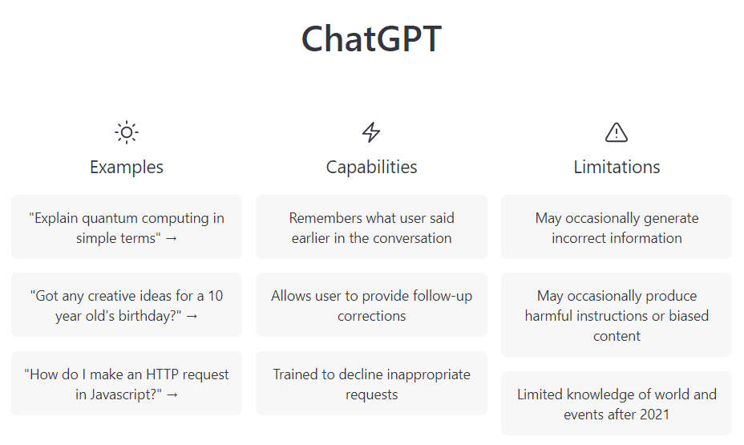
It is important for developers and users to be aware of the potential dangers and take steps to mitigate them, such as regular audits and transparency about the chatbot's capabilities and limitations.

Example Questions to ask:
- What are some interview questions for a Data Analysis?
- What’s the best way to reach out to potential customers?
- What are the essential skills for a successful business leader?
- Write a list of ways to improve customer service.
- Write a mission statement for my company, which offers X, Y, and Z.

Use ChatGPT Content Creation
Most marketing experts agree that creating engaging content is one of the best ways to build a following and attract customers. The challenge is that content creation takes a lot of time — in most industries, posting on social media or your blog several times per week is standard, and each piece of content generally takes anywhere from two to six hours. Unfortunately, this can pull an entrepreneur away from other critical activities involved in keeping their business operating.
It's important to always add your own spin to the content.
ChatGPT can significantly reduce the amount of time that it takes for small business owners to generate the content they need, including articles, blog posts, video scripts and social media posts.

General Use Cases of ChatGPT for Business
1- Content creation - Businesses can leverage ChatGPT for content creation to streamline and enhance their marketing efforts, enabling them to generate engaging, high-quality content more efficiently. By incorporating ChatGPT into their content strategy, companies can automate the production of:
- Blog posts
- Articles
- Social media posts
- Promotional marketing materials tailored to their target audience.
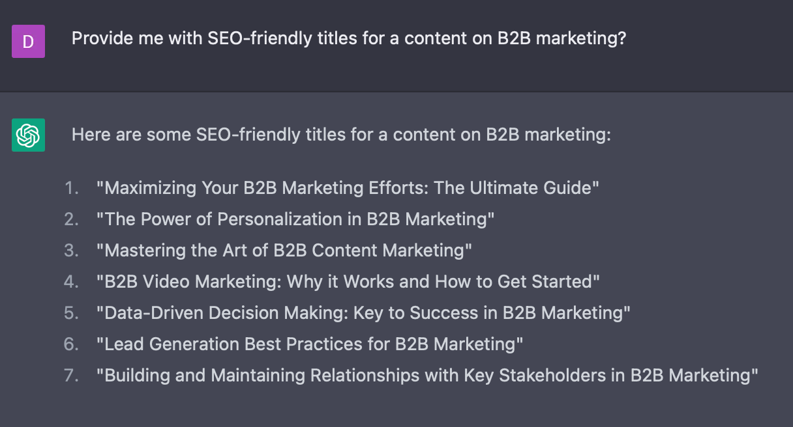
Figure 1 ChatGPT SEO-friendly title suggestions for contents in B2B marketing
2- Language translation - Businesses can harness ChatGPT for translation services, enabling seamless communication across linguistic barriers in today’s increasingly globalized market. By integrating ChatGPT into their operations, companies can gain access to real-time, accurate translations for various content types, such as emails, reports, marketing materials, and product documentation.
3- Email and communication - Businesses can employ ChatGPT to enhance email and communication processes personalized to customers, leading to more effective and efficient internal and external correspondence. By using ChatGPT, employees can quickly draft, edit, and proofread emails, ensuring they are polished and professional.
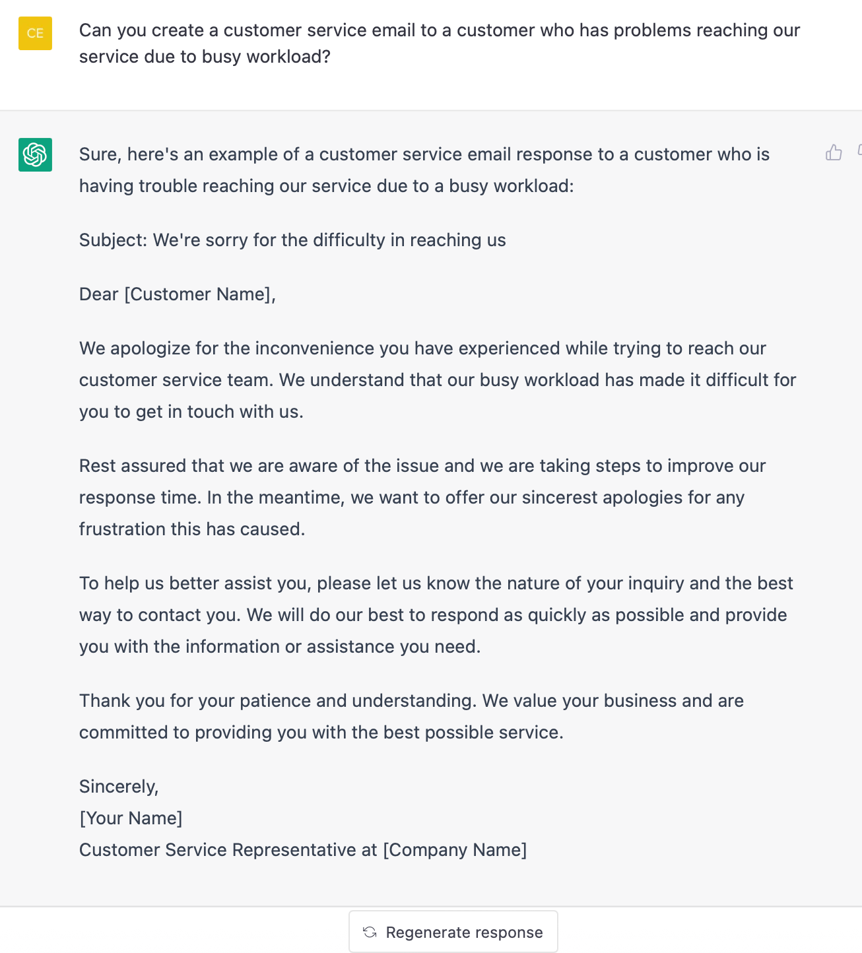
Figure 2 - ChatGPT providing an email template for a certain customer problem.
Furthermore, ChatGPT can be utilized to generate templates for recurring emails, such as:
- Sales pitches
- Follow-ups
- Meeting requests
This allows employees to maintain consistent messaging while saving time.
4- Idea generation and brainstorming - Businesses can use ChatGPT to generate ideas and facilitate brainstorming sessions, providing a creative and innovative approach to problem-solving. By integrating ChatGPT into brainstorming sessions, employees can input their initial ideas or problems, and the model can generate related concepts or potential solutions based on the given context.
Furthermore, ChatGPT can assist in refining ideas and proposals, offering feedback and suggestions to enhance the quality and feasibility of those ideas.
5- Creating presentations - By leveraging ChatGPT’s natural language understanding capabilities, employees can obtain suggestions for presentation topics, key points, and arguments based on their initial input or a specific subject area.
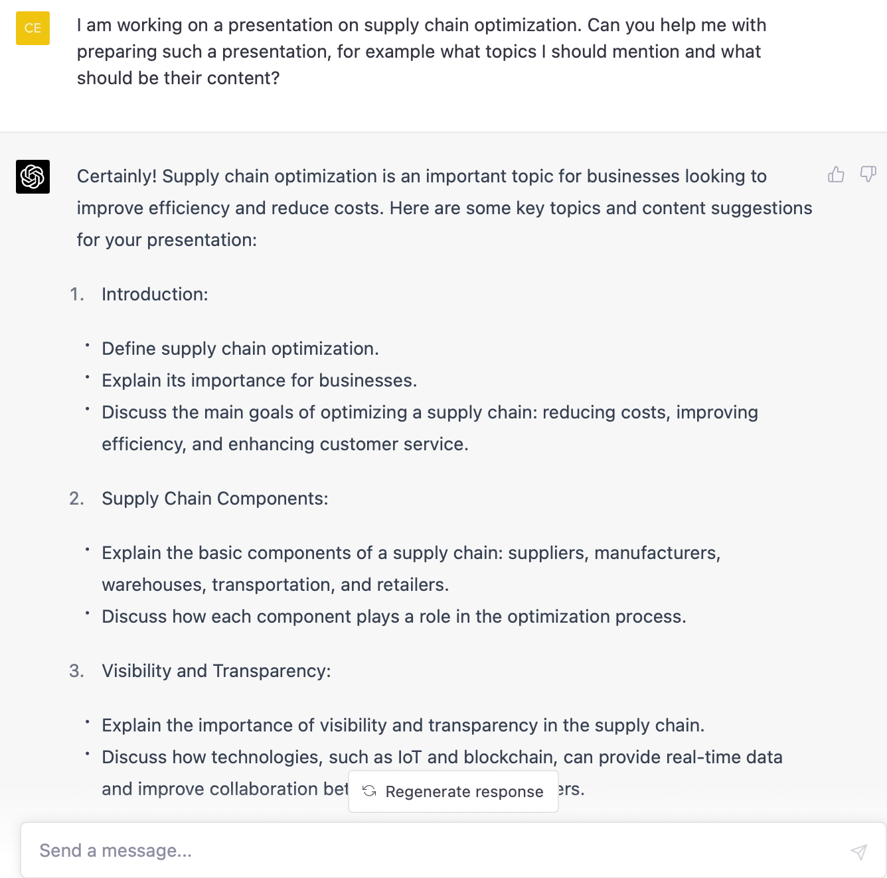
Figure 3 - ChatGPT offers presentation structure and key points to mention.
Furthermore, the AI tool can assist in generating concise and engaging text for slide content, ensuring that the core messages are conveyed clearly and effectively. ChatGPT can also help in crafting compelling headlines, bullet points, and speaker notes, allowing presenters to focus on the delivery and visual aspects of their presentations.
6- Employee training - Businesses can leverage ChatGPT to elevate employee training programs, providing customized and engaging learning experiences tailored to individual needs. By integrating ChatGPT into training platforms, companies can generate contextually relevant instructional content based on employees’ roles, skill levels, and learning goals, such as:

- Tutorials
- Case studies
- Quizzes
The AI model can also be utilized to answer trainees’ questions, offering instant support and clarification on complex topics or tasks. It can also assist in identifying knowledge gaps and suggesting targeted learning resources to bridge those gaps, ensuring continuous skill development and growth.
7- Human resources - ChatGPT can assist in employee onboarding, providing essential information and guidance to new hires, and facilitating the orientation process. It can also help in forming interview questions for job positions.
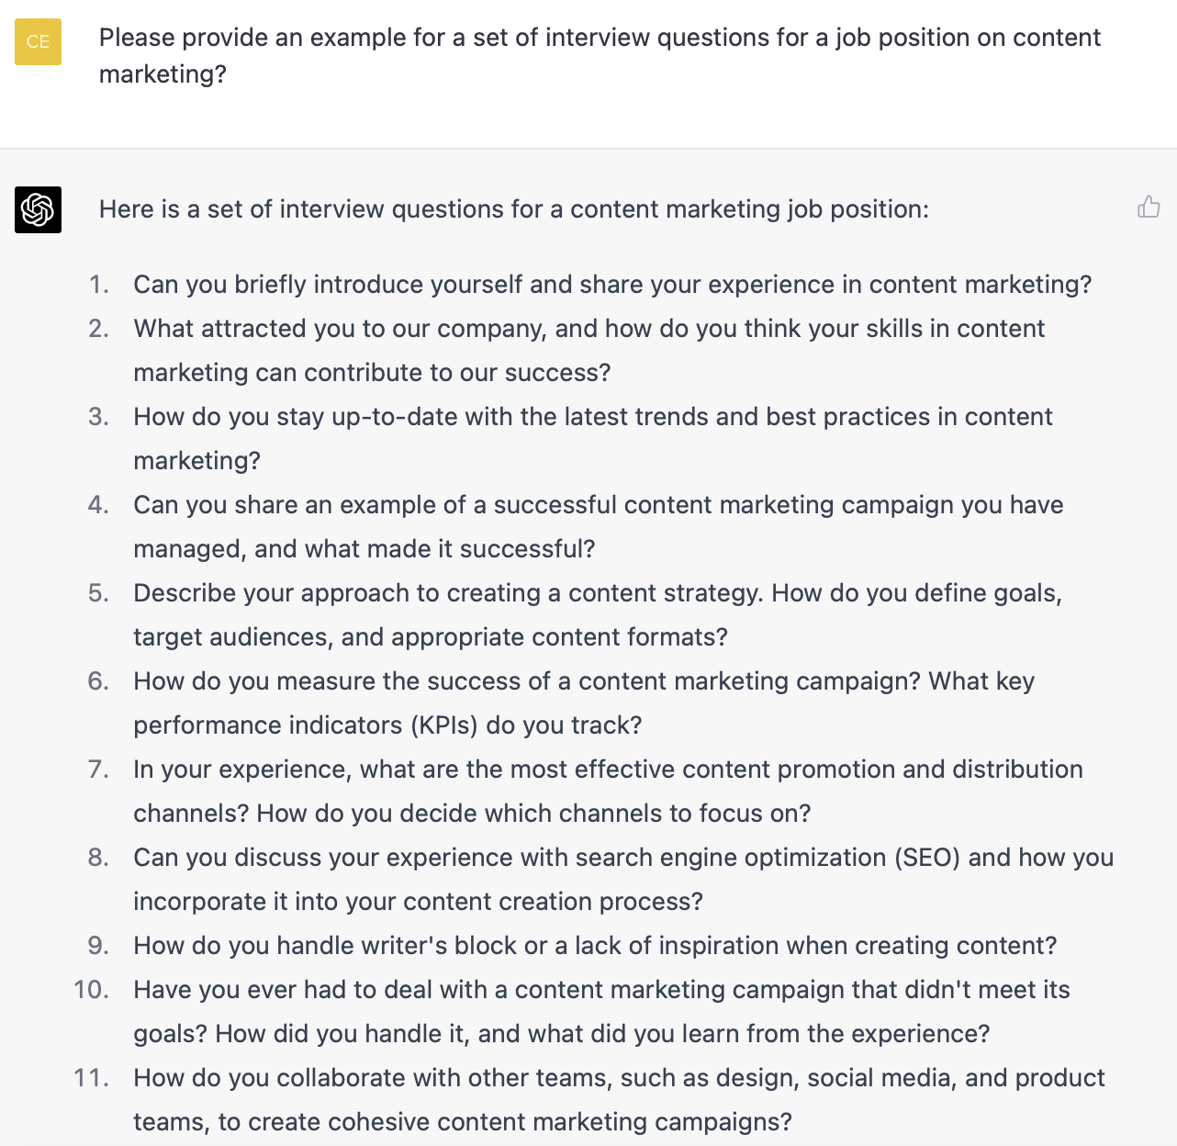
Figure 4 - ChatGPT creates a set of interview questions for a job position.
Furthermore, ChatGPT can be utilized to generate performance evaluations, feedback, and development plans, providing a more objective and data-driven approach to performance management.
Additionally, ChatGPT can be used to automate routine HR inquiries and tasks, such as updating employee information or answering frequently asked questions, freeing up HR personnel to focus on more complex tasks.
9- Web scraping - scraping helps extract structured data from websites. Businesses use web scraping as a powerful tool to Web gather information from the internet and gain insights for various purposes, such as:
- Gaining competitive intelligence for growth.
- Lead generation via contact information.
- Sentiment analysis via customer opinions and reviews.
Businesses can use ChatGPT in web scraping, for various applications like generating code for scraping websites (Figure 6) or cleaning extracted data.
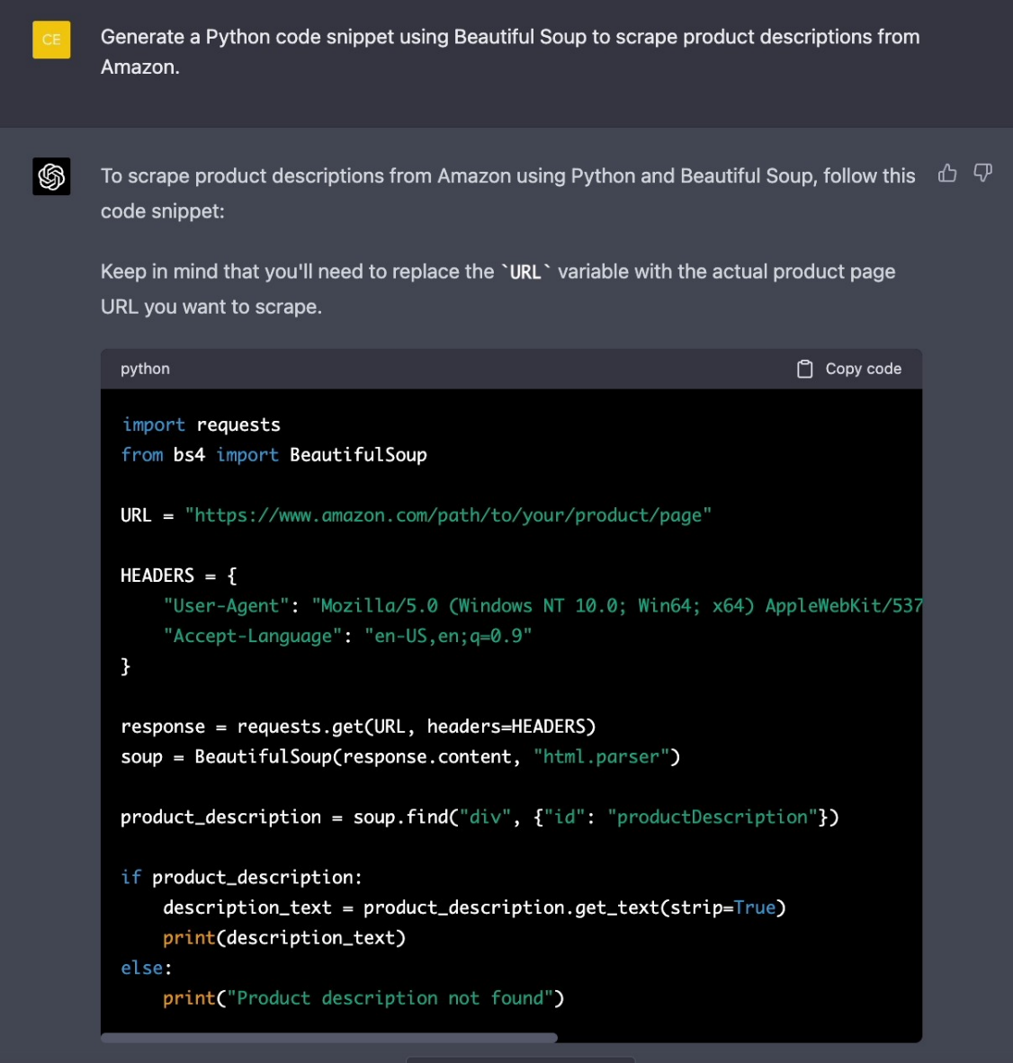
Figure 5 - Scraping from an Amazon product page.
10- Sentiment Analysis - In 2023, it is projected that 80% of businesses will embrace solutions incorporating sentiment analysis. This natural language processing (NLP) technique categorizes text, images, or videos according to their emotional content as positive, negative, or neutral. By doing so, it offers insights into consumer sentiments, enabling companies to create strategies for enhancing their products or services.
As generative AI models like ChatGPT progress, companies can automate natural language processing tasks and carry out sentiment analysis without the need for manual text data analysis.

Fine-Tuned & Customized Use Cases of ChatGPT for Business
Enterprises can customize and fine-tune large language models like ChatGPT, using their own data to create more efficient and domain-specific business tools. Fine-tuning allows the models to adapt to the unique requirements, terminology, and context of the organization, making them more effective for their specific use cases.
To achieve large language model fine tuning and customization, enterprises can follow these general steps:
- Data collection: Gathering relevant, high-quality, and diverse data that represents the specific domain or use case the organization wants to address.
- Data preprocessing: Cleaning and preprocessing the collected data to ensure consistency and remove any sensitive or personally identifiable information.
- Model fine-tuning: Using the preprocessed data to train the model in a supervised or unsupervised manner.
- Evaluation: Assessing the performance of the fine-tuned model by using various metrics like accuracy, precision, or recall, depending on the application.
- Deployment: Integrating the fine-tuned model into the desired business application.
- Monitoring and maintenance: Continuously monitoring the model’s performance, collecting user feedback, and updating the model as needed.
Customer Support - ChatGPT can be trained to understand and adapt to a business’s unique products, services, and brand voice, ensuring a consistent and tailored customer experience.
With customization, businesses can utilize ChatGPT to transform their customer support efforts, delivering timely, accurate, and personalized assistance through AI chatbot or support systems. By integrating ChatGPT into customer service platforms, companies can enable many applications:
- Multilingual customer support - ChatGPT can be trained on a range of languages and can be integrated into the business chatbots. It has the potential to translate messages from one language to another, enabling effective communication between customers and businesses in different languages.
- Answering FAQs - ChatGPT can be trained on a company’s FAQ page or knowledge base to identify and respond to frequent customer inquiries. When a customer submits a question, ChatGPT can examine the message and offer a response that addresses the customer’s inquiry or guide them to additional resources that may be useful.
- Quick responses to customer inquiries & complaints - ChatGPT can be trained to detect and reply to typical customer complaints, such as problems with product quality, shipping delays, or billing errors. When a customer submits a complaint, ChatGPT can evaluate the message and offer a response that acknowledges the customer’s concerns and presents possible solutions to address the issue.
Sales & Marketing - Businesses can leverage ChatGPT to enhance their sales and marketing efforts, enabling them to reach their target audiences more effectively and efficiently. By incorporating ChatGPT into their sales and marketing strategies, companies can create many marketing opportunities:
- Personalization of customer experience - ChatGPT can generate personalized content for customers that takes into account their preferences, past behavior, and demographics. This enables businesses to create targeted content that connects with their audience on a more personalized level, resulting in higher levels of engagement and conversion rates.
- Writing product descriptions - Product descriptions are a fundamental aspect of marketing that furnish potential customers with information about a product’s features, benefits, and value. ChatGPT can assist in crafting engaging and informative product descriptions that align with the interests and preferences of the target audience.
Creating customer surveys - ChatGPT can help with creating customer surveys:
- Question generation
- Organizing survey structure
- Making surveys multilingual with its translation ability
- Survey analysis
Document review and analysis - ChatGPT can help legal teams analyze contracts, leases, and other legal documents to identify key clauses, potential risks, and areas for negotiation.
Compliance assistance - ChatGPT can provide guidance on regulatory requirements, helping businesses ensure that their operations, products, and services are compliant with applicable laws.
For more information and other uses for ChatGPT, visit How to Use ChatGPT for Business in 2023: Top 30 Applications (aimultiple.com). The information above was provided from this website.

Managing Chats
ChatGPT automatically saves your conversations with ChatGPT on the tab on your screen’s left side. You need to log in to your ID on OpenAI, click on the tab on the left side, and all your conversations with ChatGPT will be saved in this tab.
Locate the conversation on the left-hand bar - On the left side of your screen, you will see a new tab when you begin your chat with the bot. This new tab will contain all your saved conversations with the ChatGPT. If you are having trouble in
- These chats are saved by ChatGPT automatically. Therefore, you don’t need any additional steps to save a conversation. You can look it up on the new tab.
- ChatGPT will label your conversations with the chatbot based on your first prompt. This tab will contain each and every single conversation that took place between you and the chatbot unless you have deleted the conversation. if you are encountering the “Fix Conversation Not Found Error on ChatGPT,” updating your application to the latest version might help.
- However, once you have deleted the conversation (even by mistake) from the tab, you won’t be able to re-access those chats. These chats don’t contain any backup. Thus, you need to be 100% sure when you delete these conversations.
- If the chat is extremely vital for you and contains essential data, you should consider having a copy of that chat or take screenshots to ensure you have lost the data.

Rename or Delete the Conversation
ChatGPT automatically uses your first prompt as the name of the conversation between you and the chatbot. But if users want to switch the name to something more meaningful or suitable which can help identify the chat more easily, then you can do it by clicking on the tab in the left corner.
After this, you need to take your cursor to the chat that you would like to rename. You will notice “Pencil” and “Trash” icons available next to your chat’s name.
Once the conversation is deleted, it will be deleted permanently.

How to rename ChatGPT conversations
You can rename saved ChatGPT conversations by clicking on the tab in your screen’s left corner. Select the chat you want to rename, tap on the “Pencil” icon, and enter your preferred name, and the name will instantly change.

Chatbot vs ChatGPT
Chatbots and ChatGPT are both forms of natural language processing (NLP) technology, but they have different purposes and distinct capabilities.
Currently, interactions between chatbots and humans mostly happen in the customer service space (opens in new tab), and these interactions are mixed. While in some cases, chatbots can helpfully surface the answer to your pesky question that's buried deep within a website's FAQs, a lack of nuance and context defines most interactions, and they serve as a frustrating barrier before the inevitable phone call with a human operator.
ChatGPT, meanwhile, offers far more depth, and possibilities in this space, due to the way the system's been engineered. Yes, it’s still a chatbot and will certainly exhibit some flaws that won’t make it suitable for all use cases, but OpenAI’s ChatGPT could revolutionize the interactions between people and machines in all kinds of instances.

Key Differences between Chatbot and ChatGPT
Comparison | Chatbots | ChatGPT
Functionality | Rule-based, pre-determined responses | Generates text based on input
Language Understanding | Limited | High level, trained on a large dataset of text
Use cases | Customer service and navigation | Language translation, text summarization, and creative tasks
Interaction Style | Limited to pre-defined options | Flexible, able to understand and respond to open-ended prompts
Error Handling | Limited to predefined rules, may not understand unexpected input | Has the ability to understand the context and respond appropriately
Training Data | Typically trained on a small set of specific data | Trained on a large dataset of diverse text, allowing for a broad understanding of language
Customization Capabilities | Limited, can only respond to pre-defined prompts | High level of customization, which can be fine-tuned to specific tasks or industry
Microsoft 365 Copilot is a new service currently in preview mode and is not yet generally available to the public. However, you can request access to the preview by filling out a form on the Microsoft 365 Copilot website. Microsoft will review your request and notify you if you have been granted access to the preview.
It's important to note that Microsoft 365 Copilot is currently only available for Microsoft 365 E5 customers, and certain features may not be available during the preview period. Additionally, as with any preview service, there may be bugs or other issues that need to be resolved before the service is made generally available.
To request access to Microsoft 365 Copilot, Go to the Microsoft 365 Copilot website: https://www.microsoft.com/copilot.

Availabilty of Copilot

Microsoft 365 Copilot – your copilot for work
Copilot combines the power of large language models (LLMs) with your data in the Microsoft Graph and the Microsoft 365 apps to turn your words into the most powerful productivity tool on the planet.
Copilot is integrated into Microsoft 365 in two ways. It works alongside you, embedded in the Microsoft 365 apps you use every day — Word, Excel, PowerPoint, Outlook, Teams and more.
Also recently announced is an entirely new experience: Business Chat. Business Chat works across the LLM, the Microsoft 365 apps, and your data — your calendar, emails, chats, documents, meetings and contacts — to do things you’ve never been able to do before.
With Copilot, you’re always in control. You decide what to keep, modify or discard. Now, you can be more creative in Word, more analytical in Excel, more expressive in PowerPoint, more productive in Outlook and more collaborative in Teams.
Copilot will fundamentally change how people work with AI and how AI works with people. As with any new pattern of work, there’s a learning curve — but those who embrace this new way of working will quickly gain an edge.

Copilot in Word writes, edits, summarizes, and creates right alongside you. With only a brief prompt, Copilot in Word will create a first draft for you, bringing in information from across your organization as needed. Copilot can add content to existing documents, summarize text, and rewrite sections or the entire document to make it more concise. You can even get suggested tones—from professional to passionate and casual to thankful—to help you strike the right note. Copilot can also help you improve your writing with suggestions that strengthen your arguments or smooth inconsistencies. Here are some example commands and prompts you can try:
- Draft a two-page project proposal based on the data from [a document] and [a spreadsheet].
- Make the third paragraph more concise. Change the tone of the document to be more casual.
- Create a one-page draft based on this rough outline.

Copilot in Excel works alongside you to help analyze and explore your data. Ask Copilot questions about your data set in natural language, not just formulas. It will reveal correlations, propose what-if scenarios, and suggest new formulas based on your questions—generating models based on your questions that help you explore your data without modifying it. Identify trends, create powerful visualizations, or ask for recommendations to drive different outcomes. Here are some example commands and prompts you can try:
- Give a breakdown of the sales by type and channel. Insert a table.
- Project the impact of [a variable change] and generate a chart to help visualize.
- Model how a change to the growth rate for [variable] would impact my gross margin.

Copilot in PowerPoint helps you turn your ideas into stunning presentations. As your storytelling partner, Copilot can transform existing written documents into decks complete with speaker notes and sources or start a new presentation from a simple prompt or outline. Condense lengthy presentations at the click of a button and use natural language commands to adjust layouts, reformat text, and perfectly time animations. Here are some example commands and prompts you can try:
- Create a five-slide presentation based on a Word document and include relevant stock photos.
- Consolidate this presentation into a three-slide summary.
- Reformat these three bullets into three columns, each with a picture.

Copilot in Outlook works with you in your inbox and messages so that you can spend less time on email triage and more time on communicating—better, faster, and more easily. Summarize lengthy, convoluted email threads with multiple people to understand not only what has been said, but the different viewpoints of each person and the open questions that have yet to be answered. Respond to an existing email with a simple prompt or turn quick notes into crisp, professional messages—pulling from other emails or content that you already have access to from across Microsoft 365. Use toggles to adjust the tone or length of your note. Here are some example commands and prompts you can try:
- Summarize the emails I missed while I was out last week. Flag any important items.
- Draft a response thanking them and asking for more details about their second and third points; shorten this draft and make the tone professional.
- Invite everyone to a “lunch and learn” about new product launches next Thursday at noon. Mention that lunch is provided.

Copilot in Teams takes the work out of working together. Copilot helps you run more effective meetings, get up to speed on the conversation, organize key discussion points, and summarize key actions so that the entire group knows what to do next. In your chat, Copilot gets you answers to specific questions or catches you up on anything you’ve missed, all without interrupting the flow of discussion. By adding Copilot to your meetings and conversations, you now also have a powerful tool to help with common tasks such as creating meeting agendas based on chat history, identifying the right people for follow-ups, and scheduling the next check-in. Here are example commands and prompts you can try:
- Summarize what I missed in the meeting. What points have been made so far? Where do we disagree on this topic?
- Create a table of pros and cons for [topic being discussed]. What else should we consider before making a decision?
- What decisions were made, and what are some suggested next steps?

Find information about Copilot by visiting this website: Introducing Microsoft 365 Copilot | Microsoft 365 Blog.

Glossary

A
Algorithms: A set of rules or instructions given to an AI, neural network, or other machines to help it learn on its own; classification, clustering, recommendation, and regression are four of the most popular types.
Artificial intelligence: A machine’s ability to make decisions and perform tasks that simulate human intelligence and behavior.
Artificial neural network (ANN): A learning model created to act like a human brain that solves tasks that are too difficult for traditional computer systems to solve.
Autonomic computing: A system's capacity for adaptive self-management of its own resources for high-level computing functions without user input.

C
Chatbots: A chat robot (chatbot for short) that is designed to simulate a conversation with human users by communicating through text chats, voice commands, or both. They are a commonly used interface for computer programs that include AI capabilities.
Classification: Classification algorithms let machines assign a category to a data point based on training data.
Cluster analysis: A type of unsupervised learning used for exploratory data analysis to find hidden patterns or grouping in data; clusters are modeled with a measure of similarity defined by metrics such as Euclidean or probabilistic distance.
Clustering: Clustering algorithms let machines group data points or items into groups with similar characteristics.
Cognitive computing: A computerized model that mimics the way the human brain thinks. It involves self-learning through the use of data mining, natural language processing, and pattern recognition.
Convolutional neural network (CNN): A type of neural networks that identifies and makes sense of images.

D
Data mining: The examination of data sets to discover and mine patterns from that data that can be of further use.
Data science: An interdisciplinary field that combines scientific methods, systems, and processes from statistics, information science, and computer science to provide insight into phenomenon via either structured or unstructured data.
Decision tree: A tree and branch-based model used to map decisions and their possible consequences, similar to a flow chart.
Deep learning: The ability for machines to autonomously mimic human thought patterns through artificial neural networks composed of cascading layers of information.

F
Fluent: A type of condition that can change over time.

G
Game AI: A form of AI specific to gaming that uses an algorithm to replace randomness. It is a computational behavior used in non-player characters to generate human-like intelligence and reaction-based actions taken by the player.
Genetic algorithm: An evolutionary algorithm based on principles of genetics and natural selection that is used to find optimal or near-optimal solutions to difficult problems that would otherwise take decades to solve.

H
Heuristic search techniques: Support that narrows down the search for optimal solutions for a problem by eliminating options that are incorrect.

K
Knowledge engineering: Focuses on building knowledge-based systems, including all of the scientific, technical, and social aspects of it.

L
Logic programming: A type of programming paradigm in which computation is carried out based on the knowledge repository of facts and rules; LISP and Prolog are two logic programming languages used for AI programming.

M
Machine intelligence: An umbrella term that encompasses machine learning, deep learning, and classical learning algorithms.
Machine learning: A facet of AI that focuses on algorithms, allowing machines to learn without being programmed and change when exposed to new data.
Machine perception: The ability for a system to receive and interpret data from the outside world similarly to how humans use our senses. This is typically done with attached hardware, though software is also usable.

N
Natural language processing: The ability for a program to recognize human communication as it is meant to be understood.

R
Recurrent neural network (RNN): A type of neural network that makes sense of sequential information and recognizes patterns, and creates outputs based on those calculations.

S
Supervised learning: A type of machine learning in which output datasets train the machine to generate the desired algorithms, like a teacher supervising a student; more common than unsupervised learning.
Swarm behavior: From the perspective of the mathematical modeler, it is an emergent behavior arising from simple rules that are followed by individuals and does not involve any central coordination.

U
Unsupervised learning: A type of machine learning algorithm used to draw inferences from datasets consisting of input data without labeled responses. The most common unsupervised learning method is cluster analysis.

