Microsoft Teams
Beyond the Basics
Etiquette and Avoiding Chaos

Microsoft Teams
What is Teams? 1
What is a Team? 1
Teams User Interface 1
Menu 1
Plan for Teams 1
Teams, Channels and Tabs 2
Types of Teams 2
Team Roles 3
Create a New Team 3
Channels 3
General Channel 3
Add a Channel 4
Private Channels 4
Tabs 5
Files Tab 5
Wiki Tab 5
Other Tabs (Apps) 5
Manage Tabs 5
Managing Channels 6
Channel Notifications 6
Pin a Channel 6
Hide Channels 6
Channel Settings 7
Channel Privacy 7
Get Email Address 8
Get a Link to a Channel 8
Connectors 8
Delete a Channel 9
Managing Roles in Teams 9
Change Member Type 9
Managing a Team 10
Hide a Team 10
Show a Hidden Team 10
Manage a Team 10
Edit a Team 11
Get a Link to a Team 11
Manage Tags 11
@Mention a Tag in a Channel 11
Delete a Team 11
Leave a Team 11
Converse and Share in Teams 12
@Mentions 12
Manage @Mentions with Custom Tags 12
Posts 12
Important or Urgent Chats in Teams 13
Voicemail 13
Notifications 13
Modify Notifications 14
Microsoft Teams Meetings 14
Meeting Options 14
Choose who can bypass the lobby 14
Let people calling in by phone bypass the lobby 14
Get notified when callers join or leave 14
Prevent attendees from unmuting themselves and sharing video 14
Record Automatically 15
Allow meeting chat 15
Allow reactions 15
Enable Q&A 15
Allow attendance report 15
Default meeting options 15
Change meeting options 15
Instant meetings 15
Lock a Meeting 16
Microsoft Teams etiquette: 8 best practices 16
Presence 16
Respect Microsoft Teams etiquette when people are set to Do Not Disturb 18

Microsoft Teams

What is Teams?
Microsoft Teams is the ultimate messaging app for your organization—a workspace for real-time collaboration and communication, meetings, file and app sharing, and even the occasional emoji! All in one place, all in the open, all accessible to everyone.
Microsoft Teams is a hub for teamwork that helps teams stay organized and allows to make more conversations all at one place. It is an application that pulls in teams for better team communication and collaboration to work together through chat.

What is a Team?
A team is a group of people gathered to get something big done in your organization. Sometimes it’s your whole organization.
In Microsoft Teams, you work together – as a Team, on project or just information that you need to share with multiple people. Teams is more than just “teams”…it is where you will go and store communications, chats, meetings, video or calls.

Teams User Interface

Menu
Along the left-hand side you can navigate to different areas within Teams, such as Chats, Meetings, Files and Activity.
- Activities: Shows you the last activities of the Teams that you are part of.
- Chat: This holds your Team conversations, providing a complete chat history. However, for a chat within a Team you should use the Teams menu and hold the group chat in 'Conversation'.
- Teams: An overview of all your Teams that you are part of and allows you to drill-down into each Channel within the Teams. This is also where you can create Teams.
- Meetings: The Meetings tab pulls your meetings in from Outlook and allows you schedule meetings within the Meetings tab that are sent to a Team. If you want to schedule other meetings with external users or individuals, you will still need to use Outlook, as the Teams Meeting tab is only to schedule a meeting with a Team. (Remember the aim is team collaboration, not calendar management).
- Files: Within Files you can quickly find and view files across OneNote, OneDrive and within Teams (stored in their own SharePoint sites). There’s also a very helpful ‘Recent’ tab so you can quickly access the latest documents you were working on, as well as a shortcut to your Downloads.

Plan for Teams
Before getting started it’s important to understand how Teams fits into the larger Office 365 picture, as creating Teams has some wider implications. Every Team created will automatically create a matching Plan (find out more on this in our Guide to Planner here), SharePoint Team Site, Office 365 Group and shared OneNote. While this brings a number of great benefits, such as shared documents and centralized team information, it can cause some governance and admin headaches.
- What is the objective of the Team?
- What will the Team be named?
- Who will need access to the Team?
  - Who will be the Owner(s) of the Team?
  - Will there be any external members?
- What information will be available in the Team?
  - Channels
  - Tabs
- Always start with a Private Team and no members or guests.

Teams, Channels and Tabs
To start your teamwork collaboration, you need a team. Setting up Teams is easy and done in a few clicks, requiring a Team name and a description; this then allows team members to be added. As mentioned above, a new Team will create a matching Office 365 Group, OneNote, SharePoint site and Plan—so this does need to be done with some caution.
Teams are made up of channels, which are the conversations you have with your teammates. Each channel is dedicated to a specific topic, department, or project.
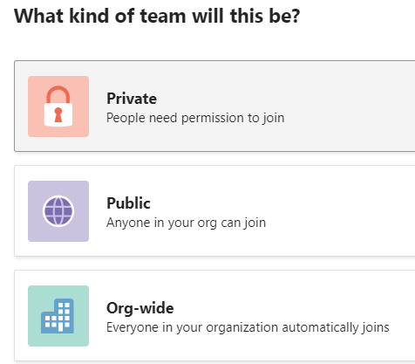
Each Team has subsections, which are called Channels, and a General Channel will automatically be created. You can have multiple Channels within a Team; for example, you could have a 'Marketing' Team and then Channels such as 'Social Media', 'Product Launch', 'Blogs' etc. Or a Company could be a Team and Channels can relate to departments - you can choose whatever suits your organization’s way of working. Whenever there is a new notification or activity, the Channel will become bold.

Types of Teams
When you create a new Team, you will need to choose what kind of team you need. There are 3 options:
- Private – people need permission to join.
- Public – Anyone in your org can join.
- Org-Wide – Everyone in your organization automatically joins.
You can change the Team type at any time. It is recommended that when you first create the Team, make it Private until you have it fully really for the members or guests.
- Use unique names for each new Team.
- The Description is the objective of the Team.

Team Roles
Owners, Members and Guests can be assigned to your Team. The role can be changed at any time. Each role has different permission to the Team by default and you can manage the setting for further control over what they can and can’t do in the Team.
- Owners - Team owners manage certain settings for the team. They add and remove members, add guests, change team settings, and handle administrative tasks. There can be multiple owners in a team.
- Members - Members are the people in the team. They talk with other team members in conversations. They can view and usually upload and change files. They also do the usual sorts of collaboration that the team owners have permitted.
- Guests - Guests are people from outside of your organization that a team owner invites, such as partners or consultants to join the team. Guests have fewer capabilities than team members or team owners, but there's still a lot they can do.

Create a New Team
In Microsoft Teams you can create a new team from scratch, or you can link it to an existing Office 365 group. That way you will continue to use your existing SharePoint site, OneNote notebook, etc.
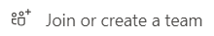
- A new Team can be created from scratch or from a group.
- From the Navigation Pane on the left, click on Teams.
- At the bottom of the window click on Join or create a team
- Click Create team. 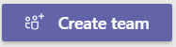.
- Build a Team from Scratch.
- Choice the kind of team you want; Private, Public or Org-wide.
- Name the Team and enter a description if needed.
- Click Create.
NOTE: you should wait on adding members or guests to a Team until you have it created.
Example of a Marketing department team. Here we have a channel for Social Media, Events, Web sites, Newsletters, Team fun, Random ideas & questions.

Channels
Each Channel will have their own tabs along the top. Conversation (group chat), Files (shared documents) and Notes (shared OneNote) are automatically created, and you can then add your own tabs.

General Channel
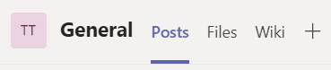
When a new Team is created there will automatically be a gene ral channel. The general channel will include Posts, Files and Wiki Pages.
- Posts – Notifications and chats/communications get posted in the Posts tab.
- Files – This is where general files related to the Team will be placed. This is a SharePoint document library.
- Wiki - Open a Wiki tab so you can collaborate quickly and easily. Draft documents, track notes, share ideas, edit, and chat all in one place.
By default, the General channel is created for you when you create the team. There are many useful purposes for this channel:
- Use it to share an overview of what the team wants to achieve such as a project charter or who's who in the team.
- Use it for new team member onboarding and other high-level information that a new team member would find useful.
- Use it for announcements or configure the SharePoint News connector to post your modern status reports to this channel.
- For new or single purpose teams, it may be the only channel at the beginning as you decide how Teams can best support your goals.
You can’t rename the General Channel and all new Channels will be alphabetized under the General Channel.

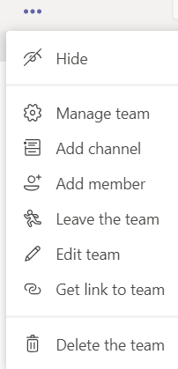
Add a Channel
If you want to add additional Channels to a Team:
- From the Team click on the eclipse … menu, then Add Channel.
- Enter the name for the Channel, Description and Privacy options.
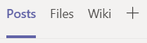
- Click Add.
Each new Channel you add will have 3 tabs – Posts, Files and Wiki.

Private Channels
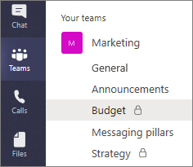
Only the users on the team who are owners or members of the private channel can access the channel. Anyone, including guests, can be added as a member of a private channel as long as they are already members of the team.
You might want to use a private channel if you want to limit collaboration to those who have a need to know or if you want to facilitate communication between a group of people assigned to a specific project, without having to create an additional team to manage.
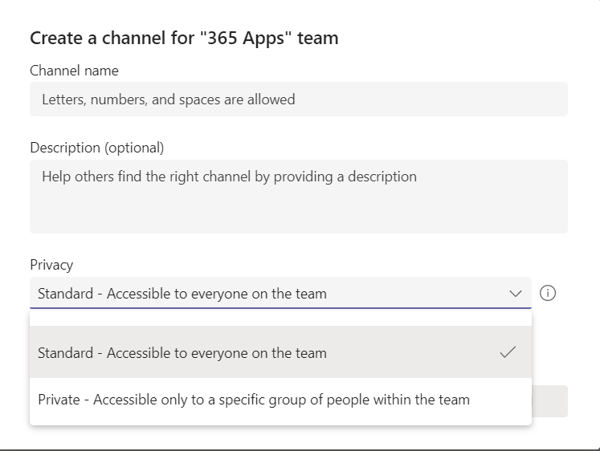
A lock icon indicates a private channel. Only members of private channels can see and participate in private channels that they are added to.
When a private channel is created, it's linked to the parent team and can't be moved to a different team. Additionally, private channels can't be converted to standard channels and vice versa.
To make a Channel Private: When creating a Channel, click on Privacy and choose, Private.

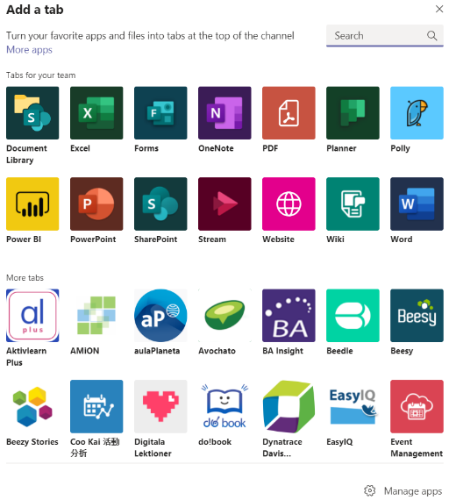
Tabs
Tabs allow team members to access services and content in a dedicated space within a channel or in a chat. Owners and team members can add tabs to a channel, private chat, and group chat to help integrate their cloud services. Tabs can be added to help users easily access and manage the data they need or interact with the most.
To Add a Tab:
- Open the Team, open the Channel.
- At the top of the Tabs click on the Plus Sign.
- In the Add a Tab dialog box, choose the option you want.
- Depending on the option chosen, you may be prompted for more details otherwise it will just at the tab name at the top.

Files Tab
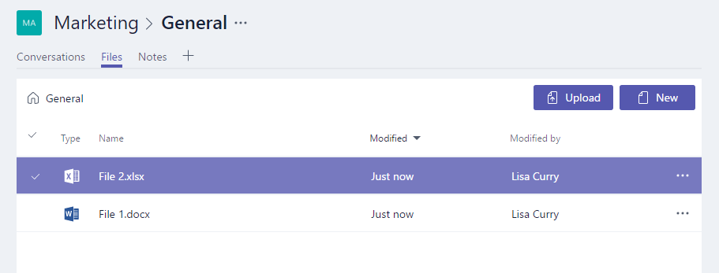
In your Teams window, you can perform a variety of tasks directly within that window or browser, so that you avoid flicking between different applications. These tasks include the ability to delete, download, move files, open, copy, edit or get a link to share with others – giving you all the key features you would get in the native apps.
You can also start a Group chat alongside the file, to allow team discussions while all working on the files - and this conversation will appear in your Conversation thread.

Wiki Tab

Other Tabs (Apps)
There are several Tabs (Apps) that can be added to the Channels in your Teams, Chats, etc. Here are some popular options:
- Tasks by Planner and To Do –makes it easy for your team to stay organized, assign tasks, and keep track of your progress.
- Excel – Direct access to an Excel Workbook.
- Web - Excel, PowerPoint, Word, and PDF files must be uploaded to the Files tab before they can be converted to tabs. Any existing uploaded file can be converted to a tab with a single click.

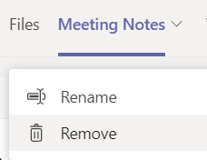
Manage Tabs
If you want to Rename or Remove a Tab in a Channel, right click on the Tab name. From the menu, choose the option you want.
- Rename allows you to change the name.
- Remove will delete the Tab. The information in the Tab will be permanently removed.
Note: You can’t remove or rename the Posts and File Tabs in a Channel.

Managing Channels
You can make changes to a Channel by opening the options from the … eclipse menu.

Channel Notifications
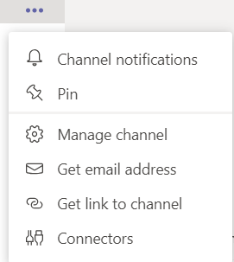
You can turn on and off notification for each Channel.
All new Posts – notify me every time there is a new post in this channel (Banner and Feed or Only Show in Feed).
- Banner and feed - will send notifications to your device and to Activity at the top left of the Teams app. Feed will skip sending notifications to your desktop and will only show up in your activity feed.
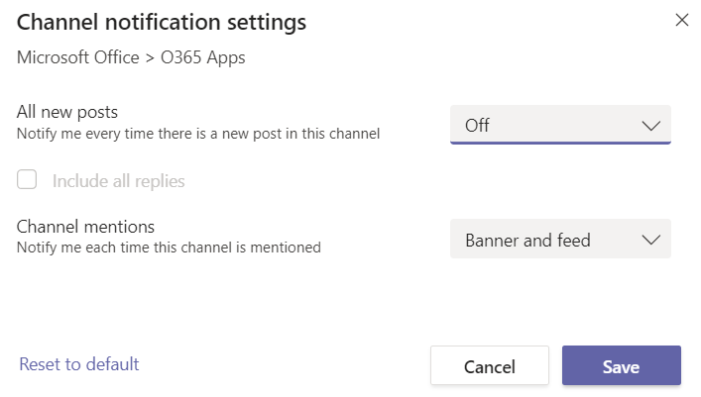
Below are the different types of settings you'll find in channel notifications:
- All new posts will notify you each time someone starts a new conversation in the channel
- Include all replies will notify you any time someone replies to a conversation
- Channel mentions will notify you whenever someone @mentions the channel

Pin a Channel
Pinned channels stay at the top of the list so you don’t have to hunt them down.
To pin a channel, go to a channel name and select … eclipse then Pin. This ensures that the channel stays at the top of your list. If you change your mind, just select it again and unpin it.
Once you pin a channel, they will be displayed at the top of the Teams pane. You can drag it into the order you want. Do this for several channels and you'll have all pinned channels within easy reach.

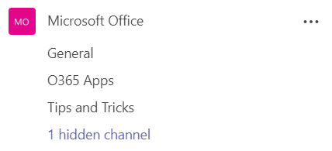
Hide Channels
Just like with Teams, Channels can be hidden. A hidden Channel will be listed at the bottom of the Channels for that Team.
You may want to hide a channel because you are still developing it. Once you are ready for Members to see it, you can unhide it.

Channel Settings
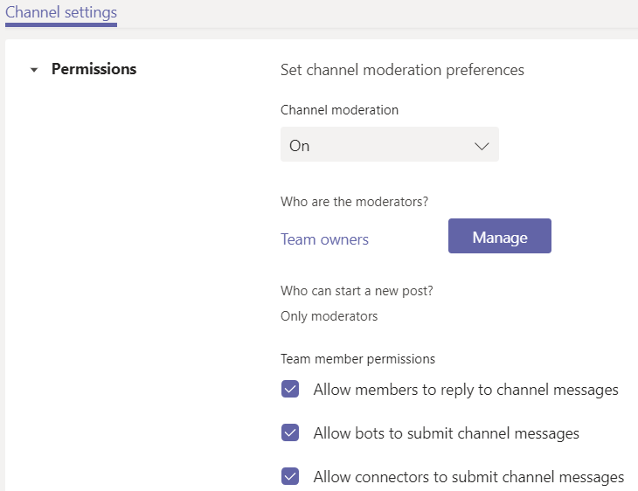
In the Manage a Channel section, you can set permissions like moderation preferences and who can start a new post.
Team owners can turn on moderation for a channel to control who can start new posts and reply to posts in that channel.
Team owners can also add team members as moderators. A team owner might not have the subject matter expertise at the channel level to best support channel moderation. By allowing specific team members to moderate a channel, the responsibility of managing content and context within a channel is shared between team owners and channel moderators. For example, a team owner can add business owners or content owners as moderators, which lets them control information sharing in that channel.
What can a channel moderator do?
Channel moderators can:
- Start new posts in the channel. When moderation is turned on for a channel, only moderators can start new posts in that channel.
- Add and remove team members as moderators to a channel. Keep in mind that by default, team owners are channel moderators and can't be removed.
- Control whether team members can reply to existing channel messages and whether bots and connectors can submit channel messages.

Channel Privacy
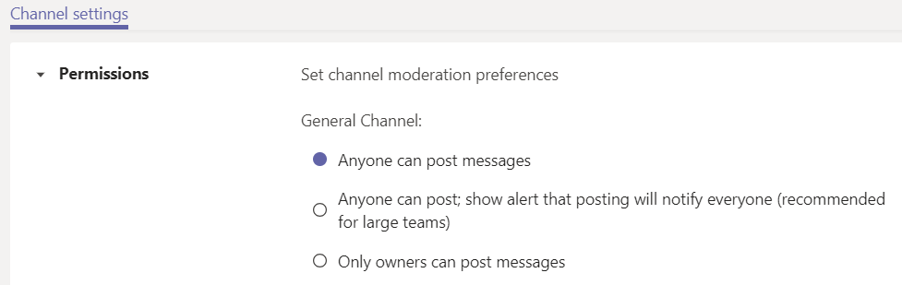
Private – Accessible only to a specific group of people within the team.
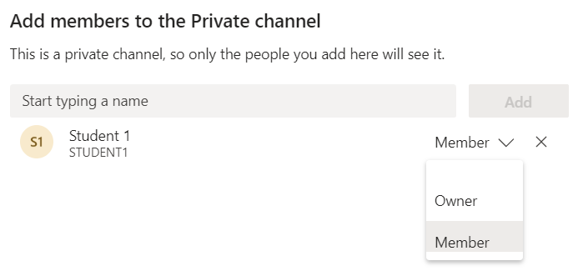
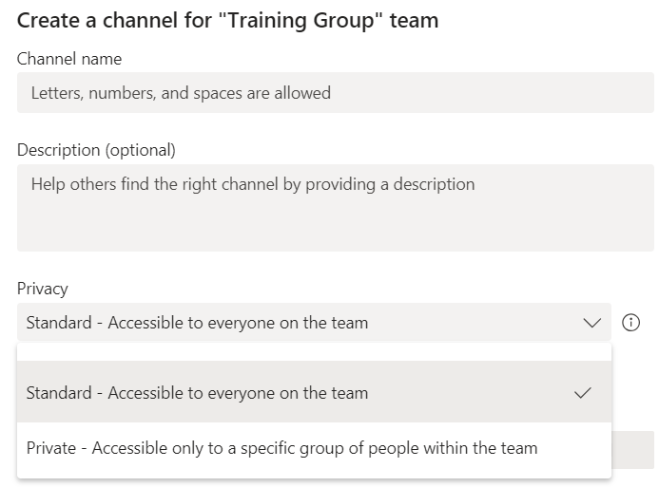

Get Email Address
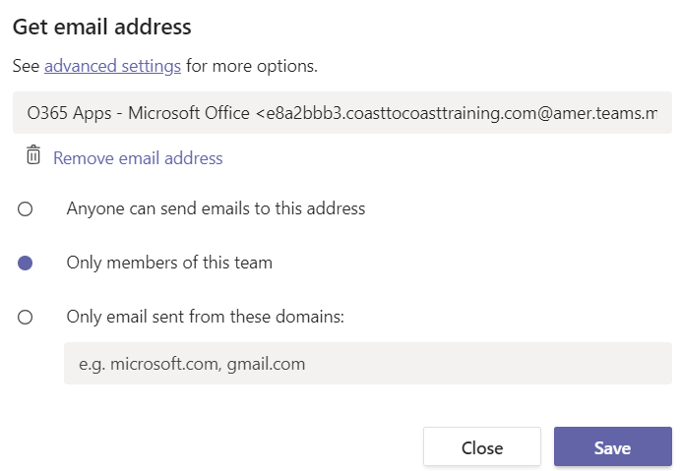
Each Channel has an email address. If you want to send an email to a channel in Teams, use the channel email address. Once an email is part of a channel, anyone can reply to it to start a conversation.
- From the … eclipse of the Channel, click Get Email Address.
- Click copy and then save it somewhere you can easily access it, such as in your contacts.
By clicking on advanced settings, you can change who has the ability to email the Channel address.
When a Member sends an email to the Channel, it will be displayed in the Post tab.
When you reply to an email message in a thread, it creates a conversation about the email within Teams. However, this does not send an email reply to the original sender. Any comments or conversations you have about the email in a channel aren't visible outside of Teams.

Get a Link to a Channel
Just like with Teams, Channels links can be copied and pasted then shared with others.
- Next to the Channel name, click on the … eclipse then Get a link to a Channel.
- When you click Copy, it is holding the link in the clipboard, go to where you want to paste it, then share it.

Connectors
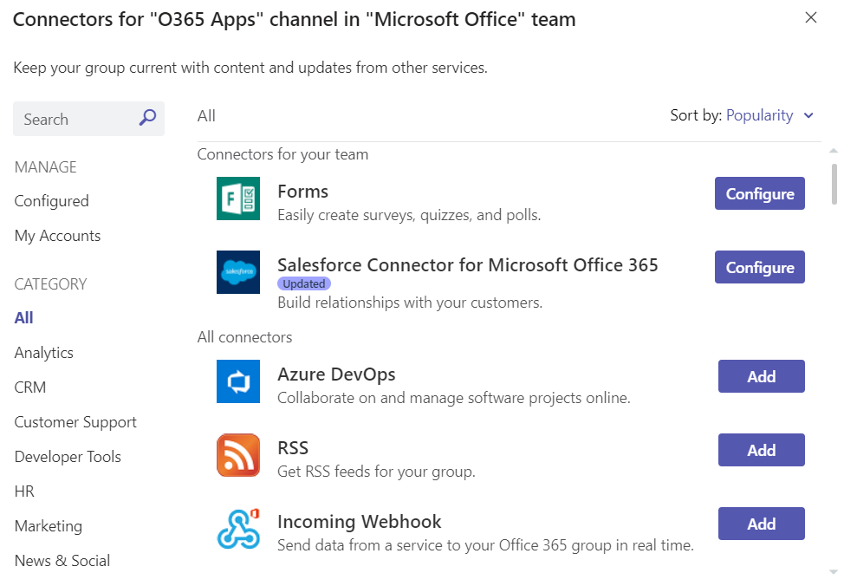
Keep your group current with content and updates from other services. Connectors keep your team current by delivering frequently used content and service updates directly into a channel. With connectors, your Microsoft Teams users can receive updates from popular services such as Twitter, Trello, Wunderlist, GitHub, and Azure DevOps Services within the chat stream in their team.
Any member of a team can connect their team to popular cloud services with the connectors if the team permissions allow, and all team members are notified of activities from that service. Connectors will continue to function even after the member who has initially setup the connector has left. Any team member with the permissions to add\remove can modify connectors setup by other members.
Office 365 connectors can be used with both Microsoft Teams and Office 365 groups, making it easier for all members stay in sync and receive relevant information quickly. Both Microsoft Teams and Exchange use the same connector model, which allows you to use the same connectors within both platforms. It is worth noting, however, that disabling connectors for the Office 365 Group that a team is dependent upon will disable the ability to create connectors for that team as well.
When you connect to a service, you will need to fill in the required information of the selected connector and click Save. Each connector requires a diverse set of information to function properly, and some may require you to sign-in to the service using the links provided on the connector configuration page.

Delete a Channel
If you no longer need a Channel in a Team, you can delete it. From the … eclipse menu for the Channel, click on Delete this Channel.
Team owners get to decide which team members can delete and restore channels.
Keep in mind that once you delete a channel, you also lose its entire conversation history. However, the OneNote sections associated with that channel will still show up on your team's SharePoint site.
To Delete a Channel: Go to the … eclipse menu, click Delete this channel.

Managing Roles in Teams
Within Microsoft Teams there are different roles for users. By default, a user who creates a new team is granted the owner status. In addition, owners and members can have moderator capabilities for a channel (provided that moderation has been set up).
Depending on your role, will depend on the permissions you will have.
- Owners - Team owners manage certain settings for the team. They add and remove members, add guests, change team settings, and handle administrative tasks. There can be multiple owners in a team.
- Members - Members are the people in the team. They talk with other team members in conversations. They can view and usually upload and change files.
- Guests – People outside of your organization/domain that are added to a Team are automatically added as a Guest.
The current role for a user can be changed by an Owner.
If an Owner is going to leave a Team, they can assign someone else to become and Owner before they leave the Team.

Change Member Type
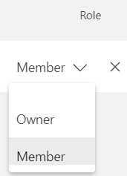
To change the Role of a user from Member to Owner:
- From the … eclipse next to the Team name, click on Manage Team.
- In the Members category, select the member you want to modify.
- On the right side of the member name, click the down arrow and click Owner.
- To Delete the member, click the X.

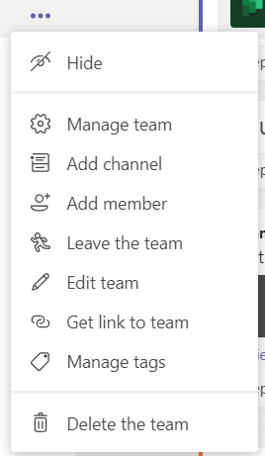
Managing a Team
When a Team is created you can change options like members, channels and other options. You can access the options by clicking on the … eclipse next to the Team name. Then from the menu, click on the option you want to manage.

Hide a Team
If you don't want a team or channel to show in your teams list, hide it.
Go to a team or channel name and select More options More options button, then Hide.
This is a great way to clean up your list and focus on the teams and channels you're active in.
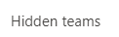
Note: Hidden teams are moved down to the Hidden menu at the bottom of your teams lists. Hidden channels are grouped together at the bottom of their respective team.

Show a Hidden Team
Hiding a team will remove it from your teams list, but you can always access or show it again by selecting Hidden Teams at the bottom of the Teams pane.
- To show the Team, click on the … eclipse next to the Team name then click Show.
Note: Hidden Channel at the bottom of the channel list, then from the list click on the Channel you want to Show.

Manage a Team
If you need to modify a Team, click on the … eclipse next to the Team name.

On the right side of the window it will display a menu of options:
- Members – add, remove or change the type of members.
- Pending Requests – only visible for private Teams. You will see any requests users make to joining a Team.
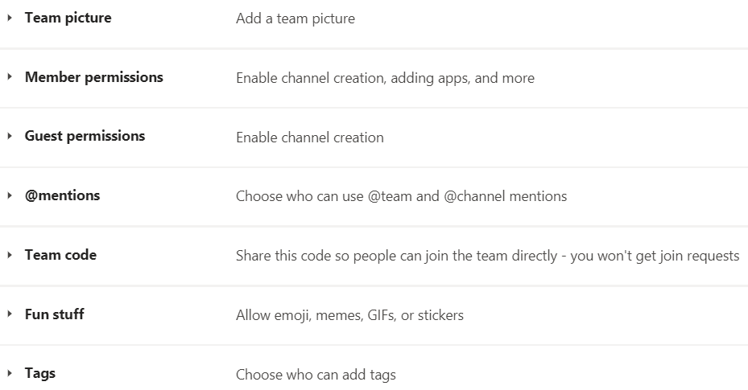
- Channels – add new channels, manage channels, etc.
- Settings – from the settings you can manage things like Team picture, member permissions, @mentions, fun stuff and more.
- Analytics – overview of the number of members, total size of files saved based on a time range.
- Apps – display details on apps available in Teams.

Edit a Team
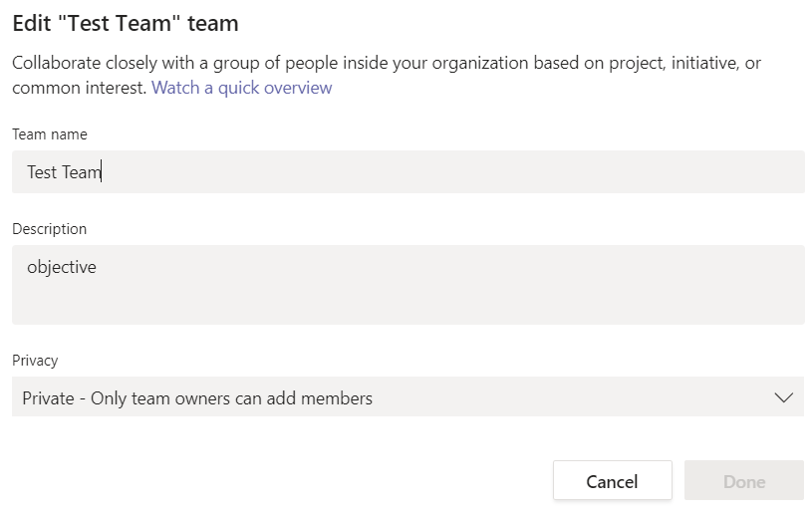
The Edit Team option can be used to change the name of the Team, description or the Privacy levels.
- Private
- Public
- Org-Wide

Get a Link to a Team
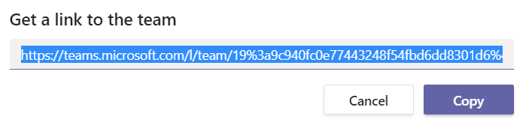
The option for Get a Link to a Team refers to sharing a hyperlink for a specific Team to Copy and Paste into an email or other areas. Whomever you share the link with, will have access to the Team by clicking on the link.

Manage Tags
Tags let you quickly reach a group of people all at once. With tags, you can categorize people based on attributes, such as role, project, skill, training, or location. For example, a "Nurse" or "Manager" or Designer" tag will enable you to reach groups of people in Teams without having to type every single name.
- Click the Manage Tags from the Team … eclipse. Here you can create tags and assign them to people on your team.

@Mention a Tag in a Channel
In a channel conversation, simply @mention a tag in your message and select the tag from the list. The tag will appear just like any @mention, and the people associated with the tag will get notified.

Delete a Team
If you want to delete a team (and you’re the team owner), go to the team name and click the … eclipse, then Delete the team. Your team will be permanently removed.
Notes:
- Deleting a team removes the team mailbox and calendar from Exchange.
- The corresponding SharePoint site and all its files will also be deleted.
- And any OneNote notebook, Planner plan, PowerBI workspace, or Stream group affiliated with the team will also be deleted.
- Team owners and IT admins can recover deleted teams for up to 30 days.

Leave a Team
You can leave a team at any time by going to the team name and clicking … eclipse then Leave the team.
Note: You can leave a team on your own, but only an admin can remove you from an organization or an org-wide team.

Converse and Share in Teams

@Mentions
To get someone's attention in a channel conversation or a chat, @mention them. Just type @ before their name and then select them from the menu that appears.
Note: You can also mention someone simply by typing their name. Start by capitalizing the first letter and as you continue to type the name, a list of people will show for you to choose from.
They receive a notification, which they can click to go directly into the point in the conversation where they were mentioned.
To get the attention of an entire team, try one of these:
- Post something in the Team's general channel. The channel name appears bold for every team member.
- Type @team to message everyone on that team.
- Type @channel to notify everyone who has favorited that channel.

Manage @Mentions with Custom Tags
Team owners can create custom tags in Teams sites. These tags can be used to notify certain people within your team. You can tag people based on attributes such as: role, project or location You can create custom tags by going to the ellipses next to the team you want to create the custom tags for and select Manage Team. In the Members tab you’ll see the Tags column. Here you can create, add, and remove tags. To use your custom tag @mention enter @followed by the tag name.
You can create custom tags by going to the ellipses next to the team you want to create the custom tags for and select Manage Team.
In the Members tab you’ll see the Tags column. Here you can create, add, and remove tags.

Posts
The Posts tab in Microsoft Teams appears in the General channel, as well as any additional channels you create. All class members can view and add to conversations in the General channel. In other channels, use @mention button Mention to invite certain students or staff to participate in a conversation.
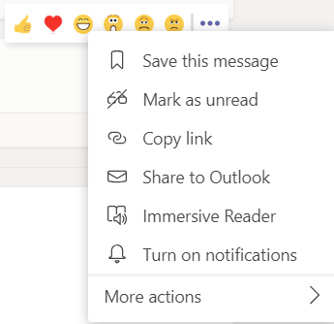
Posts are different from chats because they are visible to everyone in a channel and not private. Documents shared in a conversation automatically become part of the Files tab in that file.
Note: The Posts tab was formerly called Conversations.
You can manage a “post” by hesitating on it, a popup menu will appear. From the menu you can Save a message, copy a link and other options.

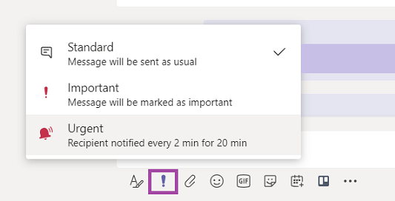
Important or Urgent Chats in Teams
If you want to make sure people pay attention to your message, mark it as important or urgent.
To do that, select Set Delivery Options Mark as important button beneath the compose box, and then select Important or Urgent. That adds the word "IMPORTANT!" or "URGENT!" to your message. Once in the message, you’ll be able to include files, links, or pictures.
An urgent message will notify a person or group repeatedly, every 2 minutes for 20 minutes, or until they read it. You’ll have to judge based on your organization and culture what messages are urgent.
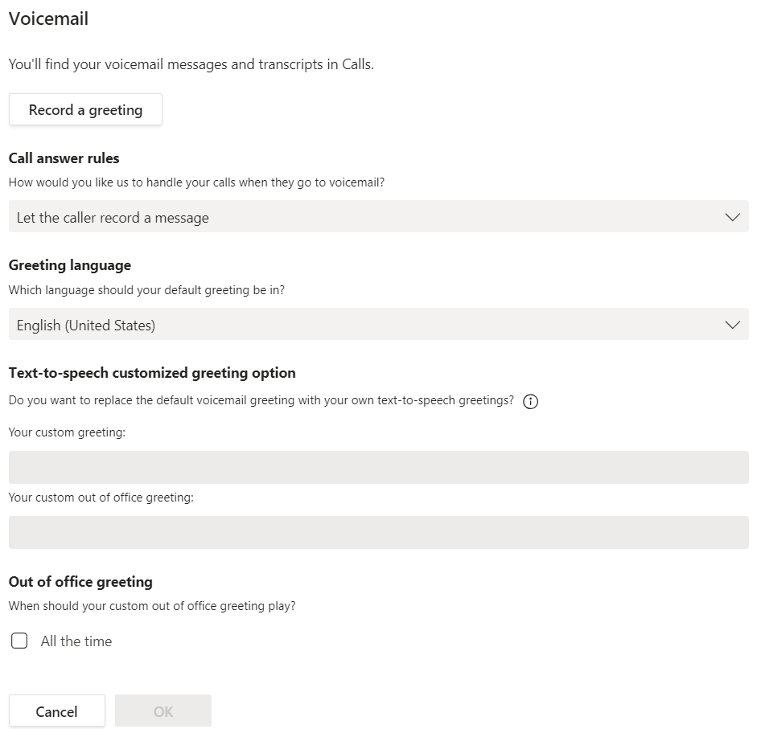
Note: If you don't see the option to mark a message as urgent, it may be because there are more than 20 members in your group chat. Additionally, your administrator needs to enable urgent messages.

Voicemail
If you call someone thru Teams and they don’t answer, you can leave them a voicemail message.
To check your voicemail, choose Calls then Voicemail.
The message will be posted in their Activities and an Email will be sent with a link to the message.
To set up your voicemail greeting in Teams:
- Click on your picture in the upper-right corner of the Teams
- Click Settings from the dropdown.
- Choose the Calls tab on the left of the window.
- Under the Voicemail heading, you’ll see a button titled Change Voicemail Greeting.

Notifications
Microsoft Teams is absolutely loaded with features designed to enhance collaboration. Between the chats, channels, Teams, @mentions, and likes, notifications can certainly get out of control in a hurry!
That said, it’s also super important to understand how to make sure you’re not missing anything important or relevant to your workstream.
There are three primary options when it comes to notifications in Microsoft Teams.
- Banner and email notification setting will show a banner message pop-up in the lower right of the screen and send an email (you can set the frequency) with the notification information.
- Banner notification will still show, but no email will be sent.
- Only show in feed notification will only be visible via the feed in the upper left of the application.
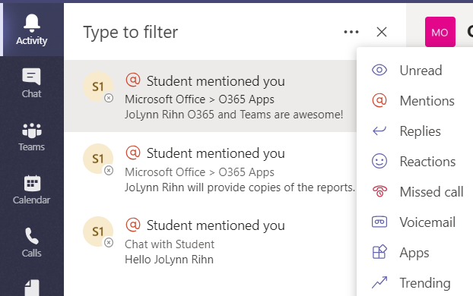
You’ll still find the number of notifications in your activity feed, and via the feed you’ll be able to keep a list record of recent notifications. You can also filter the notifications in your feed by type, a feature that comes in handy when looking through your recent @mentions.

Modify Notifications
You can change notification in different areas:
In a Channel, click on the … eclipse menu, then Channel notifications.
In your Profile, click on your picture at the top right, then Settings, then Notifications.

Microsoft Teams Meetings

Meeting Options
Participant settings are meeting options that affect how participants engage and interact during a meeting. Although default meeting options are determined by an org's IT admin, meeting organizers can change them for a specific meeting.

Choose who can bypass the lobby
You can decide who gets into meetings directly and who should wait to be let in by using the lobby. If you choose to have people wait, you (and anyone else allowed to admit people) will see a list of people in the lobby. From there you can choose whether to admit or deny them.

Let people calling in by phone bypass the lobby
You'll see a toggle next to Always let callers bypass the lobby. When this setting is enabled, people calling in by phone will join your meeting without having to wait for someone to admit them.

Get notified when callers join or leave
You may want to receive an alert when someone calling in by phone joins or leaves your meeting. Your admin might have enabled these alerts by default.
To change this setting, select the toggle next to Announce when callers join or leave?

Prevent attendees from unmuting themselves and sharing video
- To avoid distractions in large meetings, you may want to decide when attendees can unmute and share their video.
- To prevent attendees from unmuting, turn off the toggle next to Allow mic for attendees?
- To prevent attendees from sharing video, turn off the toggle next to Allow camera for attendees?

Record Automatically
If you turn on this option, a recording and transcription of your meeting will begin as soon as the meeting starts.

Allow meeting chat
In general, people who are on the meeting invite can participate in a meeting chat before, during, and after the meeting.
If you select Disabled for this option, there will be no meeting chat at any time.
If you select In-meeting only, the meeting chat will be unavailable before and after the meeting.

Allow reactions
Choose whether people can use live reactions in a meeting. If you choose not to allow it, they will still be able to raise their hand.

Enable Q&A
Use Q&A to allow attendees to post, reply, and react to questions in real-time during a meeting.

Allow attendance report
Enable attendance reports in Teams meetings to view and download details about who attended your meeting, how long they attended, and more.

Default meeting options
Default meeting options are set by your IT admin and may affect your meeting’s security or which features you can use.

Change meeting options
If you organize a meeting, you can access and change its settings in a few different ways:
Scheduled meetings
There are several different ways to get to Meeting options for a scheduled meeting:
- In Teams, go to Calendar , select a meeting, and then Meeting options.
- In a meeting invitation, select Meeting options.
- During a meeting, select More actions at the top of the meeting window, and then Meeting options. A panel will open on the right, and you can change your options right from there.
- Another way to get there during a meeting is to select Show participants in the meeting controls. Then, above the list of participants, choose Manage permissions .

Instant meetings
Once you've started a meeting by selecting Meet now from a channel or Calendar :
- Choose Show participants in your meeting controls. You'll see a list of everyone in the meeting.
- Above the list, select Manage permissions to go to Meeting options.
During all other meetings, select More actions at the top of the meeting window, and then Settings>Meeting options. A panel will open on the right, and you can change your options from there.

Lock a Meeting
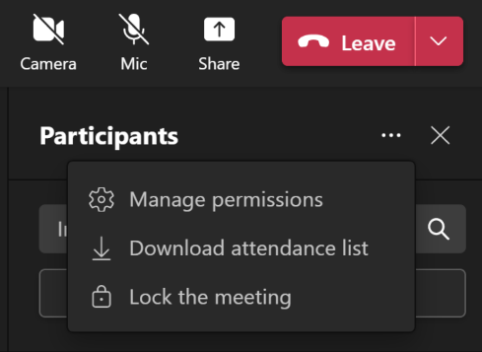
In Teams, meeting organizers can choose to lock their meetings to prevent subsequent join attempts. Anyone attempting to join a locked meeting from any device will be informed that the meeting is locked.
- Once you're in a meeting, select Participants > ... > Lock the meeting (or unlock it when locked).
When a meeting is locked, no additional participants will be able to join, but invitees can still access the meeting chat, recording, and other meeting info.
Note: Once participants leave the meeting, they will not be able to join again until the meeting is unlocked.

Microsoft Teams etiquette: 8 best practices
- Join a meeting on mute.
- Use background blur to minimize distractions.
- Turn the camera on when possible.
- Follow a detailed agenda.
- Download the Teams app to your computer.
- Don’t over-invite people.
- Stay muted while you’re not talking.
- Zoom in when sharing your screen.

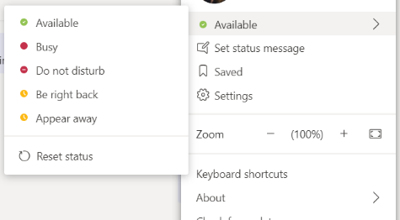
Presence
Your presence information is a quick way for other people to see your availability status. Presence is automatically set based on your Outlook calendar, but you can change it manually if you want to.
As an example, if you have a meeting currently scheduled in Outlook, your status appears as “In a meeting”. When you’re in an audio or video call, your presence indicator appears red, as Busy, and your status is updated to “In a call.”
You can also manually set your presence status to include details you want others to see. Your presence can also include a personal note that appears in your Contacts list and on your contact card. This gives people more information about what you’re up to.

Change your presence status:
- Click the status menu drop-down arrow below your name on the main window, and then click the status you want to show other people.
- To revert from the status, you set and have automatically update your status, click the status menu and then click Reset Status.
- Choose the appropriate status.
Make sure you set your status accurately. The following table describes each presence status that other people may see for you, what each status means, and which ones you can set yourself.
If your presence is | It means you are | How this status gets set
Available | Online and available to contact. | Set automatically for you based on your keyboard activity or Outlook calendar. You can also set this status when you want others to know you’re in your office even though the computer is idle.
Be Right Back | Stepping away from the computer for a few moments. | You can set your presence to this anytime you want.
Away/Appear Away | Logged on but your computer has been idle, or you’ve been away from your computer for a specified (set by you) period of time. | Set automatically for you based on your keyboard activity or Outlook calendar. Teams sets your status to “inactive” when your computer’s been idle for five minutes, and to “away” when your status has been inactive for five minutes. (To change these default values, click the Options button, click Status, and then click the arrows next to Show me as Inactive when my status has been idle for this many minutes and Show me as Away when my status has been Inactive for this many minutes.) You can also set your presence to this anytime you want.
Off Work | Not working and not available to be contacted. | You can set your presence to this anytime you want.
Busy | Busy and don’t want to be interrupted. | Set automatically for you based on your Outlook calendar. You can also set your presence to this anytime you want. If you manually set it to Busy, it will revert back to your Outlook calendar status in 24 hours, if you do not change it before then.
In a call | In a Teams for Business call (a two-way audio call) and don’t want to be disturbed. | Set automatically for you based on your phone activity.
In a meeting | In a meeting and don’t want to be disturbed. | Set automatically for you based on your Outlook calendar.
In a conference call | In a Teams conference call (a Teams with audio) and don’t want to be disturbed. | Set automatically for you when you have joined a conference call or a meet now session.
Do Not Disturb | Don’t want to be disturbed and will see conversation notifications only if sent by someone in your workgroup. | You can set your presence to this anytime you want. If you manually set it to Do Not Disturb, it will revert back to your Outlook Calendar status in 24 hours, if you do not change your status before then.
Presenting | Giving a presentation and can’t be disturbed. | Set automatically for you when you are presenting in a Teams meeting. You can change this setting in the Status options window.
Out of Office | You are out of the office. | Set automatically for you based on your Outlook calendar.
Out of the office (automatic reply is on) | You have set the automatic reply feature in Outlook. | Set automatically for you when you set automatic replies in Outlook.
Offline | Not signed in. You’ll appear as Offline to people whom you’ve blocked from seeing your presence. | Set automatically for you based on your keyboard activity or Outlook calendar.
Unknown | Your presence can't be detected. | This status might appear to contacts who are not using Teams as their instant messaging program.

Respect Microsoft Teams etiquette when people are set to Do Not Disturb
So we’ve covered communicating with people. But what about when you can’t reach them when they’re on Do Not Disturb?
There’s one hard and fast rule here. Do not disturb!
When someone has the red presence indicator with a white line through, this means they could be doing one of a few things:
- Presenting their screen during a meeting.
- Focusing on deep work.
- In an important meeting and they don’t want to get distracted.
- Tending to a personal matter.

