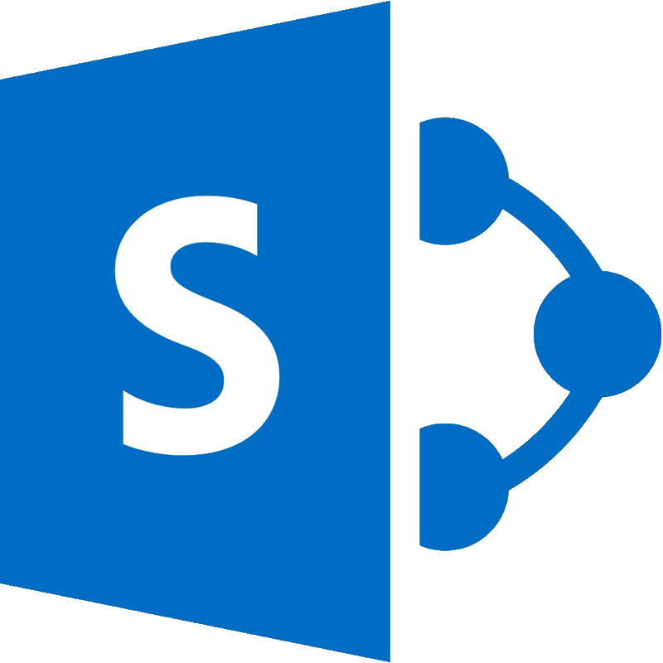

Microsoft SharePoint
Beyond the Basics

Copyright©2023 Virtual Training Co. All rights reserved. This publication or any part thereof, may not be reproduced or transmitted in any form or by any means, electronic or mechanical, including photocopying, recording, storage in an information retrieval system, or otherwise without written permission of Virtual Training Co, 661 Green Ct, Onalaska, WI 54650.

Working in Microsoft SharePoint
SharePoint is a website-based collaboration system that uses workflow applications, “list” databases, and other web parts and security features to empower business teams to work together. SharePoint also gives the company using the platform the ability to control access to information and automate workflow processes across business units.
SharePoint Sites are like websites. They can contain pages that you access by clicking on a link, document libraries, apps, etc. The term Site refers to an individual “website” based on SharePoint.
You can use the sites as a secure place to store, organize, share, and access information from any device. All you need is a web browser, such as Microsoft Edge, Internet Explorer, Google Chrome, or Mozilla Firefox.
In a SharePoint site you can view News, Announcements, Timeline, Calendars, Document Management, Images, and so much more.
SharePoint can be used as an intranet portal to share company information to all employees.
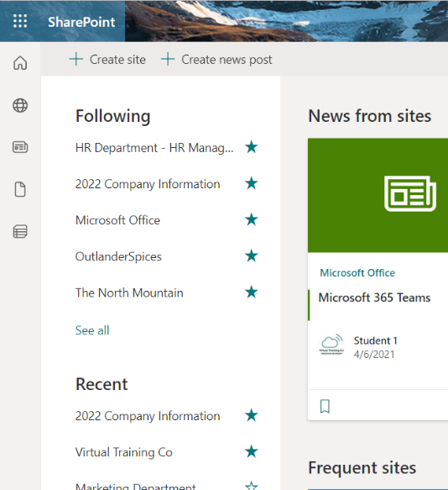
SharePoint Online - The Microsoft Cloud version of SharePoint, SharePoint Online, has many additional integration capabilities with other cloud applications. It is paired in functionality with many of the other offerings Microsoft packages with an Office 365 or Microsoft 365 license.

How to Access SharePoint?
You don’t need to install/download software to use SharePoint, you just need an Internet connection.
- Open your browser of choice, then go to at www.office.com/signin.
- Enter your username and password.
- From the home page of your Microsoft 365 account, select the SharePoint icon located on the left or top menu, or open it from in the app launcher.
Once you open the SharePoint app you will be at the Home Page. From here you can Open any Site or Create New Sites.

SharePoint User Interface
Each SharePoint site has a Home or Landing Page. The Home Page can include several objects and have different styles of formatting.

Navigation Pane (Quick Launch)
The left navigation pane shows SharePoint sites you follow, those you've visited recently, and sites your company wants to spotlight.
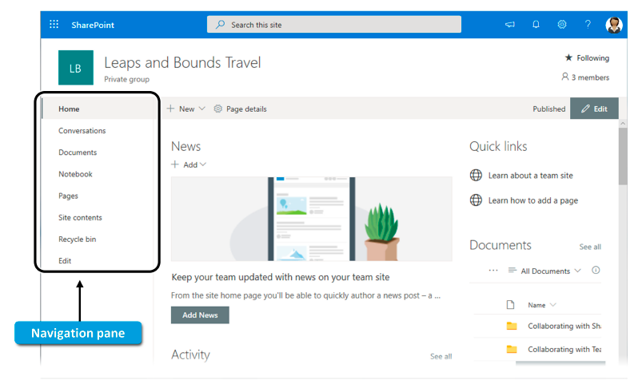
- Following displays sites you follow, like your team's site or a site from another group you work with.
- Recent shows any site you've gone to recently.
- Saved lists news articles you've saved to read later.
- Featured links displays sites your company wants to showcase.
SharePoint can have a Navigation Pane on the left or top of the window. You can also navigate to different elements by clicking on links.
The navigation can be customized otherwise as an object is added to the site it will be added automatically to the navigation.

Before you Build…Plan
Time spent planning is time well spent. Understanding what other SharePoint sites exist within you organization, needs of users, return on investment, etc. The list can be long but here are a few things to consider.

Common Mistakes with SharePoint
1. Not planning before you build your site - When a site's content is logically organized and easy-to-find, it's easier to maintain and manage, and site users are more productive. You should plan out your site strategy before creating your site. Some basic things to consider:
- What kind of content will you have on sites?
- How will your users find and access content?
- What do users need to do with content?
- How will your users find and access content?
- How will they navigate the site?
- What kind of content will you have on sites?
After you have given some thought to the number and type of sites that you want, do some planning for the content that will be stored on these sites. The goal for this content planning is to determine:
- What kinds of lists, libraries, or pages you want to create on sites to organize content - Libraries can be used to store documents and other files, while lists can be useful for tracking tasks or issues. Pages are individual items within a site where you can display content, apps, links, and more.
- What kinds of apps you want to include - SharePoint built-in apps such as document libraries and lists, but you can also create your own apps or buy apps from third-parties in the SharePoint Store.
- Whether you want to create content types - Content types help you customize how you handle and track specific kinds of content.
2. Neglecting to implement a governance strategy - What is governance? According to the official Microsoft documentation, governance is the set of policies, roles, responsibilities, and processes that dictate how an organization’s business divisions and IT teams work together to achieve common goals.
3. Change Site Settings – before you share your Site with others, make sure you have all setting in place.

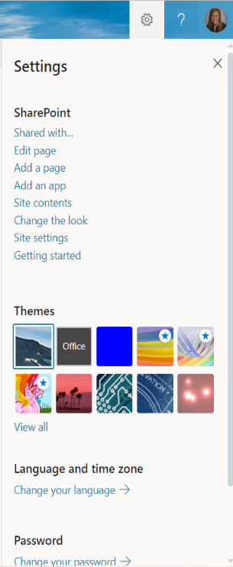
SharePoint Settings
Understanding the settings for sites will help with planning how things will be used and accessed.
From the gears icon at the top right of a SharePoint Site, you can manage things like Sharing, Edit Page, Add a Page, etc.
- Click on the Icon.
- Click on the Settings option you need.

Site Settings
The Site Settings is where you can change or add Users and Permissions, Access Wed Designer Galleries, do Site Administration, Change/Setup Search options, change the Look and Feel of your Site, set the Site Actions, access the Site Collection Administration and configure Microsoft Search Settings.

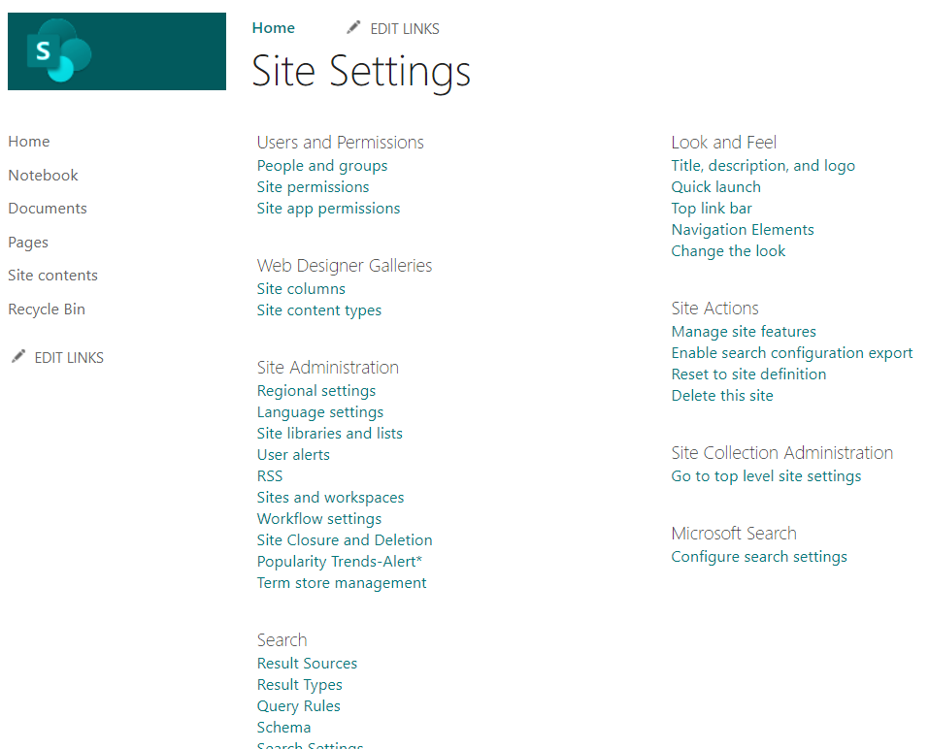

SharePoint Site Permissions
Once you create a SharePoint site, then someone should be responsible to manage the site. There comes the role of a SharePoint site owner. A SharePoint Site owner is the user who will have the full control to a particular SharePoint site.
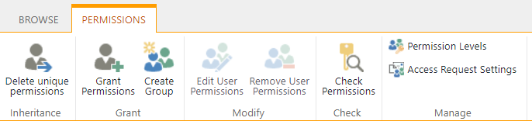

What is a Subsite?
A site is a container of objects which can include lists, document libraries, and pages. A site can also contain nested sites called sub sites. Sometimes the terms site and subsite are used interchangeably. They are essentially the same thing, as a subsite is just a site that lives underneath another site.
When you will create a site under any site, we call it a subsite in SharePoint. SharePoint site is the site that also we call as the top-level site. 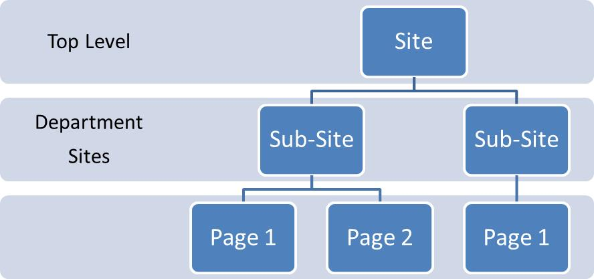

Working with Hub Sites
SharePoint hub sites help you meet the needs of your organization by connecting and organizing sites based on project, department, division, region, etc. making it easier to: Discover related content such as news and other site activities. Apply common navigation, branding, and site structure across associated sites.
Hub Sites is what allows to build common navigation for all those separate sites (collections) you have in your tenant (Office 365 Groups and Communication Sites). With Subsites, you could also build common navigation, by maintaining it at the root of a site collection, but the minute you had to create common navigation among multiple site collections.

You need to SharePoint admin to create Hub Sites.
Hub site should be used to bunch sites together, create an intranet or roll up information together. Bunching or associating sites together should be done based on departments, organizations, key features, team or based on keywords or location etc. or if you want to roll up specific information from different sources.
Use hub sites when you need:
- Consistent branding across a collection of associated sites.
- Increased visibility to collections of related content.
- Enhanced search and navigation capabilities for content relevant to specific groups of people.
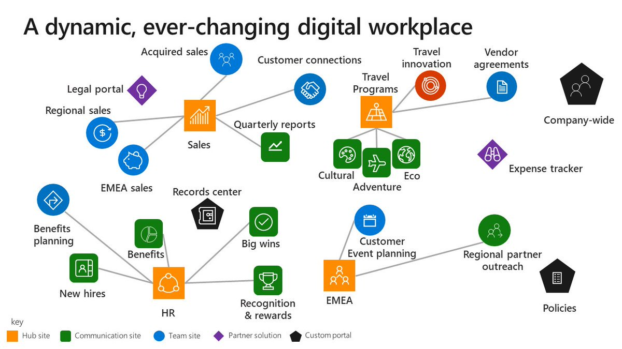

Create a Hub Site
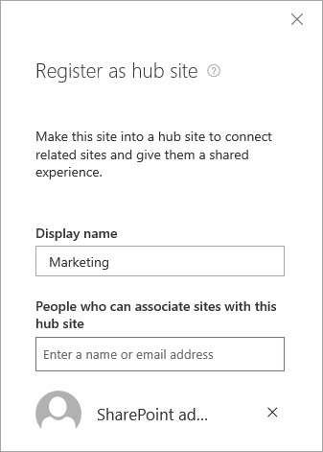
Once a Site has been created, you can turn it into a Hub Site from the SharePoint Admin.
- Go to Active Sites.
- Select the Site you want to become a Hub Site.
- From the menu at the top, click on Hub Site.
- Choose Register as hub site.
- Enter a display name for the hub site, and specify the individual users or security groups you want to allow to associate sites with the hub. If you leave the People who can associate sites with this hub box empty, any user can associate their site with the hub.
- Click Save.

Subsites vs Hub Sites
Hub sites introduce us a flat structure which can be moved easily as sites are just associated and not created under them. So, uniqueness is in the flat structure which can be implemented easily. Difference between the Hub site-based structure and the traditional structure is as below:
Hub site based | Traditional – Site collections – sub sites
Flat structure | Hierarchy based structure
Sites are associated and not created under it | Sites are created under a main site
Access permissions do not have any impact in | Access permissions are inherited by default or needs to be managed separately
Easy to move around sites and change structure or associations | No easy ways to change the structure

Create a New Site
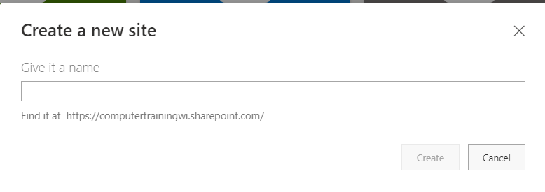
Once you open the SharePoint app, you can create a new Site from the menu at the top. You can choose between creating a Communication Site or a Team Site.
Enter the Site name and click Create.
Or
From the SharePoint Admin Center, Active Sites, click Create from the top menu. Choose Team site or Communication Site.
Once the site is up and running, you’ll notice a few core functions available immediately. These include:
- Conversations: A private message board for your team members
- OneNote Notebook: A place for employees to contribute and save ideas
- Documents: Where you’ll store and share documents
- Site Pages: Custom web pages for your teammates

What is a Page?
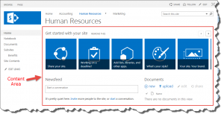
A page is basically an area to display content to users, such as images, hyperlinks, lists, libraries, web parts, and text. This content can be arranged and organized in whatever way the page creator chooses. The content area of a page is what you see below and to the right of the navigation elements of SharePoint.
Every site has at least one page, which would be the home or landing page. Additional pages can be added to the site by users.

Making SharePoint Site Pages
Want to turn your SharePoint site into a mini-intranet for your team members? Make Site Pages, which are only accessible to and viewable for those in your designated group. Pages work with modern web parts, allowing users to easily customize their page by embedding videos, incorporating feeds from Yammer, adding documents and including images.
You can save text and images on each site page. Click “Pages” in your left-hand navigation menu. When the top menu bar appears, click “+New.” Your page types will include:
- Site Pages: Blank spaces you can create with only a title
- Wiki Pages: A place for team members to collaborate on content creation
- Web Part Pages: Pre-designed layouts with dashboard-style features and widgets

Add and publish a page
- Go to the site where you want to add a page.
- Go to the home page of the site.
- Select + New, and then select Page.
Alternately, you can go to an existing page, select + New, and select Page. Or you can choose Copy of this page to create a new page that has the same web parts and content as the existing page.
- Choose a page template to start with. For this example, we'll use the Blank template. Then select Create page.
- Add a page name in top area where it reads Add a name. A page name is required to save the page.

Add Web Parts
Web parts are the building blocks of your page.
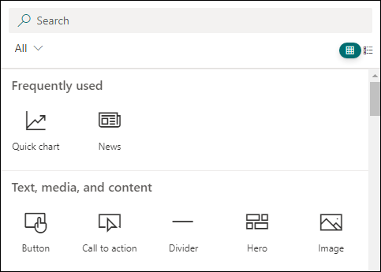
- Hover your mouse below the title area and there will be a line with a circled +, like this:
Select + to add content like text, documents, video and more.
- You can also add sections and columns to a page.
- When you're done editing, you can select Save as draft to save your changes and close edit mode. Your audience won't be able to view or read the page until you publish it. Only people with edit permissions on your site will have access.
- When you are ready for your audience to view and read the page, select Publish.

SharePoint Notebook
Each SharePoint team site comes with a OneNote notebook link in the Quick Launch. It opens the Online version of OneNote, Microsoft's note-taking tool that is part of the Office package.
OneNote Online works well in the browser, and by having it in SharePoint you can easily share it with other team members. The OneNote notebooks are stored in each team site's Site Assets library.

Share a Site
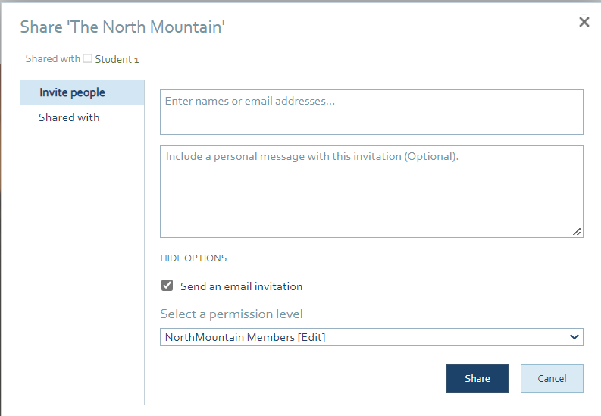
When the site is ready to be used, you can share it with others. If you're a Microsoft SharePoint site owner, you can give other people access to the site by adding them as owners, members, or visitors. If the site is a SharePoint site, you might even be able to share it with people outside your organization, depending on the permissions set for your organization and for the specific site.
- Click the Share icon at the top right.
- Enter the names or email addresses of the people you want to share with.
- You can add a message if you are sending a link via email.
- Uncheck Send an Email invitation if you don’t need it.
- Select a permission level 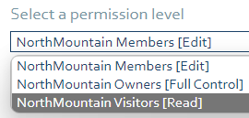
- Click Share.
You can also share by going to the Setting for the Site as noted in the Site Owner information.

Working with Documents in SharePoint
Your SharePoint document library offers many ways to work with your files, from creating files to copying and moving them between folders. You can view the work that you and others have done on the files and save earlier versions that you can restore if needed. You and your team have a lot of control over where, what, and how you work with your files.
- Lists - A list is a Web site component where your organization can store, share, and manage information. For example, you can create a task list to track work assignments or track team events on a calendar. You can also conduct a survey or host discussions on a discussion board.
- Libraries - A library is a special type of list that stores files as well as information about files. You can control how files are viewed, tracked, managed, and created in libraries.

Create a New Document
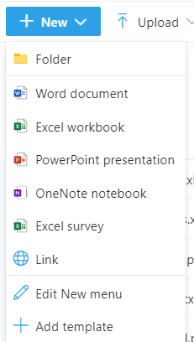
After you create a SharePoint document library, you'll need to add content. You can start by creating or uploading documents and files.
When you choose a new Microsoft 365 document, a generic file is created in the library (Document.docx, book.xlsx, etc), and a blank document is opened in the respective app.

Upload a Folder or Files
You can upload files to a document library in SharePoint by dragging them from your computer and dropping them into the document library.

Drag and drop to a document Library
- Open the document library where you want to upload a folder or files.
- Select files or folders on your computer and drag and drop the folder or files onto the document library page.

Edit Files
Files associated with Microsoft 365 apps like Word, Excel, and PowerPoint can be opened and edited online when you click the file name in a document library. When you edit in Microsoft 365, all changes are automatically saved.
When you have a desktop app such as Word, it will show up when you open or edit the file. If you choose a desktop app, the document will open in the app and you can edit it like any other file. Unlike the online version of Word, Excel, or PowerPoint, to keep changes, you need to explicitly save the document before you exit.
When a file is selected, you can use the toolbar at the top of the window or if you hesitate on the name, click on the show actions, you will get a popup menu of more choices.

Delete Files
If an item in a document library is no longer needed, you can delete it. When you delete a folder, SharePoint also deletes any files or folders that are contained in it.
If you delete something but need to get it back, you may be able to restore it from the recycle bin.
To Delete a File:
- Select the file then use the tools at the top, click Delete.
- Or hesitate on the file name, click on the show actions, then click Delete.

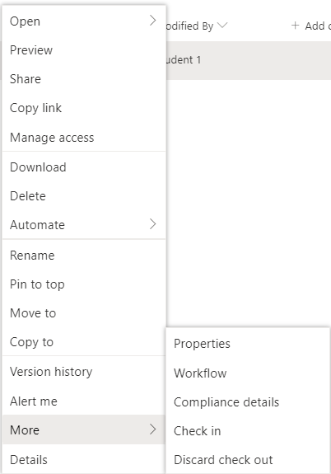
Check Files In or Out
When you check out a file, you lock out others from making any changes. This helps prevent coworkers from undoing or overwriting each other's changes.
While you have a file checked out, nobody else can check it out or edit it. When you check the file back in, others can see the changes you've made.
To Check Out or Check In a File:
Select the file, then from the tools at the top, click on Check Out or Check In.
Or
Select the file, then from the eclipse menu, hesitate on More then click on Check Out or Check In.

Share a File or Folder
The files you store on a SharePoint site are usually available to everyone with permissions to the site, but you may want to share specific files or folders with people who don't otherwise have access to the site. When you share files and folders, you can decide whether to let people edit or just view them. You can see who a SharePoint file is shared with, and stop sharing SharePoint files or folders, or change permissions, at any time.
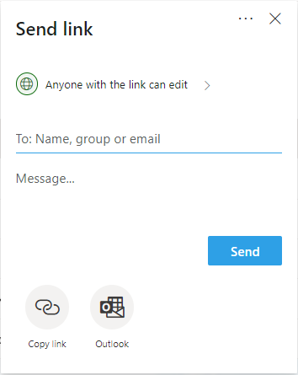
Here's how you share files or folders in SharePoint:
- Select the file or folder you want to share, and then select Share.

- (Optional) Click the dropdown list to change the type of link. The Details pane opens, where you can change who can access the link and whether people can edit the item you’re sharing.

View and Work with Version History
The SharePoint Online version history creates a new version of files that are saved or checked in to a document library.
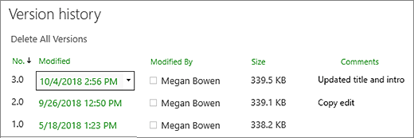
In the Version History, you can view comments that were added when the file was checked in, the file size, and the date when it was checked in or saved to a document library. You can also choose to restore or delete a version of the file.
View version history in SharePoint
- Open the list or library from the Quick Launch bar.
If the name of your list or library does not appear, click Site contents or View All Site Content, and then click the name of your list or library.
- Right click on the space between the item or document name and date, and then click Version History from the menu. You might need to scroll the menu to see Version History.
If you don't see Version History, click the ellipsis (...) in the dialog and then click Version History.
- In the Version History dialog, hover next to the version you want view and click the down arrow on the right side to get a list of options.
- Click View.

Alert Me
To stay updated when your SharePoint documents or items on your site change, create alerts. You can set up an alert for a list, library, folder, file, or list item. For example, you can set up an alert for a specific folder in a library, without receiving alerts when changes occur in the rest of the library.

Get alerts on item changes in SharePoint Online
You can get an alert whenever a file, link, or folder is changed in a SharePoint Online document library. Depending on the item (file, folder, link), you may see different options when you set an alert.
- Go to the list or library.
- Select the file, link, or folder for which you want to get an alert.
- From the list of options for the list or library, select the ... (ellipses), and then select Alert Me.
- In the Alert me when items change dialog, select and change the options you want.
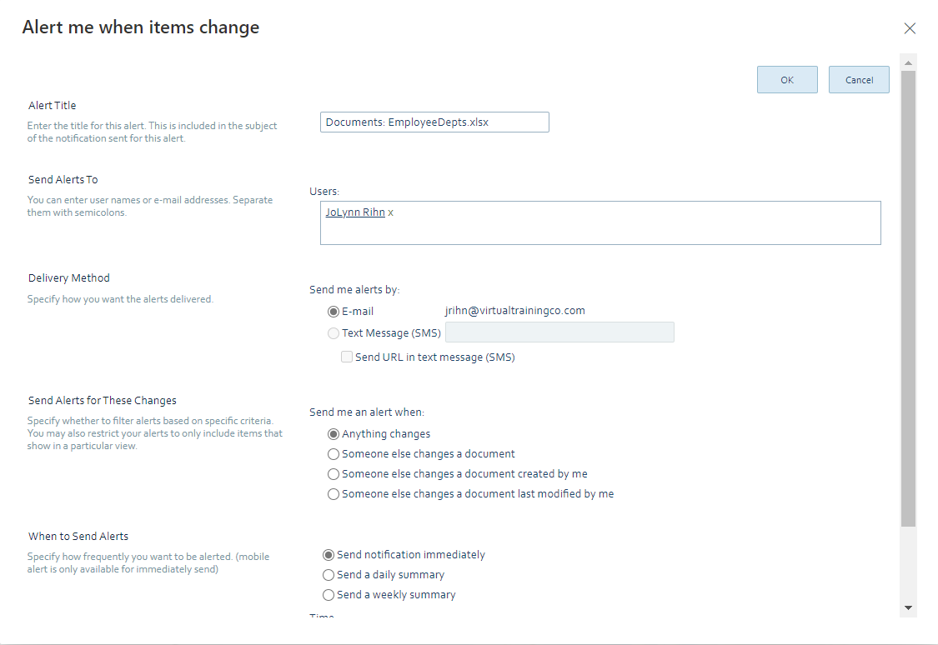
- To save, select OK.

Live Collaboration on Files
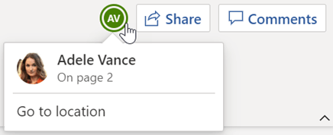
When you open a file that is stored on a SharePoint site, others can open the file at the same time as you. Unless there are restrictions on the file, multiple people can add, edit, delete content on the file at one time.

Work with others on the same document, at the same time
- Open the document for editing in Office for the web.
- The number of people currently editing the document appears at the top of the document in Office Online.

SharePoint Tasks
A Microsoft SharePoint project task list displays a collection of tasks that are part of a project. A task is a discrete work item that a single person can be assigned. A project is typically a series of activities that has a beginning, middle, and end. Examples include projects that produce a product or service, such as producing a product demonstration for a trade show, creating a product proposal for stakeholders, or organizing a corporate event.
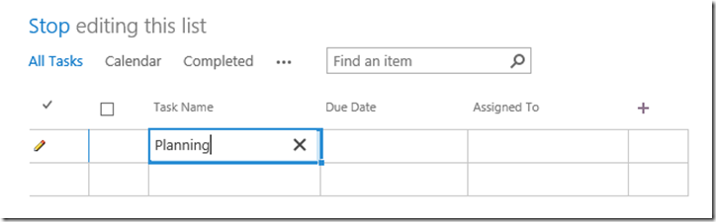
After you create a SharePoint project task list, you can add tasks, assign resources to tasks, update the progress on tasks, and view the task information on bars that are displayed along a timeline.
One of the first steps to managing a project is to add the tasks that get your project done. Your list of tasks can be as simple as a checklist of things that need to get done, or it can be somewhat more involved, with start and finish dates, relationships with other tasks, and other associated task information. A simple checklist of tasks and a scheduled list of tasks both use the same list on your site, so you can start with a simple checklist, and then add detail to the tasks later to make it a scheduled list of tasks.

Add a Task
If you are just getting started with your project planning, or if you don’t anticipate this project being particularly complicated, a simple checklist of tasks may be enough for you to effectively manage your project. Your checklist may include due dates for your project’s tasks, and assignments to project team members.
To add a simple checklist of tasks:
- On the Quick Launch for your site, click Tasks.
- On the Tasks page, click Edit.
- In the Task Name column, type a name for each task that needs to be completed in your project. Press Enter to move to the next line after adding a task.
Tip: Do you want to add a new task between two tasks that are already listed? Click in the space to the left of the check box for an existing task, and then press Insert. A new row is added above the existing task that you selected. You can also click Insert in the Hierarchy group on the Tasks tab.
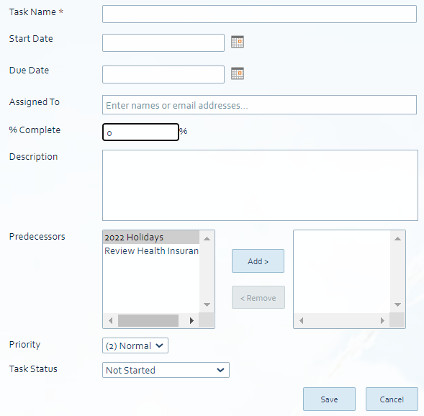
- In the Due Date column, type or select a date for when each task in the list should be complete. If you’re not sure when a task needs to be complete, leave this column blank for that task.
- In the Assigned To column, type or select the name of each person who will work on each task in the list.
Tip: A best practice is to only assign one person to each task. If you need to assign more than one person, this can lead to issues with marking tasks as complete.
- When you have finished adding your simple checklist of tasks, click Stop.

Add a Scheduled List of Tasks
If your project is somewhat complex, you may find that a scheduled list of tasks helps you keep track of the work in a more manageable way.
To add a scheduled list of tasks:
- On the Quick Launch for your site, click Tasks.
- On the Tasks page, click New Task. Or, on the Tasks tab of the ribbon, click New Item.
Note: If you initially created a simple checklist of tasks, but the project became a bit more involved, you can easily add more detail to your existing tasks. To select a task, click in the space to the left of the check box for it, and then, on the Tasks tab of the ribbon, click Edit Item. This opens the task so that you can add greater scheduling detail.
- Type a name for your task in the Task Name box.
- Type or select a start and finish date for your task in the Start Date and Due Date boxes. If you’re not sure of either of these dates, leave this information out for now. You can always return later and add information by editing the task.
- Type the name or email address of the person you want to work on the task in the Assigned To box.
Tip: A best practice is to only assign one person to each task. If you need to assign more than one person, this can lead to issues with marking tasks as complete. If Ann finishes her work on the task, it makes sense for her to check it off as complete on her My Tasks page. However, this marks the task as complete for everyone assigned, not just Ann. Someone else on the task may still have work to do. If you decide that you do still need to assign more than one person to a task, you can separate names with a semicolon (;).
- If work has already begun on the task, enter a percentage in the % Complete box, to indicate approximately how much work has been done, and what is left to do.
Tip: This is a great field for your project’s team members to update on a regular basis. It can help you understand how work on your project is progressing, and whether your project is on track to finish on time.
- Type a brief description of the task in the Description box, if you would like to provide greater detail about the work that is involved. This may be helpful for executives or other stakeholders who are trying to understand your project.
- Use the boxes and buttons next to Predecessors to indicate which tasks in your project need to be completed before the current task can start.
For example, let’s say you create a task called “Publish press release,” which can’t begin until the “Write press release” task has completed. Select the “Write press release” task from the box on the left, and then click Add to move it to the box on the right. This indicates that the “Write press release” task is a predecessor to (that is, it precedes) the “Publish press release” task.
- Select the appropriate priority level from the Priority list.
- Select the appropriate status level from the Task Status list.
Tip: This is another field that is helpful for your project team members to update regularly. It can help you stay on top of work blockages, schedule delays, and other critical scheduling issues.
- Click Save.

SharePoint Calendar
You can use a calendar to store team events, including meetings, social events, and all-day events. You can also track team milestones, such as deadlines or product release dates, that are not specific to a time interval. With a calendar on the SharePoint site, you and your colleagues will have easy access to common schedules and dates.

Add Event or Item to SharePoint Calendar
There are two ways to add an event to the calendar, either you can click on the particular cell from the calendar list like this or you can click on Events from the ribbon and click on New Events.
With the Calendar visible, hesitate on the date, then click on Add at the bottom right corner.
Or
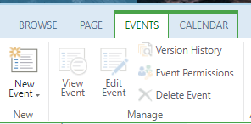
When you click on the Calendar to select it, a ribbon appears at the top of the window. Click on the Events tab then new Event.
Fill out the details needed like the Title, Location, Start and End date/time, etc.
Use the Category to pick what type of Event you are creating.
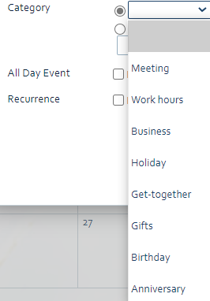
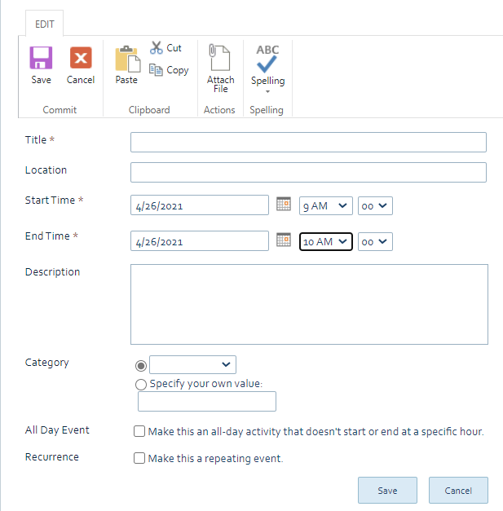

Microsoft Search
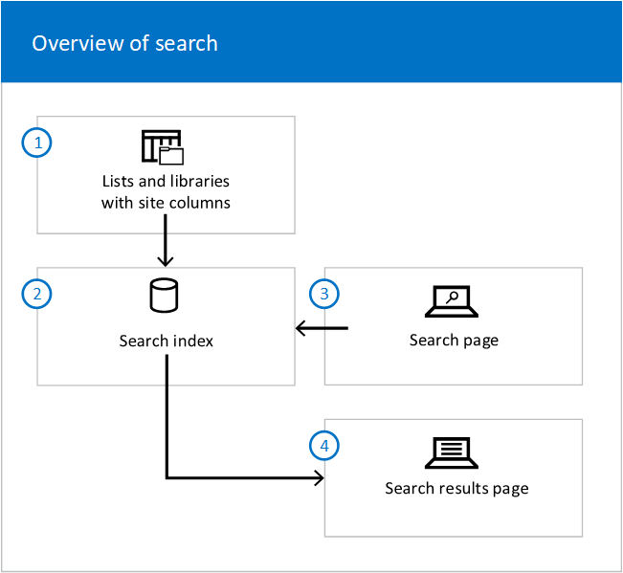
Microsoft Search helps you find what you need to complete what you’re working on. Whether you're searching for people, files, org charts, sites, or answers to common questions, you can use Microsoft Search throughout your workday to get answers.
The Microsoft Search box is placed at the top of SharePoint, in the header bar.
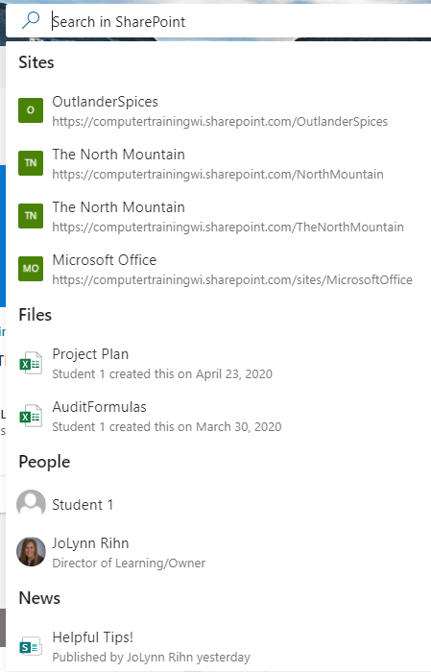
Search is personal. Other people might see different results than you, even when you both search for the same Microsoft words. The results one user sees are different from what other users see, even when they search for the same words. Users see results before they start typing in the search box, based on their previous activity and trending content in Microsoft 365, and the results update as they type.

How to Search
- Click in the Search box at the top of the window in the title bar.
- You will see categories like Sites, Files, People and News to pick from otherwise you can just type in what you are looking for.
- Click see more results to open the Search window.
- From the top menu you can view files related to the search criteria or filter if necessary.
- Click Exit Search at the top left of the window when you are finished.

Get back to what you've been working on
If you’re in Bing, on your SharePoint start page or Office.com, here are some useful searches: Search for “my files” and then press Enter. You’ll get up to 10 of the files you’ve been working on lately.
- Search for a person’s files, for example “Daisy Philips' files”, and then press Enter. You’ll get a list of the files that the person has shared with you. This is useful if you two are collaborating on files together, or you’d like to find back to files the person has shared with you.

