Microsoft SharePoint and Teams Governance
Developed by JoLynn Rihn, Virtual Training Co

Copyright©2023 Virtual Training Co. All rights reserved. This publication or any part thereof, may not be reproduced or transmitted in any form or by any means, electronic or mechanical, including photocopying, recording, storage in an information retrieval system, or otherwise without written permission of Virtual Training Co, 661 Green Ct, Onalaska, WI 54650.

Being the Champion for your Company's Teams and SharePoint
Champions are essential to driving awareness, adoption, and education in your organization. A champion is a person, primarily motivated by helping others, who is interested in new technology (specifically Teams) and helping other employees use it in alignment with your best practices. Depending on the size of your organization you may have this as a formal part of the person's role, but often employees take on this role themselves because of their core motivation to help others.
Champions should:
- Be formally trained to increase their depth and breadth of knowledge
- Be encouraged and empowered to guide, teach, and train their peers
- Have consistent and positive reinforcement that affirms the impact of their efforts
- Have a clear plan to execute
Who are your Champions?
- Start with a list of departments. Are there groups within your departments?
- Who would make a good Champion from the department or group?
For more information on Microsoft Champions visit Become a Champion – Microsoft Adoption.

Microsoft Governance
What is governance in SharePoint or Teams? Governance is the set of policies, roles, responsibilities, and processes that control how your organization’s business divisions and IT teams work together to achieve its goals.
Every organization has unique needs and goals that influence its approach to governance. Larger organizations will probably require more—and more detailed—governance than smaller organizations. A good governance plan can:
- Streamline the deployment of products and technologies, such as SharePoint.
- Help keep your organization's system secure and compliant.
- Help ensure the best return on your investment in technology.

Governance Team
Your governance policies should support your organization's goals and be kept up-to-date as your organization's needs change. We recommend that you create a team from various disciplines across your organization to develop and maintain these policies. Include people from as many of the following roles as possible:
Role | Responsibility
Executive stakeholders | Key executives should define the overall goals of the governance committee and periodically evaluate the success of the implemented practices and policies.
Financial stakeholders | Financial officers should make sure that governance rules and processes help increase the return on your organization's investment in SharePoint.
Business division leaders | Business leaders represent the teams that do the primary work of the enterprise and drive the architectural and functional requirements of the deployment. They work with information architects to structure the information architecture and taxonomy standards. Business leaders also work with IT leaders to create service-level agreements and other support policies.
IT managers | IT managers help develop their service offerings and determine how to achieve their IT responsibilities (for example, improving security and maintaining reliability) while supporting the features required by the business teams.
Software development leaders | Software development leaders help determine which customization tools are approved, how to verify code security, and ensure code-related best practices.
Technical specialists | Technical specialists design, build, and run IT services and solutions.
Trainers | Instructional experts should develop a training plan for your organization.
Influential information workers | The members of your organization who do the day-to-day work should help ensure that the services and information architecture meet their needs.
Information architects or taxonomists | Members of these groups design information systems and taxonomies. Based on their analysis of the information needs of the audience, they develop plans that support organizational objectives and define site architecture and navigation.
Compliance officers | Governance includes making sure that an organization meets its regulatory and legal requirements and manages its corporate knowledge. If your organization has roles that are responsible for compliance or legal oversight, include representatives from those disciplines in your governance team.

Your organization might not have all of these roles, or it might use a different name for some of these roles.

Why is SharePoint and Teams Governance Important?
Governance is an integral part of a SharePoint and Teams deployment but can often be skipped or under-valued.
By building and following a governance plan, your staff are included and educated – which means that SharePoint and Teams stay organized and correct, which often saves the IT department (and end-users) a lot of time and headaches.
SharePoint and Teams governance capabilities overlap with other Microsoft 365 services.
Governance is a system of agreed policies, procedures and processes for handling the shared resource. Contained in those policies should be designated roles and responsibilities for access rights and action rights.
Decisions to consider:
- Who can create a SharePoint Site or Microsoft Team?
- Naming conventions
- Guest access
- Approved Apps
- Content management and structure
- Data Security

SharePoint Governance
Governance for SharePoint should start with the app itself, then the individual Sites. If you are a site owner, create a governance model to address your site’s policies, processes, roles, and responsibilities. A model like this will help you manage how people use your site. For example, you might want to require check-out of files so that multiple people don't try to edit a file at the same time.
Consider prioritizing and defining the following:
- Site training for site owners: Provide basic navigation, search, and document management training for new site owners.
- Site support: Assign a designated site expert on your team to troubleshoot problems and be a liaison to a SharePoint administrator.
- Site creation and usage guidelines: Often times organization have outlined company policy around site creation. Provide an up-to-date link to the appropriate guidelines, provide contact information for site owners and content authors in case they need assistance.
- Content publishing and auditing: Plan to audit site and page content as often as necessary to keep the site relevant. Establish an audit schedule and assign content owners for large lists and libraries.

Common Mistakes with SharePoint
1. Not planning before you build your site - When a site's content is logically organized and easy-to-find, it's easier to maintain and manage, and site users are more productive. You should plan out your site strategy before creating your site. Some basic things to consider:
- What kind of content will you have on sites?
- How will your users find and access content?
- What do users need to do with content?
- How will your users find and access content?
- How will they navigate the site?
- What kind of content will you have on sites?
After you have given some thought to the number and type of sites that you want, do some planning for the content that will be stored on these sites. The goal for this content planning is to determine:
- What kinds of lists, libraries, or pages you want to create on sites to organize content - Libraries can be used to store documents and other files, while lists can be useful for tracking tasks or issues. Pages are individual items within a site where you can display content, apps, links, and more.
- What kinds of apps you want to include - SharePoint built-in apps such as document libraries and lists, but you can also create your own apps or buy apps from third-parties in the SharePoint Store.
- Whether you want to create content types - Content types help you customize how you handle and track specific kinds of content.
2. Neglecting to implement a governance strategy - What is governance? According to the official Microsoft documentation, governance is the set of policies, roles, responsibilities, and processes that dictate how an organization’s business divisions and IT teams work together to achieve common goals.
3. Change Site Settings – before you share your Site with others, make sure you have all setting in place.

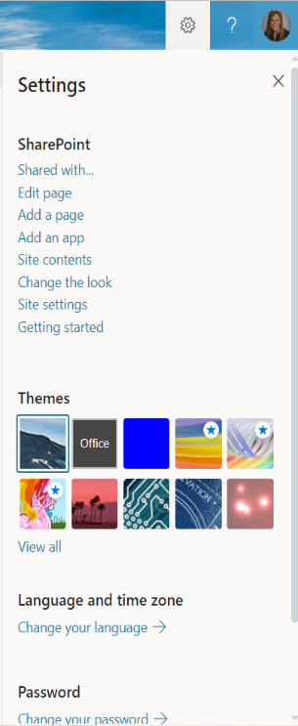
SharePoint Settings
Understanding the settings for sites will help with planning how things will be used and accessed.
From the gears icon at the top right of a SharePoint Site, you can manage things like Sharing, Edit Page, Add a Page, etc.
- Click on the Icon.
- Click on the Settings option you need.

Site Settings
The Site Settings is where you can change or add Users and Permissions, Access Wed Designer Galleries, do Site Administration, Change/Setup Search options, change the Look and Feel of your Site, set the Site Actions, access the Site Collection Administration and configure Microsoft Search Settings.

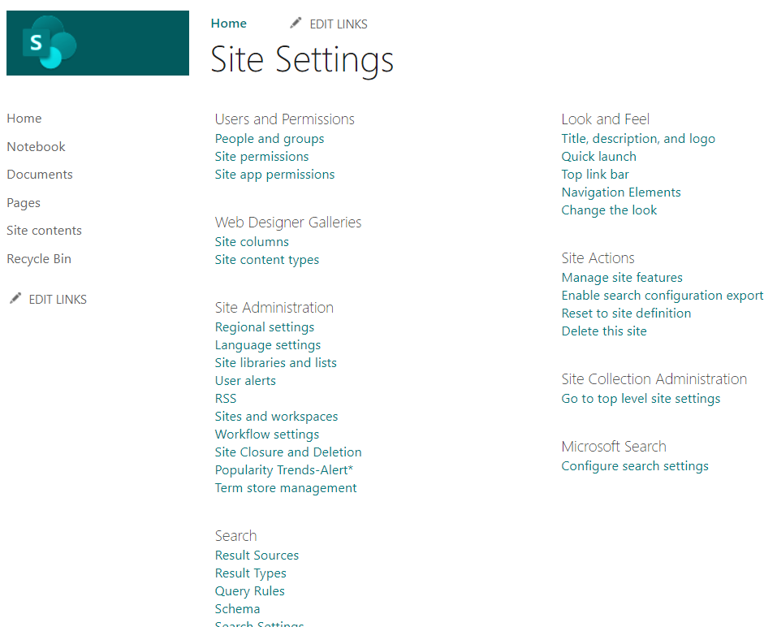

SharePoint Site Permissions
Once you create a SharePoint site, then someone should be responsible to manage the site. There comes the role of a SharePoint site owner. A SharePoint Site owner is the user who will have the full control to a particular SharePoint site.
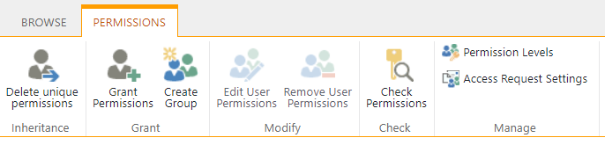
SharePoint

Plan for Governance in Teams
Teams provides a rich set of tools to implement any governance capabilities your organization might require. This article guides IT pros to ask the right questions to determine their requirements for governance, and how to meet them.
Ensuring that you’re able to contain sprawl, keep internal data safe and have everything functioning as efficiently as possible for your end users requires some serious governance measures.
There needs to be enough control to keep the creation process in line with business policies. At the same time, the process also needs to be quick and simple enough for end users to understand it.

Group and team creation, naming, classification, and guest access
Your organization might require that you implement strict controls on how teams are named and classified, whether guests can be added as team members, and who can create teams. You can configure these areas by using Azure Active Directory (Azure AD) and sensitivity labels.

- | - | -
 | Decision points | - Does your organization require a specific naming convention for teams?  - Do team creators need the ability to assign organization-specific classifications to teams?  - Do you need to restrict the ability to add guests to teams on a per-team basis?  - Does your organization require limiting who can create teams?
 | Next steps | - Document your organization’s requirements for team creation, naming, classification, and guest access.  - Plan to implement these requirements as a part of your Teams rollout.  - Communicate and publish your policies to inform Teams users of the behavior they can expect.

Collaboration governance planning recommendations
Follow these basic steps to create your governance plan:
- Consider key business goals and processes - create your governance plan to meet the needs of your business.
- Understand settings in services - settings in groups and SharePoint interact with each other, as do settings in groups, SharePoint and Teams and other services. Be sure to understand these interactions as you plan your governance strategy.
- Plan to manage user access - plan the level of access you want to grant users in groups, SharePoint, and Teams.
- Plan to manage compliance settings - review the available compliance options for Microsoft 365 groups, Teams, and SharePoint collaboration.
- Plan to manage communications - review the available communications governance options for collaboration scenarios.
- Plan for organization and lifecycle governance - choose the policies you want to use for group and team creation, naming, expiration, and archiving. Also, understand the end of lifecycle options for groups, teams, and Yammer
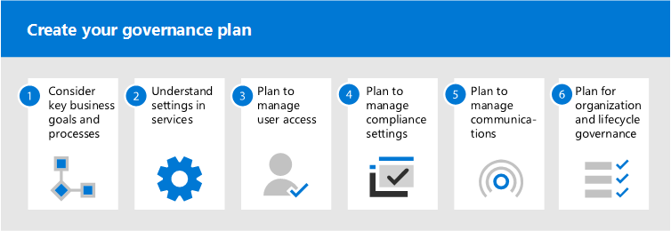
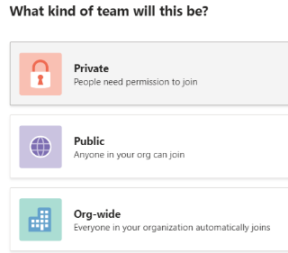
Microsoft Teams adoption quick start checklist - Microsoft Teams | Microsoft Docs

Types of Teams
When you create a new Team, you will need to choose what kind of team you need. There are 3 options:
- Private – people need permission to join
- Public – Anyone in your org can join
- Org-Wide – Everyone in your organization automatically joins
You can change the Team type at any time. It is recommended that when you first create the Team, make it Private until you have it fully really for the members or guests.
- Use unique names for each new Team.
- The Description is the objective of the Team.

Team Roles
Owners, Members and Guests can be assigned to your Team. The role can be changed at any time. Each role has different permission to the Team by default and you can manage the setting for further control over what they can and can’t do in the Team.
When considering it’s important to know that these roles can give end users a great deal of power and connections to external applications and storage locations.
- Owners - Team owners manage certain settings for the team. They add and remove members, add guests, change team settings, and handle administrative tasks. There can be multiple owners in a team.
- Members - Members are the people in the team. They talk with other team members in conversations. They can view and usually upload and change files. They also do the usual sorts of collaboration that the team owners have permitted.
- Guests - Guests are people from outside of your organization that a team owner invites, such as partners or consultants to join the team. Guests have fewer capabilities than team members or team owners, but there's still a lot they can do.
Don’t add members or guests until after the Team is created and ready to go LIVE.

Teams and SharePoint Documents
What content in SharePoint or Teams will be saved, archived or deleted, and after how long?
It’s important to understand that even though Microsoft Teams is a new format for collaboration, people will still be sharing files and documents back and forth, and those files will still be stored within the SharePoint sites that support the Team. This means that the classic questions around content lifecycle, records management and data protection/DLP will still need to be addressed.
It’s important to have a plan to make certain that documents are accurately labeled, that content-level security, taxonomy, and disposition is enforced and—if possible—automated, and that labels and classification accurately reflect the information within documents and files.
Office 365 has some tools like the Security and Compliance Center and the SharePoint Records Management Center that can address some of these problems, but many organizations reach out to AvePoint for assistance in fully automating and enforcing these policies across collaboration systems.
More information on SharePoint Records Management Center Implement Records Management (microsoft.com)

Microsoft 365 Org Settings
To manage some settings for each app, you can use the Org Settings from the Main menu of the Microsoft 365 Admin window.
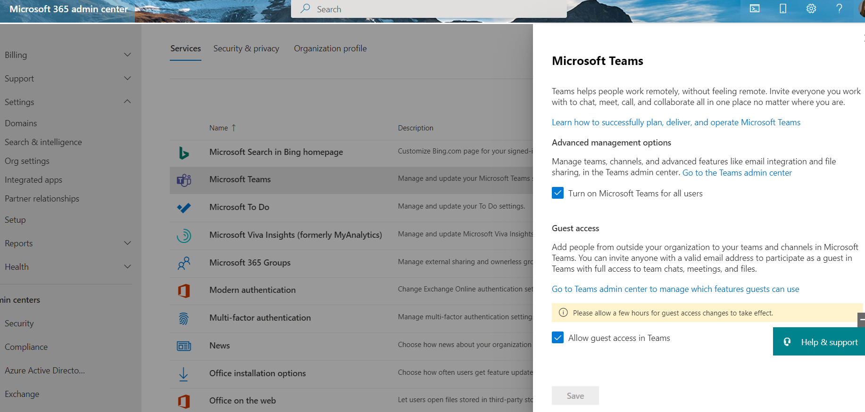

Manage Roles/Permissions
Using the Azure Active Directory Admin Center you can change default roles for your users.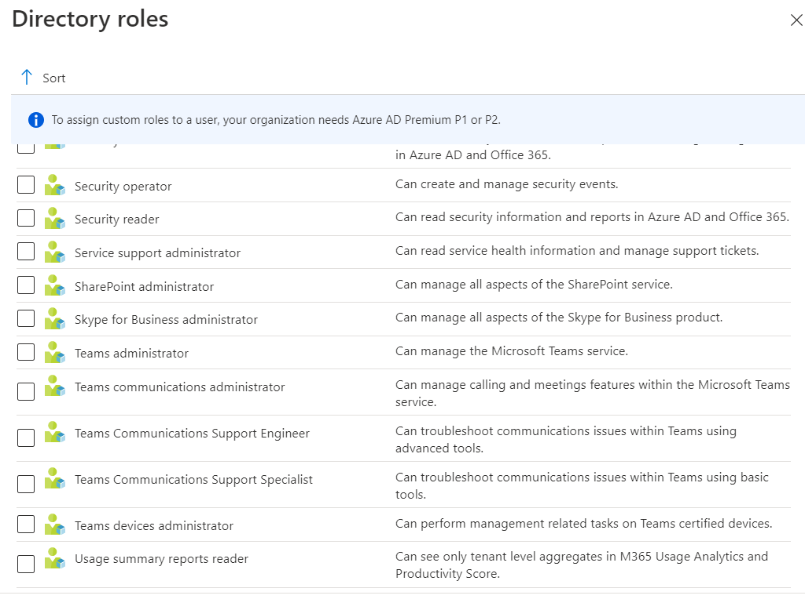

Maintenance of Sites and Teams
You can’t just build them and leave them. You will want to regularly monitor the SharePoint Sites and Microsoft Teams - Teams. We don’t just plan on how to get started but we need to think about once they go live.
How long do you want to wait before checking to see if a site is inactive? The default length of time for a Team or SharePoint Site is 90 days after site creation. Is it ready to be deleted or archived?
Before deleting a Site or Team, notify the owners/members/guests. How soon before you delete it?

Changing Sites or Teams
After a month, 3 months, etc. you will want to see how things are going. Are there changes, additions, etc that need to be made. Plan for follow-up with the stakeholders, interview or survey the users to make sure things are working the way they expected.

Manage a Team
If you need to modify a Team, click on the … eclipse next to the Team name.

On the right side of the window it will display a menu of options:
- Members – add, remove or change the type of members.
- Pending Requests – only visible for private Teams. You will see any requests users make to joining a Team.
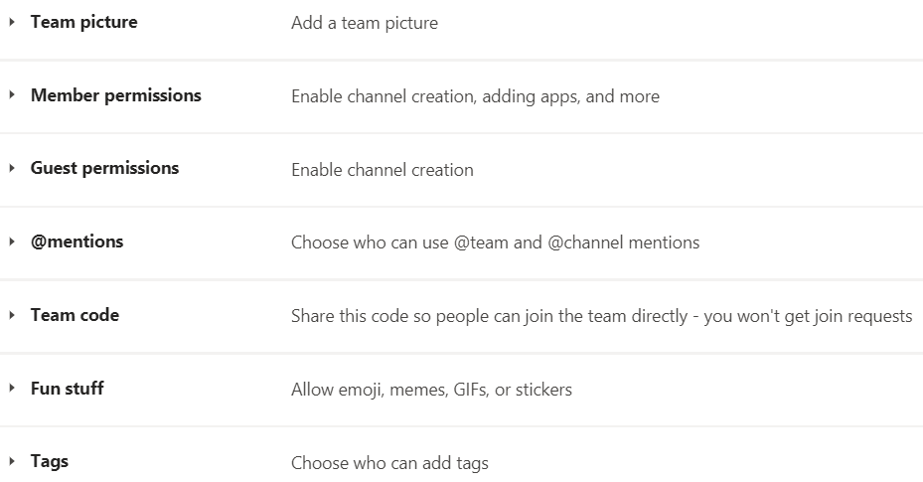
- Channels – add new channels, manage channels, etc.
- Settings – from the settings you can manage things like Team picture, member permissions, @mentions, fun stuff and more.
- Analytics – overview of the number of members, total size of files saved based on a time range.
- Apps – display details on apps available in Teams.

A Team can also be managed by going to the Admin Site online.

Delete a Team
If you want to delete a team (and you’re the team owner), go to the team name and click the … eclipse, then Delete the team. Your team will be permanently removed.
Notes:
- Deleting a team removes the team mailbox and calendar from Exchange.
- The corresponding SharePoint site and all its files will also be deleted.
- And any OneNote notebook, Planner plan, PowerBI workspace, or Stream group affiliated with the team will also be deleted.
- Team owners and IT admins can recover deleted teams for up to 30 days.

Deleting a Site
Sites are retained for 93 days and then permanently deleted.

Archive or restore a team
Archive a team when it’s no longer active, but you want to keep it around for reference or to reactivate in the future. The conversations and files in the team become read-only once you archive it. You’ll still be able to search through it for stuff you need—you can even keep it as a favorite. Only team owners can archive and restore teams.
To Archive a Team:
- In Teams Admin online from the left side click on Teams then Manage Teams.
- Select the Team then click Archive from the top left.
All of the team activity is frozen once the team is archived. No one will be able to start new conversations or reply to posts in a channel, add or remove channels, edit team settings, or add apps. As a team owner, you’ll still be able to add or remove members, update roles, and delete, renew, or restore an archived team.
To restore a Team:
- From SharePoint Admin online, on the left side click on Sites, Deleted Sites.
- Select the Site you want to Restore, then click Restore at the top left.

Websites
Governance quick start for Microsoft Teams - Microsoft Teams | Microsoft Docs
Plan for governance in Teams - Microsoft Teams | Microsoft Docs
Boost adoption: Microsoft Teams governance & Settings - ShareGate Guide to Teams
Create your collaboration governance plan | Microsoft Docs
Provide Governance for Microsoft Teams Creation with a Template Policy (knowledgewave.com)
What is governance in SharePoint? – Wazeesupperclub.com
Use Microsoft Teams administrator roles to manage Teams - Microsoft Teams | Microsoft Docs

