Google Workspace

Table of Contents
Google Workspace 1
Make decisions faster, face to face. 1
Collaborate in real-time. 2
Store and share files in the cloud. 2
Secure your data and devices. 2
Workspace Apps 2
Gmail 3
What is a user? 3
Create a signature 3
Set up Gmail notifications 3
Calendars 4
Create a new calendar 4
Set up a new calendar 4
Create & share a group calendar 4
Share your calendar 4
Find shared calendars 5
Google Drive 5
Upload files and folders to Google Drive 5
Drag files into Google Drive 6
Share files from Google Drive 6
Currents 6
Four ways to use Google Currents 7
Slides 7
Edit and format a presentation 8
Add, duplicate, & delete a slide 8
Add or change animations and transitions 8
Google Meet 9
Create a Meeting 9
Join a meeting 9
Present during a Meeting 10
Stop presenting 10
Meeting Tools 10
Jamboard 10
Work together in real time 10
Host video meetings 11

Google Workspace
Google Workspace, (formerly known as Google Apps and later G Suite), is a collection of cloud computing, productivity and collaboration tools, software and products developed and marketed by Google. It consists of Gmail, Contacts, Calendar, Meet and Chat for communication; Currents for employee engagement; Drive for storage; and the Google Docs Editors suite for content creation. An Admin Panel is provided for managing users and services. Depending on the edition Google Workspace may also include the digital interactive whiteboard Jamboard and an option to purchase such add-ons as the telephony service Voice.
Being based in Google's data centers, data and information are saved directly and then synchronized to other data centers for backup purposes. Unlike the free, consumer-facing services, Google Workspace users do not see advertisements while using the services, and information and data in Google Workspace accounts do not get used for advertisement purposes. Furthermore, Google Workspace administrators can fine-tune security and privacy settings.
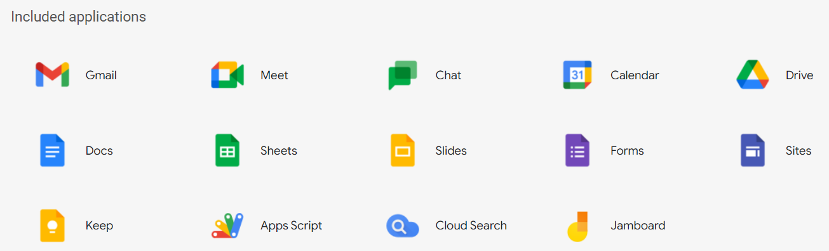
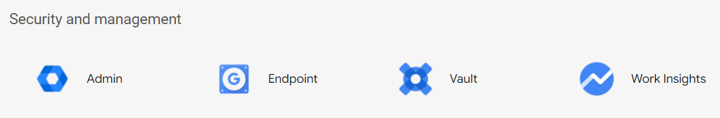

Make decisions faster, face to face.
Google Calendar brings all of your calendars together in one place, so you can manage work, personal life, and everything in between.
Use shared calendars to see when others are available and schedule meetings with automatic email invites.
With one click, turn your meeting into a video conference from any camera-enabled computer, phone, or tablet.
Share your screen to review your work as a team and make decisions on the spot.

Collaborate in real-time.
Easily work on documents, spreadsheets, and slides across your devices, with or without internet.
Work in a single document with teammates or people outside your company. See edits as others type, communicate through built-in chat, and ask questions in comments.
Multiple people can work at the same time, and every change is saved automatically.

Store and share files in the cloud.
Keep all your work in one place with secure access to your computer, phone, or tablet.
Quickly invite others to view, download, and collaborate on any file – no email attachment needed.
File updates are automatically saved and stored in Drive, so everyone can always have access to the latest version.

Secure your data and devices.
Protect your company’s data with security options like 2-step verification and single-sign-on, and use endpoint management to keep your data safe in the case of a lost device or employee turnover.
Archive email messages and on-the-record chats, and control how long they are retained.

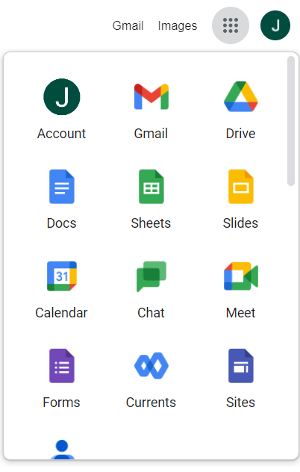
Workspace Apps
Once you are logged into your account, you will see a menu at the top right that will display a list of your apps.
To open an app, click on the icon.
With Google Workspace you can access several apps to keep your business running smoothly.
- Spaces (Currents)
- Drive and Docs
- Chat and Hangouts
- Google Meet
- Vault
- Groups for Business
- Jamboards
- Keep
- Sites
- Tasks

Gmail
Gmail lets you send and search for messages, organize your inbox, and build relationships with integrated chat and video meetings. Gmail is perfect for any organization. Get real-time messages and notifications with security in mind. Accessing and emailing made easy - the way it should be. Not taking away from your busy schedule and working that way you need it. Gmail is an effective way to stay in contact and manage your communications. Even without the internet, you can draft messages that can be made ready to send out when you’re back online. This section is loaded with tips and helpful demos of how you can save time and be more effective with Gmail. Easily elevate communications to video, chat and connect to other G Suite products.
Connect with coworkers via Google Meet or Google Chat, send an invite in Calendar, add an action to your task list — you can do all that and more without leaving Gmail
With Gmail, your email is stored safely in the cloud. You can get to messages from any computer or device with a web browser. If your administrator allows, you can join or start a video meeting in Google Meet right from Gmail. Add Google Chat to your Gmail inbox and get all the features of Chat directly in Gmail. You can also quickly organize and find important email, as well as read and draft email without an internet connection.

What is a user?
A user is defined as one personalized email address (you@yourcompany). Group email aliases such as sales@yourcompany and support@yourcompany are included in pricing and don't count as additional users.
You can access
- Mail – send and receive email messages
- Chat – send an instant chat message to co-workers
- Spaces -
- Meet

Create a signature
- Open Gmail.
- At the top right, click Settings See all settings.
- In the General tab, scroll to Signature and click Create new.
- Name your signature, then click Create.
This name is not your actual signature but is a name for the signature template.
- In the text box at the right, add your signature text.
- Use the format bar to add text colors, links, and images.
- At the bottom, click Save Changes.

Set up Gmail notifications
- At the top right, click Settings See all settings.
- Scroll down to the Desktop notifications section.
- Click the Click here to enable desktop notifications for <your organization>.
- Select New mail notifications on or Important mail notifications on.
- At the bottom of the page, click Save Changes.

Calendars

Create a new calendar
You can create calendars to keep track of different types of events. For example, you could create a calendar called "Soccer" that tracks upcoming practices and games.

Set up a new calendar
You can only create new calendars from a browser and not from the Google Calendar app. Once the calendar is created, you can find it on your browser and in the app.
- On your computer, open Google Calendar.
- On the left, next to "Other calendars," click Add other calendars Create new calendar.
- Add a name and description for your calendar.
- Click Create calendar.
- If you want to share your calendar, click on it in the left bar, then select Share with specific people.
Tip: After you create and share a calendar, you can schedule events for that calendar.

Create & share a group calendar
As an administrator at work or school, you can create calendars to share with people in your organization. These are called group calendars. For example, you might want a shared group calendar for company holidays and another one for organization-wide meetings.
Create a group calendar
Before you begin: To only share the calendar with a specific set of people in your organization, first put them in their own group.
- Open Google Calendar.
- On the left, next to Other calendars, click Add Create new calendar.
- Add the name of the calendar (for example, Marketing Team Calendar), a description, and a time zone.
- Click Create calendar.

Share your calendar
You can share a calendar across your entire organization or with a specific person or group.
- Open Google Calendar.
- On the left, click the name of your new calendar.
- Point to the shared calendar and click More Settings and sharing.
- Choose an option:
- Everyone in your organization—Under Access permissions, check the Make available for your organization box. To share the calendar, ask users to subscribe to the calendar, or share the calendar with an individual or group.
- A specific person or group—Under Share with specific people, click Add Peopleadd the email address of the individual or group you want to share the calendar with.
- In the permissions box, click the Down arrow choose an option. For details, see Permission settings.
- Click Send.
Group calendar invitations include links to calendars
Members receive email notifications with links to the shared calendar.
- Individual users and existing group members—Users get email notifications when calendars are shared.
- New group members—New group members get email notifications about the calendars they can access, typically within an hour after joining the group. New group members do not get this notification email if the group has more than 100 calendars shared to it.
These email notifications include an Add to calendar link. If a user clicks this link and then Add calendar, the calendar shows up in the Other calendars list for that user.

Find shared calendars
To help people find shared calendars, you can send them the calendar ID.
- Open Google Calendar.
- Under My calendars, find the shared calendar.
- Point to the shared calendar and click MoreSettings and sharing.
- Scroll down to the Integrate calendar section and copy the Calendar ID.
It's long.
- Paste this ID into a document or website that you give to new users.
- Tell them to take the following actions:
- Next to Other calendars, clickSubscribe to calendar.
- Paste the Calendar ID into the Add a calendar box and press Enter.
The calendar then shows up in the user’s Other calendars list.

Google Drive
You can store your files securely and open or edit them from any device using Google Drive.

Upload files and folders to Google Drive
You can upload, view, share, and edit files with Google Drive. When you upload a file to Google Drive, it will take up space in your Drive, even if you upload to a folder owned by someone else.
Types of files
- Documents
- Images
- Audio
- Video

Drag files into Google Drive
- Open Drive.
- At the top left, click New and then File Upload or Folder Upload.
- Choose the file or folder you want to upload. Or
- Open or create a folder.
- To upload files and folders, drag them into the Google Drive folder.

Share files from Google Drive
You can share the files and folders that you store in Google Drive with anyone.
When you share from Google Drive, you can control whether people can edit, comment on, or only view the file. When you share content from Google Drive, the Google Drive program policies apply.
Step 1: Find the file you want to share
Share a single file
- On a computer, go to Google Drive, Docs, Sheets, or Slides.
- Click the file you want to share.
- Click Share .
Important: If you use a Google Account through work or school, you might not be able to share files outside of your organization.
- On your computer, go to Google Drive.
- Select the file you want to share Share .
- Enter the email address or Google Group you want to share with.
- Decide how people can use your file. Select one:
- Viewer
- Commenter
- Editor
- If you use an eligible work or school account, click Add expiration to add an expiration date.
- When you share your file, each email address gets an email:
- Click Send or Share.

Currents
Currents is designed to connect your organization around shared interests, helping you collaborate with team members. Trade insights with communities, poll your organization, share posts, and more.
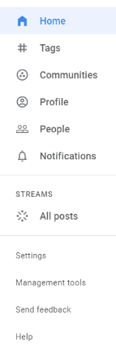
Exchange ideas and documents, and have meaningful discussions with your colleagues — all without flooding your inbox.

Four ways to use Google Currents
As an organization-wide space for conversation, Currents provides an effective channel for the following four key communications categories:
- News and large-group engagement: The most obvious use for Currents is as a place to share news and information relevant to significant numbers of people. Announcements, policy and procedure changes, and items of broad, general interest (e.g., new hires or staffing changes) make sense to share as a post as an update.
- A casual conversation stream: Currents also can be configured to allow informal, non-work related discussions (Figure A). With an increasing number of organizations now supporting remote work, informal streams can help people connect over shared interests in a way that might otherwise be difficult. A stream of hobby-related photos or just weather discussions that might typically be shared during informal breaks might be shared to Currents.
- Ask for insight: Currents also offers a place to ask a question that is visible to everyone in the organization. That increases the chances that someone with experience or expertise might reply–even if they’re not in your workgroup.
- Share experience: Another effective approach to using Currents is to make your and your team’s work more visible to other people in the company. Share news when your team reaches a significant point in a project, post a particularly novel way someone solved a problem, or simply share something you find interesting.

Slides
Create, present, and collaborate on online presentations in real-time and from any device. With easy-to-use presenter view, speaker notes, and live captions, Slides makes presenting your ideas a breeze. You can even present to Google Meet video calls directly from Slides.
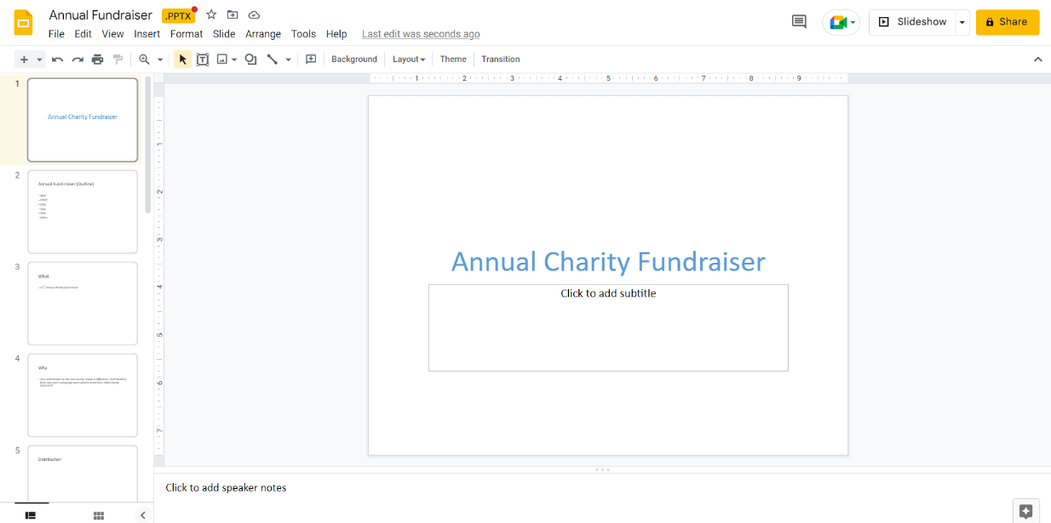
Slides include assistive features like Smart Compose and autocorrect help you build slides faster with fewer errors.
To create a new presentation:
- Open the Slides home screen at slides.google.com.
- In the top left, under "Start a new presentation," click New . This will create and open your new presentation.

Edit and format a presentation
You can add, edit, or format text, images, or videos in a presentation.
- Insert and arrange text, shapes, and lines
- Add, delete & organize slides
- Add animations to a slide

Add, duplicate, & delete a slide
To add a slide with the same layout as the current slide:
- On your computer, open a presentation in Google Slides.
- In the top left, click New slide .
To add a slide with a different layout:
- On your computer, open a presentation in Google Slides.
- In the top left, click New slide with layout .
- Choose a slide.

Add or change animations and transitions
You can create visual effects when you add animations to text, images, slides, and other objects in Google Slides. You can also animate lists one click at a time as you present.
Animate text or images
- On your computer, open a presentation in Google Slides.
- Click the text or image you want to animate.
- Click Insert Animation.
Add slide transitions
- On your computer, open a presentation in Google Slides.
- On the left, click the slide you want to transition to.
- Click Slide Change transition.
Change animations and transitions
When you add new animations, they are automatically set to "fade in." You can change transitions and animations in the panel on the right.
- On your computer, open a presentation in Google Slides.
- Click View Animations.
- Click the animation you want to change.
- To change the speed of the animation, drag the slider.
- To animate lists one line at a time, check the box next to "By paragraph."
Note: Not all animations will work when viewing the presentation in some browsers.

Google Meet
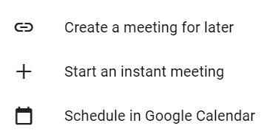
Google Meet was designed specifically for large-scale video conferences that can be joined with a link or a code. Like Zoom, businesses and organizations are its target demographic. You can start a video call, and then share the link or code or invite people via email. Then, just chat away.

Create a Meeting
You can Create a Meeting for later and get a code to copy and paste.
Start an instant meeting for right now.
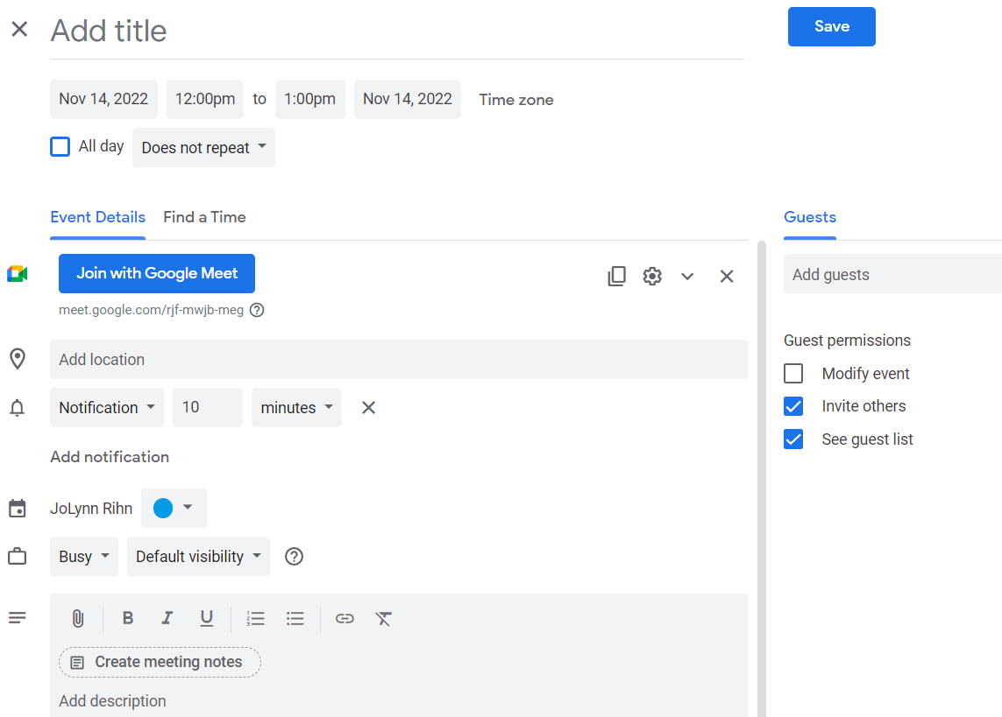
Schedule a meeting in Google Calendar.

Join a meeting
You can join a video meeting from Google Meet, Google Calendar, Gmail etc. You can also dial-in to a meeting from a phone or a meeting room or you can use Google Meet without a Google account.
You can join a meeting multiple ways: in Google Calendar, from Meet, from Gmail, from a URL link, etc.

Present during a Meeting
- At the bottom, click Present now .
- Select Your entire screen, A window, or A tab.
- If you present a Chrome tab, it shares that tab's audio by default.
- To present a different tab, select the tab you want to present, click Share this tab instead.
- If you present a Slides presentation through a tab, you can control it in Meet.
- Click Share.

Stop presenting
- In the Meet window, click Stop Presenting.
- At the bottom right, click You are presenting Stop presenting.
Important: You must use a computer and a Chrome browser to present directly to Google Meet from Google Docs, Sheets, or Slides.
You can present directly to Google Meet from Google Docs, Sheets, or Slides. This can make it easier to present a document, sheet, or slides to a meeting you are attending. Before you present, join the meeting to know if it is being recorded.

Meeting Tools
During a meeting you can record, conduct polls, use breakout rooms, raise your hand, live stream, chat, etc.
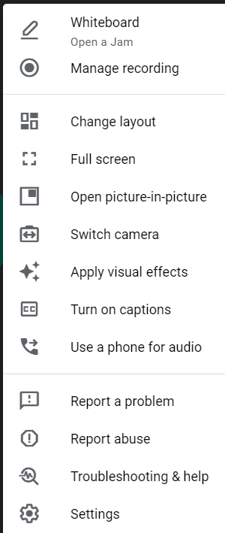
When you click on the vertical dots menu, you will see a list of options to use as well as access the Settings.
Additional tools are available on the bottom right to access Meeting details, see Participants, Chat, use Activities or host controls.

Jamboard
Jamboard is a digital interactive whiteboard developed by Google to work with Google Workspace.

Work together in real time
You can share a jam session with collaborators whether they are on a Jamboard device, mobile app or web browser.
People in up to 50 user sessions can work on a jam at once. When using a web browser, each Jamboard browser tab counts as a session.
Using a Jamboard device, you can:
- Write and draw with the included stylus.
- Search Google and insert images or webpages.
- Drag and resize text and images with your fingers.
- Sketch a box, star, cat, or dragon. Image recognition technology converts your sketch into a polished image.
Using Jamboard on a computer, you can use a web browser to:
- Write and draw using a mouse or trackpad.
- Search Google and insert images or webpages.
- Drag and resize text and images.
- Present your jam to a Google Meet video call.
- Open your jam on a Jamboard device.
Using the Jamboard mobile app, you can:
- Write and draw using your touchscreen. Drag and resize text and images with your fingers.
- Open your jam on a Jamboard device.

Host video meetings
Using a Jamboard device, you can:
- Display upcoming Google Calendar events on Jamboard.
- Tap an agenda item to start a scheduled meeting.
- Present your whiteboard to people viewing remotely.

