Using Windows 11

Table of Contents
Windows 11 1
Taskbar Improvements 1
Start Menu 2
Universal Search 2
Search Settings 2
All Apps 3
Microsoft Store 3
Power Options 3
Personalize Taskbar 3
Change the Start Button to the Left 4
Date and Time 4
Organize your Apps and Windows 4
Snap and Arrange your Apps 5
Snap Groups 5
Manage Snap Options 6
Snap Windows side by side (not new) 6
Working with Widgets 6
See More 7
Multiple Desktops 7
Switch Windows 11 Virtual Desktop 7
Rename Windows 11 Multiple Desktops 8
Change Backgrounds for Multiple Desktops Windows 11 8
Rearrange Windows 11 Virtual Desktops 8
File Explorer 9
Explore the File Explorer 9
Change File Explorer View 10
Pinning Folders to Quick Access 10
Managing Files in File Explorer 11
Sharing Files 11
Moving Files 11
Keyboard Shortcuts 12

Windows 11
Windows 11 is Microsoft’s newest major release of its operating system and the successor to Windows 10. The OS features an all-new simplified, yet modernized, interface and was designed to inspire productivity and creativity.
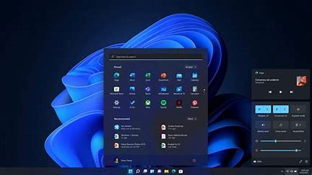
Windows 11 offers several updates and new features, including a simpler design intended to increase productivity, ease of use and creativity, ways to connect to people faster.
In Windows 11, the newly centered Start button uses the cloud and Microsoft 365 to show recent files, no matter what platform or device they were being viewed on previously, including an Android or iOS device.
A new set of features to Microsoft Windows 11 will be the introduction of Snap Layouts, Snap Groups and Desktops. These offer a “powerful way to multitask and stay on top of what you need to get done,” according to the Microsoft’s press release. With these Windows 11 features, users can organize windows and optimize screen real estate for a cleaner visual layout. Users can create and customize separate Desktops for each part of their life—like one for work and one for personal use.

Taskbar Improvements
Intuitive navigation, easy organization: With Windows 11, the user experience has been simplified. It’s a clean, fresh design that is new, yet immediately familiar. Front and center are the ability to search for anything, anywhere. It’s streamlined, intuitive, and revolves around you.
The Taskbar has a few new things you will notice right away, like the Start menu and icons are centered. But there are a few changes on the right side of the Taskbar also.
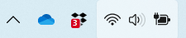
There are some new icons by default on the Taskbar, like Chat. You can still right click on an icon to manage the app or open a recent file.
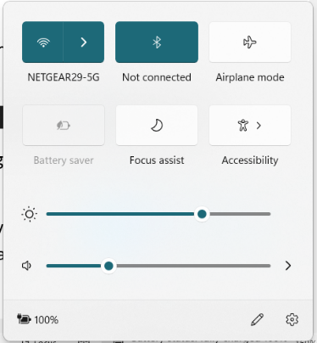
The Wifi, Speaker and Battery icons are combined in a single window. When you hesitate on the icons you can see the are highlighted together. If you click on any of the icons, the controls for all 3 open.
To view Wifi connections near you, click on the Wifi ARROW not the ICON. The icon will turn off the Wifi.

Start Menu
The Start Menu is like the master control panel for your PC. It's where you go to find the apps that you might not have already on your desktop or pinned to the taskbar, and it's where you'll find quick access to the settings menu and power controls.
If you prefer the left-oriented layout, it looks like you'll be able to move the Start Button back to that position. And, as always, you can open this menu with a tap of the Windows key.
The newly designed Start Menu consists of 3 areas:
- Search
- Pinned
- Recommended
The Start menu includes some apps that are pinned by default. You can customize the Start menu layout by pinning (and unpinning) the apps you want. For example, you can pin commonly used apps in your organization, such as Outlook, Microsoft Teams, apps your organization creates, and more.

Universal Search
Find what you want, faster. With centralized Search, you can now search across your computer and the internet right inside the Start menu, making for a quicker and more thorough search experience.
The search results start populating as soon as you start typing, with a search results interface that lets you quickly sort between Apps, Documents, Web results and other positive hits.
Select Search on the taskbar or press Windows logo key + S, then type what you want to find. You'll get personalized search results for people, email, and files in local and shared sites, or from the web.

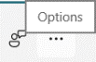
Search Settings
You can modify the search settings by clicking in the Search bar, then click on the … Options menu.
Then click on Search Settings.

All Apps
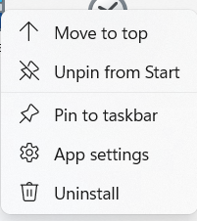
If you want to use an App that is not in the menu, click All Apps. You will see the familiar apps like Paint, Calculator, Games, WordPad and Notepad. If you have installed other apps, you will find them in the alphabetical list.
You can manage the Apps you see in the start menu. Right click on any App icon from either the main window or all Apps list – you can pin it to the Taskbar, Start Menu and more.

Microsoft Store
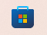
The Microsoft Store is still available for additional Apps you may need. The User Interface has been revised to look more like the Microsoft Teams window.

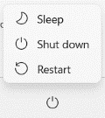
Power Options
The Power options are location on the bottom right of the Start Menu. You will have access to Sleep, Shut down and Restart.

Personalize Taskbar
If you want to modify your Taskbar open the Settings from the Start menu.
Go to Settings. Then click on Personalize.
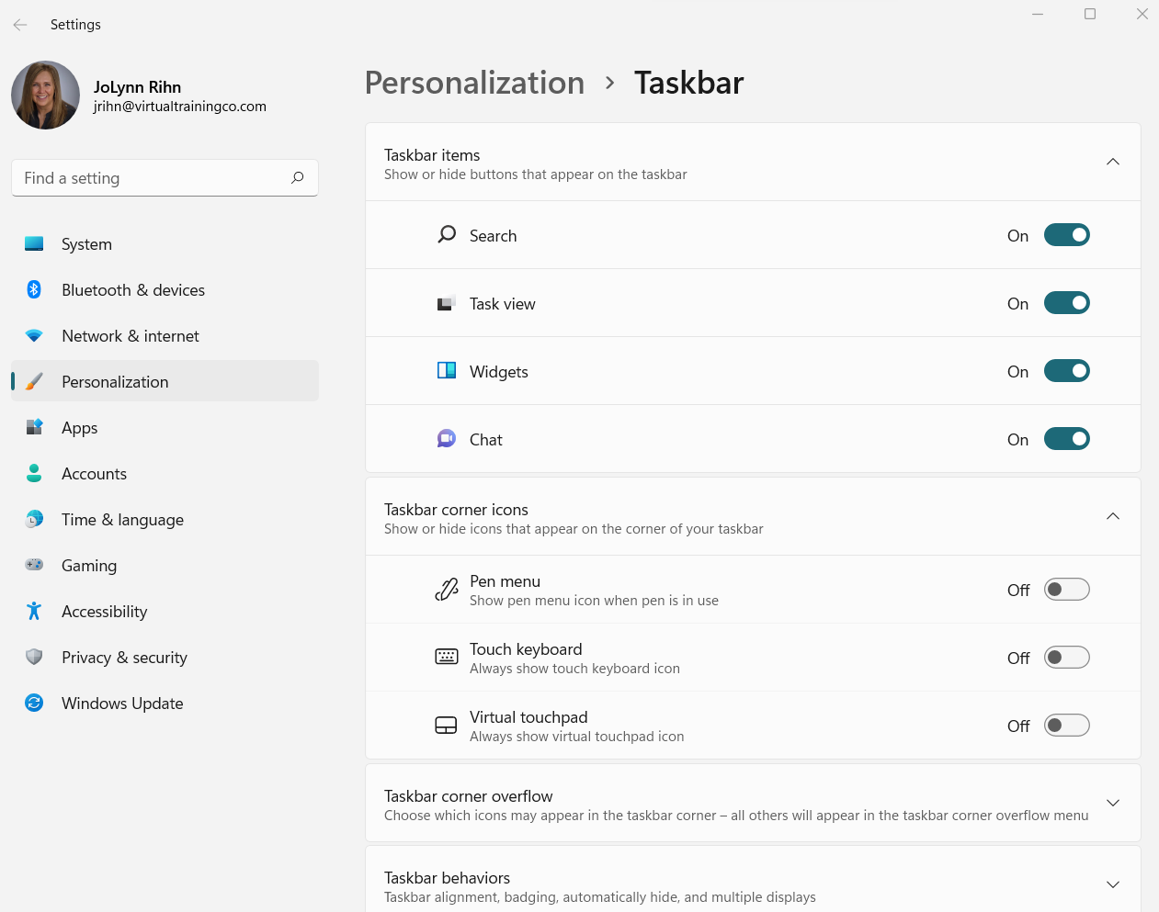

Change the Start Button to the Left
If you don't like that the Windows 11 Start button moved to the center of the taskbar, you're in luck—you can move the Start menu and other app icons back to the left corner in a few quick steps. And while it's no longer possible to have a vertical taskbar, you can customize the taskbar in other ways, such as hiding it automatically and changing which icons are visible.
- Right-click an empty area of the taskbar.
- Left click on Taskbar Settings. This takes you to the Personalize section of the Settings.
- Under the Taskbar behaviors, for Taskbar alignment, click the arrow and choose Left.
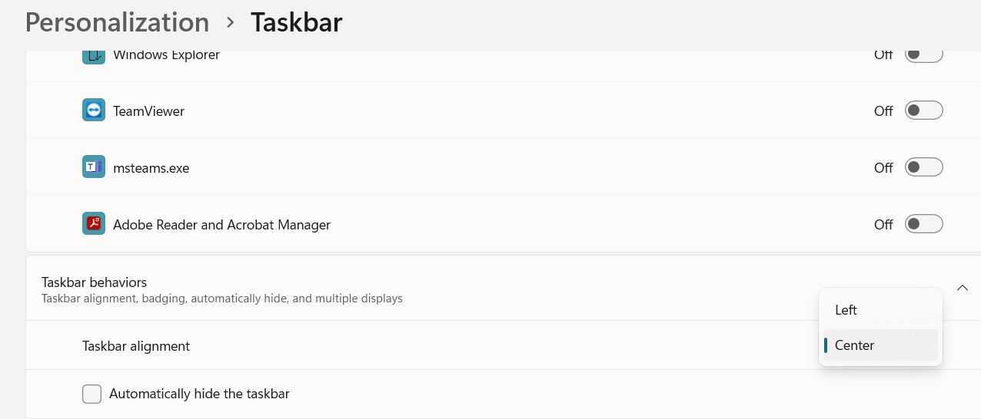

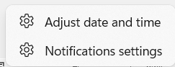
Date and Time
The date and time will appear on the bottom right of the Taskbar. Right click on the date/time to access features like:
- Adjust date and time – change time zone and more.
- Notification settings – getting notifications from different apps.

Organize your Apps and Windows
Clean desktop, clear mind. Pick up where you left off instantly with Snap Groups & Desktops, even when docking and undocking to an external monitor.

Snap and Arrange your Apps
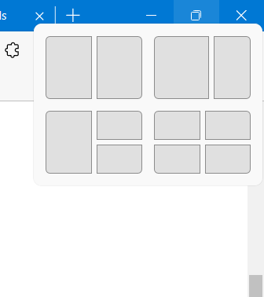
The new Snap layouts feature focus is to increase user's productivity, which helps to arrange or snap the apps logically on the screen according to the user choice. You can group and organize open windows and easily pivot between them with the groundbreaking multi-tasking tool, Snap Assist. Effortless to use—just drag windows to the edge of the screen to activate in just a few clicks.
Hesitate on Maximize or Restore Icon.
This is particularly helpful when the user has a bigger, or widescreen, and has multiple applications open as per the requirement. To invoke snap layouts, on the active Window, either press Windows key+Z or hover over the maximize button. In the earlier releases of Windows, the user had to drag the app to the edge of the screen to activate the snapping feature.
On traditional displays, you would see four layout choices and for ultrawide screens, you would see six layout choices.
To Use Snap Assist:
- Hesitate on the Maximize/Restore icon at the top right of the window.
- Click on the layout option you want to use. The current window will be placed, click on other open app to snap it to each layout section.
- Choose the location of the app, simply click the mouse button in the desired layout to snap the first active app on that part of the screen.
When the first app is snapped, snap assist would show up, asking you to select the app you want to snap on the second layout. After the second, select the app for 3rd layout (if you selected that layout) and so on.

Snap Groups
Bring together groups of apps and windows with Snap Layouts, and easily maximize and minimize the entire bunch with Snap Groups in Windows 11.
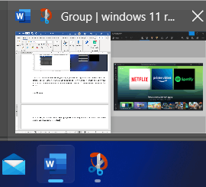
Snap groups remember the layouts used when multiple apps have been snapped mutually into a group using the Snap Layouts feature, so that you can quickly resume where you left off.
So, after using Snap groups to snap your work apps, let us say you want to take a break, and want to use Focus sessions on the Clock app. This is where the snap group feature comes in handy. You can pick up where you left them off and can open the layout with a single click. In the taskbar, it shows the title as Group.

Manage Snap Options
In case this feature is not relevant to you, Microsoft has also provided an option in Windows 11 to turn off specific settings related to Snapping in the Settings app. To turn off Snap layouts:
- Open Settings from the start menu then click on System.
- Navigate to Multi-tasking.
- Turn off the settings you like, under snapping.

Snap Windows side by side (not new)
Press Windows logo key + Right or left arrow to perfectly snap windows to the sides of your screen automatically – no manual resizing or positioning needed.

Working with Widgets
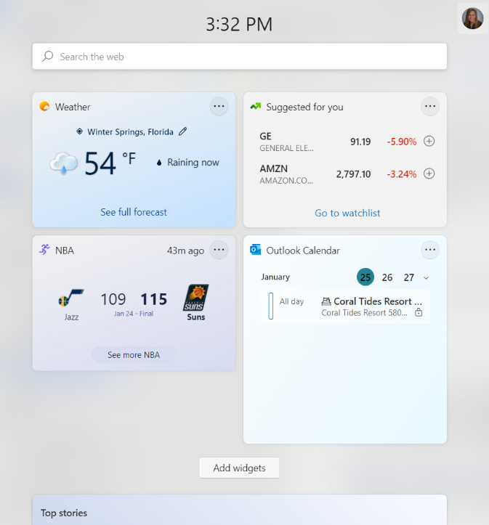
Windows 11’s new Widgets are a personalized feed powered by artificial intelligence and Microsoft Edge. Instead of using a phone to check news, weather or notifications, now users can open their Windows 11 desktop to see a similarly curated view. Widgets offers new opportunities within Windows 11 to deliver personalized content for creators and publishers.
Personalize your content feed with Widgets, so you can quickly see all the things you like to keep tabs on, from sports and weather to your schedule and to-dos. Now you can see it all in one place with just a quick left swipe of your screen.
The information you want, right at your fingertips, widgets are great ways to get bite-sized moments of news, entertainment, and more throughout your day.
Change your widget board to reflect your interests and show the info you want.
To customize:
- Open the Widgets window from the Taskbar by hesitating on the Weather at the bottom left.
- You will see the defaults Widgets in the window. To modify those, click on the More Options (…).
- You can change the size, Remove the widget or click Customize for more options depending on the Widget.
To Add a New Widget, click on the Add Widgets button at the top right.
Or access the Widget Settings by clicking on that icon.

See More
At the bottom of the screen, if you click on the See More icon, this will take you to the Internet on the MSN home page.

Multiple Desktops
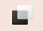
Windows 11 has improved its feature – virtual desktop and focuses more on multitasking. If you need to access multiple windows one time, it makes sense to classify and separate them, for example, you can perform your work on a virtual desktop and play games on another virtual desktop.
You can easily move from one virtual desktop to another, set different backgrounds for multiple desktops, rename the virtual desktop, and more.
If you hover the cursor over the Task View icon, the currently active desktop called Desktop 1 is displayed. To create a virtual desktop, you should click the + icon next to Desktop 1.
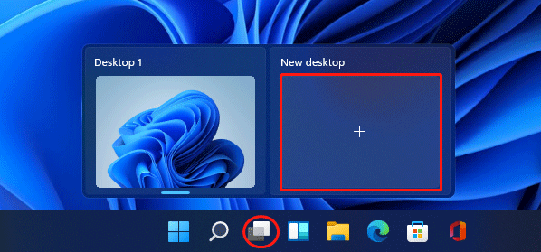
Tip: By default, the Task View button is added to Taskbar but sometimes it is hidden. In this case, you need to enable this button. Just right-click Windows 11 Taskbar, choose Taskbar settings and then switch the toggle of Task View to On.

Switch Windows 11 Virtual Desktop
If you have multiple desktops, you can switch between them easily.
- Via Task View: Put the mouse cursor on this Task View button and choose the virtual desktop you want to access.
- Via keyboard shortcut: Press the Win + Tab keys on the keyboard and select the virtual desktop you want to go to. If you want to use keyboard shortcuts to quickly switch between desktops, press Win + Ctrl + Left (switch to the one on the left) or Win + Ctrl + Right (switch to the one on the right).

Rename Windows 11 Multiple Desktops
You can rename virtual desktops in Windows 11 as per your liking and follow the steps below:
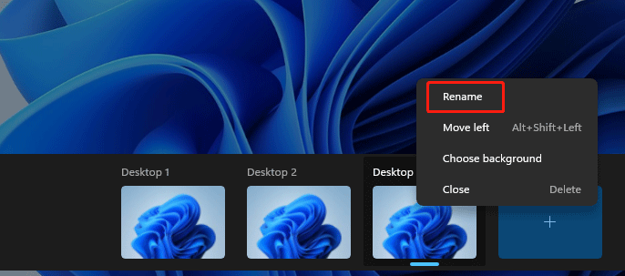
- Hover on the Task View icon, right-click on the virtual desktop, and then choose Rename. Type a new name and press Enter.
- Or, you can click the name of the virtual desktop, type in a new name, and press Enter.

You can give different names to your multiple virtual desktops based on your situation, for example, work, fun, home, etc.

Change Backgrounds for Multiple Desktops Windows 11
Windows 11 allows you to set different backgrounds for each virtual desktop and here is what you should do.
- Press Win + Tab or click the Task View button, right-click on the target virtual desktop, and click Choose background from the context menu.
- In the Windows Settings interface, choose one based on your liking.

Rearrange Windows 11 Virtual Desktops
To rearrange multiple virtual desktops, you can click Taskbar view, click the virtual desktop, hold and drag it to the desired position. Then, release the click and other virtual desktops will be also rearranged accordingly.

File Explorer
File Explorer allows you to access files stored on your local c:\Drive and network drives.
The File Explorer in Windows is the file management tool used for viewing folders and files. File Explorer in Windows 11 helps you get to the files you need quickly and, in fact, every time you open a folder in Windows, you are seeing the File Explorer. To start using the File Explorer in Windows 11, select it on the taskbar or the Start menu, or press the Windows key + E on your keyboard.

Explore the File Explorer
In Windows 11, the File Explorer application has been updated, and the interface has been simplified. When you open File Explorer, you will see three main sections:
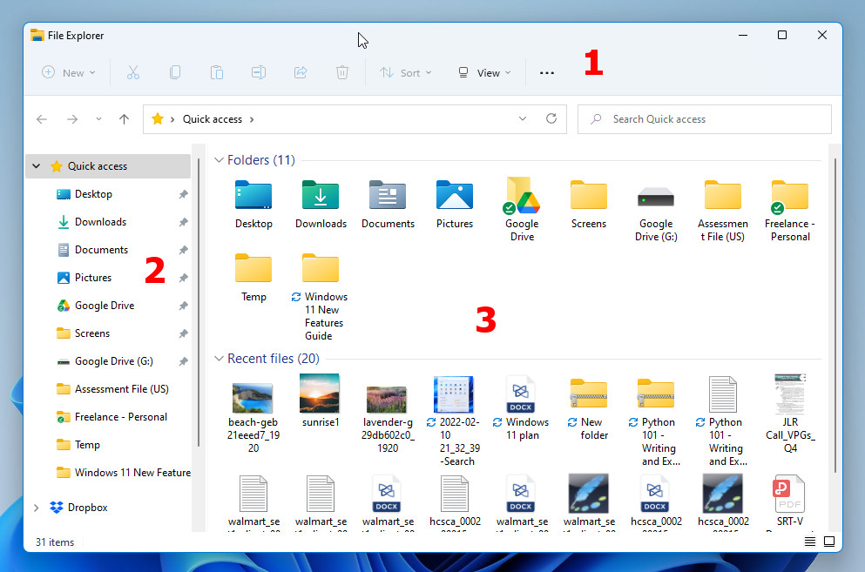
1 – File Explorer Ribbon - The bar at the top of the window is called the ribbon. This contains the tools for the File Explorer, which include Cut, Copy, Paste, Share, Delete and Sort. You will also see a dropdown menu that lets you control the way the files are viewed in the folder. Initially, most of the tools are not selectable, but this is only in the Quick Access section. As soon as you move to a different folder, selecting a file will activate the tools so you can use them.
2 – The Navigation Pane - On the left side is the Navigation pane. This contains links to the main sections of your computer, including the Desktop, Documents and Downloads (within Quick Access section), OneDrive, This PC and more. The Quick Access section at the top of the Navigation pane contains both folders you have pinned there, and folders you have recently used.
3 – Content Pane - The main part of the File Explorer window is the Content pane. When you first open File Explorer, Quick Access will be selected and so the Content pane will show both pinned and recent folders. Below this section, you will see recent files displayed (Word, PDF, MP3, images or other files you have recently opened).

Change File Explorer View
As soon as you navigate away from Quick Access, the Content pane will change to display whatever is inside the folder you navigated to. You can change the way the Content pane displays files by clicking on the View tab in the ribbon and then moving the pointer over the Show section.
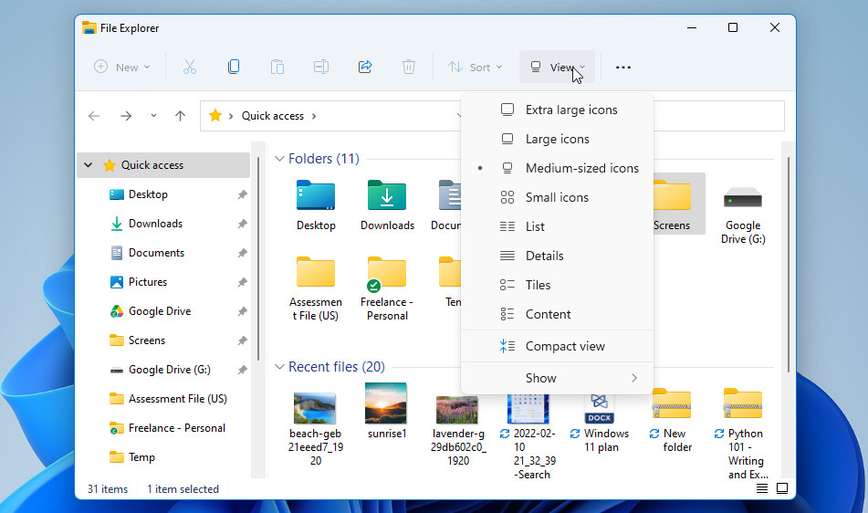
Here you can choose to show a Details pane or a Preview pane (or neither). The Details pane shows information about the folder. The Preview pane shows a preview of a file you select in the folder. This could be an image, a text file or another file type. Not all files will show a preview.

Pinning Folders to Quick Access
1 – To pin any folder to Quick Access, right-click on it wherever you see it, and then choose “Pin to Quick Access” from the action menu that opens. Pinned folders are displayed in the section with a small pin icon next to them.
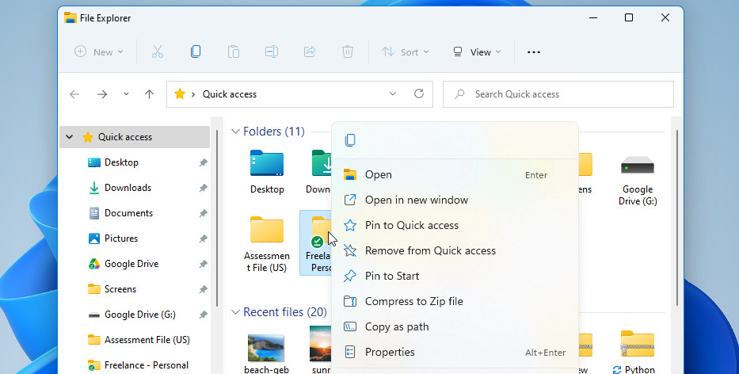
2 – If you want to see only your pinned folders in Quick Access, you can turn off recent files or frequent folders. Click the More tab in the ribbon, and then select Options. In the Privacy section, clear the checkboxes and select Apply.
3 – To remove something pinned in Quick Access, just right-click on it and select “Unpin from Quick Access”.

Managing Files in File Explorer
As mentioned above, every time you open a folder in Windows 11, you are seeing File Explorer. The actions listed below can all be done from ANY folder you open in Windows 11.

Sharing Files
To share a file, select it, then select Share in File Explorer on the ribbon. The Share panel will open, showing you the available sharing methods. These will vary, depending on the apps and software you have installed on your computer.

Moving Files
To move the location of a file or folder, select it and then select Cut in File Explorer ribbon. Navigate to the new folder location, and then select Paste in File Explorer ribbon. You can of course also use the Copy and Paste buttons if you want to copy a file to a new location instead of moving it.
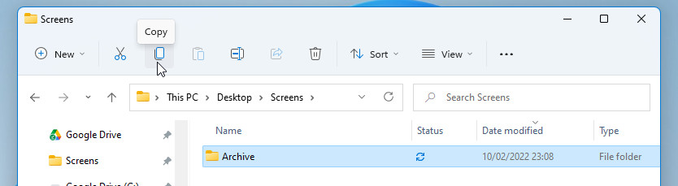
Change File View
To change how items in your File Explorer appear, select View and choose between showing icons, lists, details, and more. To reduce the space between files, select View > Compact view.

Keyboard Shortcuts
No mouse? No problem! Keyboard shortcuts provide alternate ways to do something you'd typically do with a mouse.
Press this | To do this
Windows logo key + Left arrow | Maximize the app or desktop window to the left side of the screen
Windows logo key + V | Open the clipboard history
Windows logo key + semicolon (;) | Open emoji panel
Windows logo key + H | Open voice typing
Windows logo key + S | Open Search

