Microsoft OneDrive
March 2022

What is OneDrive?
Microsoft OneDrive gives you one place to store, share, and sync your files. As part of your organization's Microsoft 365 subscription, or SharePoint Server, you can save your files in OneDrive and then work with them from almost any device.
With OneDrive you can:
- Upload files from your PC or Mac.
- Share files with others.
- Give others permission to edit files and work on them at the same time.
- Get to your files from anywhere, on your computer, tablet, or phone.
- Sync OneDrive to your PC or Mac, so you can access your files even when you're offline.

OneDrive User Interface
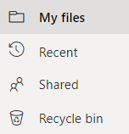
When you open OneDrive from an Internet Browser, you can use the Navigation Pane on the left you can access My files, Recent, Shared, Recycle bin or Quick access location on SharePoint.
Menu Bar
The Men Bar at the top of the window, gives you access Creating New Files/Folders, Uploading files/folders, Syncing or accessing Automate options for Power Automate Flow options.
The Menu Bar at the top can change if you select a folder or file. To select a folder or file click on the circle in front of the name. Then the Menu Bar will have commands related to managing the item selected.

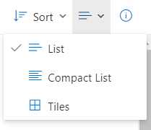
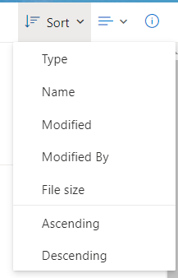
OneDrive Sorting and Views
At the top right of the window, you will have access to the Sorting and View options.
- Sorting by – type, name, modified, modified by, file size both A/Z or Z/A.
- View Options – List, Compact List or Tiles

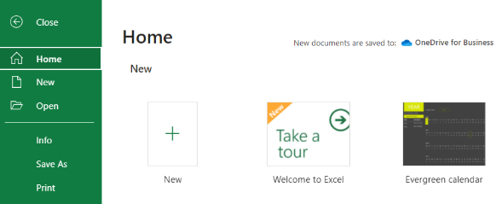
Saving Files to OneDrive
You can save files into OneDrive multiple ways. If you are using the online versions of Microsoft 365, they default to saving to your OneDrive or you can drag n drop files onto OneDrive.
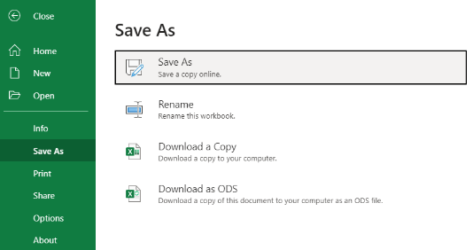
Microsoft 365 apps have autosave that will save your files to OneDrive but if you want to save to another location you can go to the File menu, click on Save As and navigate to the location.
From a desktop version of your apps, you can choose OneDrive from your Save As options.

Create New Files
You don’t always have to start a new Word doc or Excel workbook directly in the app, you can create new directly in OneDrive.
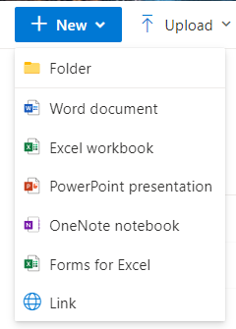
Open OneDrive and from the Menu Bar at the top, click on New.
From the Menu, choose:
- Folder – create a new Folder to store files or other folders
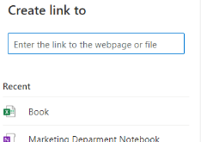
- Word document, Excel workbook, PowerPoint presentation, OneNote notebook, Forms from Excel
- Link – create a link to a webpage or file.

Sharing Files with OneDrive
If you want others to have access to a file you saved in OneDrive, you can Share it.
- From within OneDrive, you can select the file then from the Menu Bar, click Save.
- If you open a file in an application and the file is saved in OneDrive, you can share it in the app by clicking on the Share icon at the top right of the window.
- Copy Link from the Menu Bar will allow you to Paste the Link to an email, website, etc.

Sharing Files with Non-Microsoft Users
Your OneDrive files can be shared with anyone, even if they don’t have a Microsoft Account. Sharing OneDrive files allows you to securely collaborate with people outside your organization such as your business partners, vendors, clients, or customers — with or without a Microsoft 365 subscription. When you enter the name(s) of who you want to share a file with, enter their email address or name if saved in your contacts.
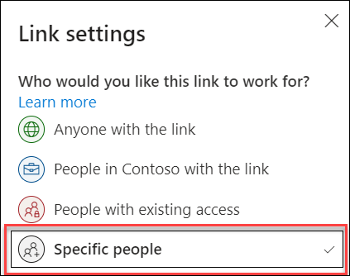
When they open the link to the file,

Create a link for secured sharing
If you want to secure your content and get a link that only works for the people you invite, select Specific people in Link settings when creating the sharing link.

The recipient will then need to verify their identity before they can view the content, but the process depends on their account:
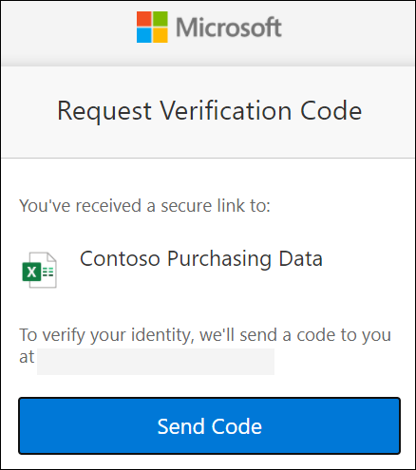 | 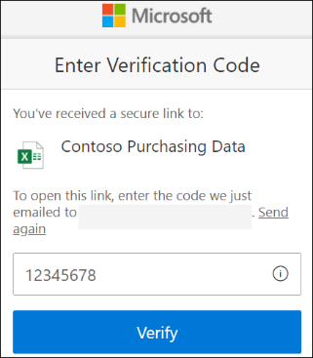
When someone who doesn't have a Microsoft 365 account wants to access the content, OneDrive or SharePoint sends a one-time passcode to their email address to verify their identity. Once they receive the code, they enter it into the verification screen to open the file.
There is no need for the recipient to sign up for Microsoft 365, OneDrive, or SharePoint account. The content is secured and the link won’t work if it’s forwarded to others – it only works for people you specified when you shared.
They can choose the app they would like to open the file with.

Managing Access to Files
Share items with lots of people you might not even know personally. For example, you can use these links to post to Facebook, Twitter, or LinkedIn, or share in email or IM. Anyone who gets the link can view or edit the item, depending on the permission you set. Users with the link cannot upload new items. Keep in mind that the link can also be forwarded and sign-in is not required.
- Open OneDrive
- Pick the file or folder you want to share by selecting the circle in the upper corner of the item. You can also pick multiple items to share them together (sharing multiple items at the same time is not available for OneDrive for work or school accounts).
- Select Share at the top of the page.
- Enter the names or email address of who you want to send the link To: .
- Select Anyone with the link can edit to customize the link options.
- Set the options you want on your link, then select Apply when you're done.
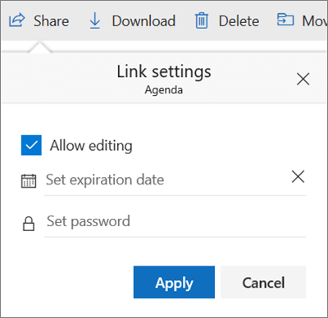
- Allow editing - When you share items with this type of link, people can edit files, and can add files in a shared folder if they're signed in with a Microsoft account. Recipients can forward the link, change the list of people sharing the files or folder, and change permissions for recipients. If you're sharing a folder, people with Edit permissions can copy, move, edit, rename, share, and delete anything in the folder.
- Unchecking this box means that people can view, copy or download your items without signing in. They can also forward the link to other people. However, they cannot make change to the version on your OneDrive.
- Set expiration date - The link will only work until the date you set. After that, the link will be invalid, and you will need to create a new link for users requiring access to your file or folder.
- Set password - When a user clicks the link, they will be prompted to enter a password before they can access the file. You'll need to provide this password separately to users.
- When finished click Apply. This will return you back to the main window.

Link Settings
OneDrive users also have the option to restrict the level of access (anyone with the link, only people within your organization, only people with existing access to the file, or only individuals you specify). Also, if you opt to disable editing, you can also opt to prevent viewers from downloading the file.
- Click on the Pencil icon to the right of the To:.
- Click Link Settings.
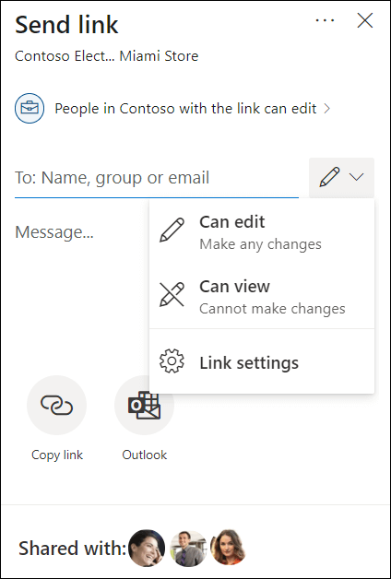
- Anyone gives access to anyone who receives this link, whether they receive it directly from you or forwarded from someone else. This may include people outside of your organization.
- People in <Your Organization> gives anyone in your organization who has the link access to the file, whether they receive it directly from you or forwarded from someone else.
- People with existing access can be used by people who already have access to the document or folder. It does not change the permissions on the item. Use this if you just want to send a link to somebody who already has access.
- Specific people gives access only to the people you specify, although other people may already have access. If people forward the sharing invitation, only people who already have access to the item will be able to use the link. Note that in order to track access and ensure security, you can only share with someone who is in your organization or has a Microsoft Account.
- Allow editing - When you share items with this type of link, people can edit files, can add files in a shared folder, and can delete files in a shared folder if they're signed in. Recipients can forward the link, change the list of people sharing the files or folder, and change permissions for recipients. If you're sharing a folder, people with Edit permissions can copy, move, edit, rename, share, and delete anything in the folder.
By default, Allow editing is turned on. If you want people to only view your files, uncheck the check box. With OneDrive for work or school accounts, you can also quickly select editing permissions without having to open the sharing link settings. Simply select the pencil icon next to the Name, group or email box, then give the recipients edit or read-only permission. If you want to select or modify more options, select Link settings to access the additional options.
At the bottom of the Send link window, the Shared with list shows everyone who has access to the file. Each round item has either a photo of an individual or the initials of a group that the file has been shared with. If you want to edit the access level for an individual or group, select a photo or group initials to open the Manage Access page.

Sharing Folders
When you share folders with Edit permissions, people you share with can add the shared folders to their own OneDrive. This lets them keep the folder alongside their own folders and items, easily move items between folders, and more easily work on it offline. Any updates they make sync with the shared folder, so everyone with access to the folder is up to date.
Tip: The recipient can add shared folders to their OneDrive, not individual files. If you want the recipient to add files to their OneDrive, put the files in a folder first, and then share the folder.

Collaborate in real-time using the Microsoft 365 Integration
When you share a file from OneDrive with other Microsoft users, multiple people can access the file at one time. This is called real-time collaboration.
Benefits of real-time collaboration - The benefits are becoming clear as more businesses and groups implement and adopt online collaboration tools such as online whiteboards. Here are just a few proven benefits of real-time collaboration:
- Improved participation and knowledge sharing from working together as a team just as you would if you were in the same room.
- Increased efficiency and productivity from a simplified and seamless process that eliminates back-and-forth communications and replaces the chaos of multiple versions with a single, shared document living in the cloud.
- Higher employee morale and job satisfaction and decreased feelings of isolation and loneliness associated with remote work.
- Streamlined workflow with meetings, conversations, and file sharing—all happening simultaneously.
- Greater cost-effectiveness over traditional methods of collaboration which require office space, equipment, and travel.
- Expansive reach and scope from the ability to connect anyone inside and outside your business including employees, clients, and vendors.
When more than one person is in a file, you will see their profile circle at the top right of the window.

Accessing OneDrive with File Explorer
Like other storage locations, you can access your OneDrive directly in File Explorer. You can use OneDrive like your other drives, C:/Drive, network drives, etc.
- When you open File Explorer, on the left side of the window, click on OneDrive.
- On the right side of the window you will see your folders and files that are saved in OneDrive.
- You can open the files, copy, cut, etc. just like any other file or folder.
If OneDrive is not already added to your File Explorer, you can add it: Click on the following link - https://www.microsoft.com/en-in/microsoft-365/onedrive/download to install the OneDrive app on your PC.

Known Folder Backup
OneDrive essentially backs up everything you put in the OneDrive folder to your online cloud but if you have other files/folders you want backed up, you can have them saved into OneDrive.
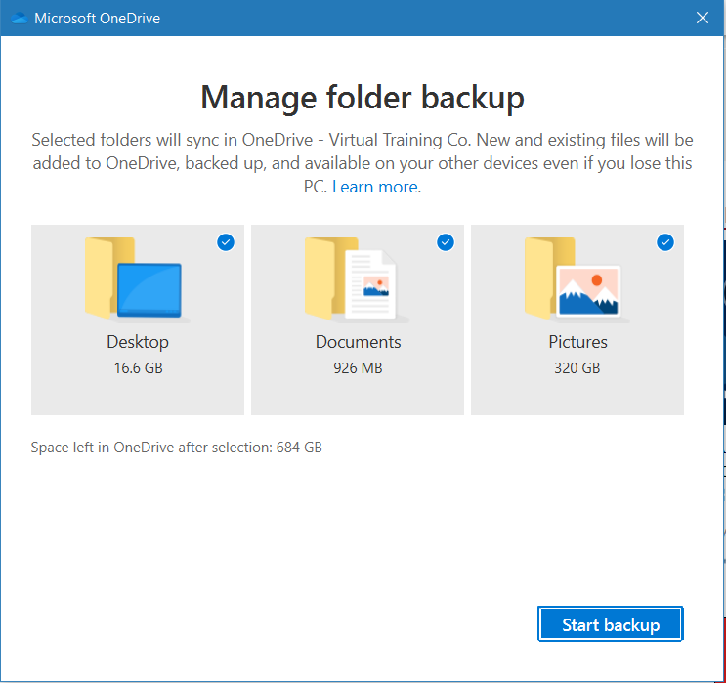
Known folders are global pointers in Windows representing a location on the user’s drive. They help users to organize their most important files and access them across different applications. KFM (Known Folder Move) helps you move your docs, desktop, and pictures into OneDrive. Even the Screenshots and Camera Roll folders are included when the Picture folder has opted into KFM.
To setup files/folders to be backed up:
- In File Explorer, right click on the cloud icon for OneDrive.
- Click Settings, Backup then Manage Backup.
- In the Mange Folder Backup dialog box, check or uncheck the Desktop, Documents, Pictures, etc.
- Click Start Backup.

Syncing Files with OneDrive
With OneDrive, you can sync files between your computer and the cloud, so you can get to your files from anywhere - your computer, your mobile device, and even through the OneDrive website at OneDrive.com. If you add, change, or delete a file or folder in your OneDrive folder, the file or folder is added, changed, or deleted on the OneDrive website and vice versa. You can work with your synced files directly in File Explorer and access your files even when you’re offline. Whenever you’re online, any changes that you or others make will sync automatically.
Autosave is turned on for all files opened from a Microsoft application that is saved on OneDrive.
If you have a file saved in OneDrive that you need to work on while not connected to the Internet, you can Always Keep on this Device. Then make your changes and when you reconnect to the Internet, the change file will automatically sync back to OneDrive.
- To turn on Always Keep on this Device – in File Explorer, right-click on the file and select Always Keep on this Device. You will see a green check mark next to the file in the status column.
Request Files feature
With the file request feature in OneDrive, you can choose a folder where others can upload files using a link that you send them. People you request files from can only upload files; they can't see the content of the folder, edit, delete, or download files, or even see who else has uploaded files.
Important:
- Request files is only available for OneDrive for work or school accounts and your admin must enable Anyone links in OneDrive. Please contact your admin if you don't see this feature.
- This feature is not available for Office 365 Government, Office 365 operated by 21Vianet, OneDrive for home, or Office 365 Germany.
With a file request:
- Anyone with the file request link can send you a file; they don't need to have OneDrive.
- All the files sent to you are saved in a single folder that you choose.
- Every file will have a prefix to help you identify who uploaded it.
- If two files with the same name are uploaded, OneDrive will automatically add a number to the name of the second file.
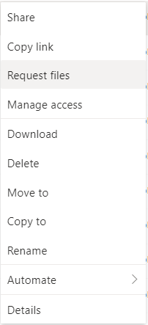
- People who respond to your request can only upload files. They can’t view or edit the contents of your OneDrive.
To use Request Files:
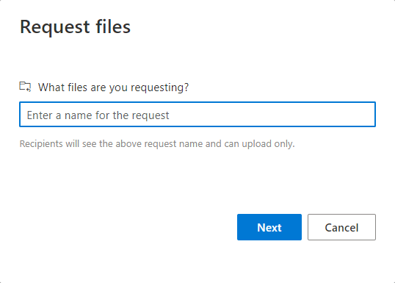
- In OneDrive, right click on the folder, then select Request Files.
- Enter the name of the file, click Next.
- Copy the link or send via email.
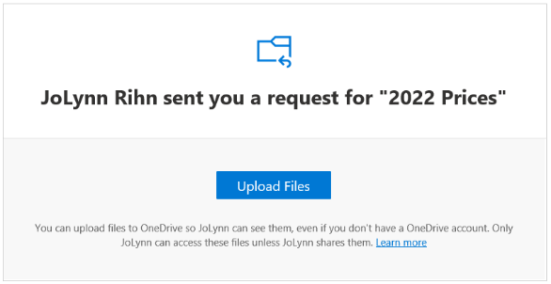
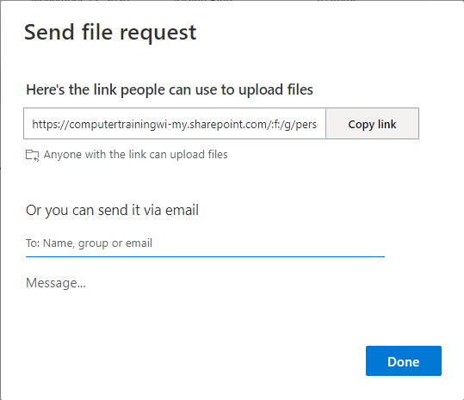
If you email them, they will receive a message like this (see pic) where they can click on the Upload Files and it will open the link. Click select files, navigate to the location, then click Upload.

